URWERK presents UR-220, codenamed “The Falcon Project”

Geneva, September 15, 2020

Just a few months after launching its UR-210 “final edition” model, the independent watchmaker, URWERK, has put into orbit a newcomer in its UR-Satellite collection: the UR-220 “Falcon Project”.

With its manually wound movement and control board on its back, the new UR-220 goes back to URWERK’s earlier technologies in a case that is sleeker, more ergonomic and as stunning as ever. One exceptional feature is the return of the Oil Change indicator in a new guise.

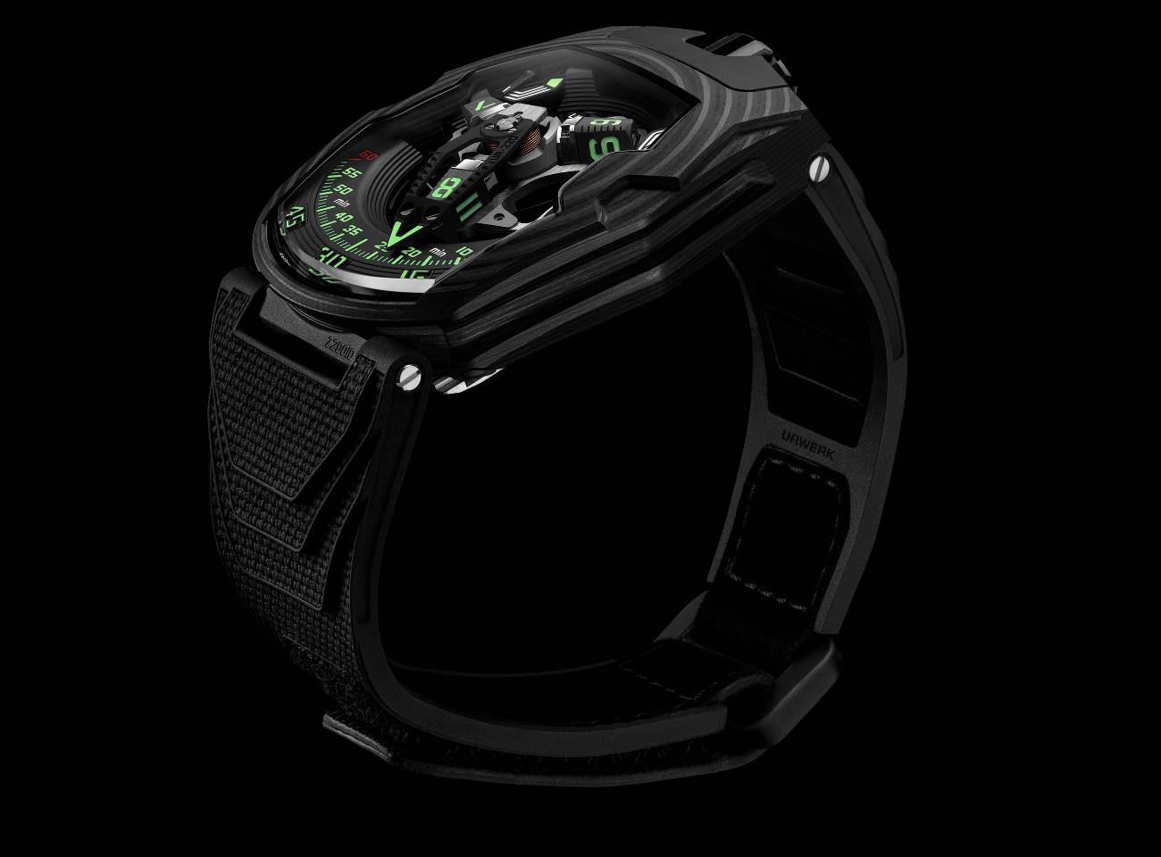

A quick glance to the UR-220 could be misleading. Look again because everything has changed here. Although the UR-220 has adopted some of the features of its predecessor, the entire movement has been reconceived, redesigned and reworked.

Instrument panel
For a change we’ll start with the back of the watch, which shows how much the 200 series modules have evolved. URWERK’s signature Oil Change indicator returns after years of absence to show the accumulated engine running time of the watch. This original type of information had for long featured in the UR-110 models. It returns with some well thought out upgrades.

In the UR-220, the Oil Change indicator takes the shape of a numerical counter calibrated in months, shown on two adjacent rollers. The log of the movement’s running time is started by the owner of the watch who removes a security pin and presses the pusher on the back of the UR-220. From then on, the counter displays the accumulated running time of the watch in months. When it reaches 39 months, it is time to take the watch in for a service and oil change. URWERK’s watchmakers will set the counter back to zero and replace the pin at the end of the service. “It’s more than a numerical counter making a cold tally of the months,” says Felix Baumgartner, URWERK’s co-founder. “The Oil Change indicator tells you for how long your watch has actually been working on your wrist, and reflects the energy you have fuelled it with every day. It connects you with your watch.”

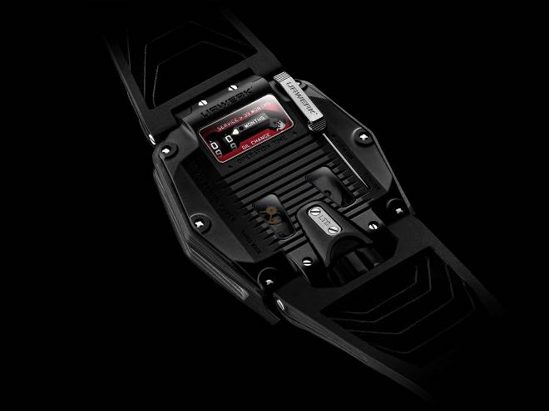
The unbearable lightness of carbon
On the material side, the UR-220 is clad in carbon. This is the first time URWERK has adopted the high-tech transformation of this common element. The result is an extremely tough but featherweight case, composed of 81 ultra-thin layers of high-resistance 150g CTP carbon compressed into a hard resin. The carbon structure of the UR-220 has a pattern all of its own with a finesse and regularity that emphasises the curve of the case.
“I wanted to have the finest possible pattern traced along the length of the UR-220’s case,” explains Martin Frei, URWERK’s other co-founder. “We therefore needed a special kind of carbon in layers that are not only parallel but as thin as possible. The concentric pattern you can see on the surface of the UR-220 is the result of this choice. The carbon layers underscore the curves of the sapphire-crystal glass of this watch. In terms of style and technique this UR-220 is just the way I wanted it.”

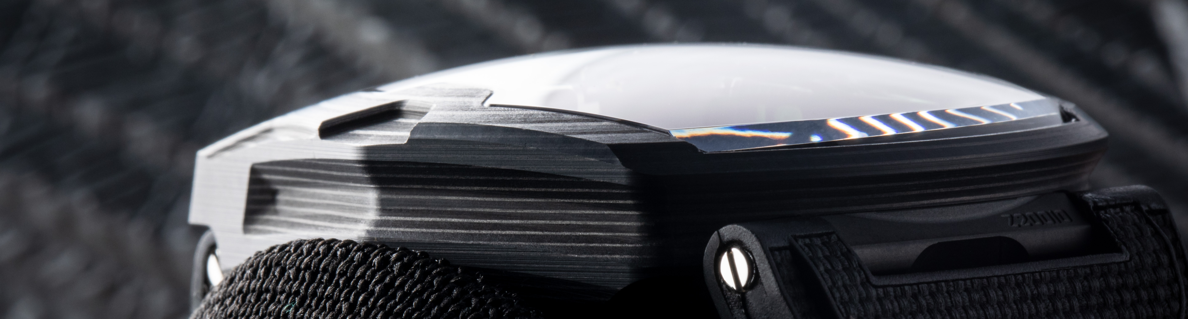

Carrousel and switchback
The UR-220 adopts the patented satellite indication of its predecessor, in which the wandering hours are indicated on three rotating cubes. In turn they pick up the minutes pointer as they enter the 120° scale of 60 minutes. At the end of the hour, the minutes pointer leaps back to the start of the scale to be picked up by the next hour. To minimise the inertia of the retrograde minutes, each side of the pointer has been pierced to make it as light as possible.
The only other indication on the dial is that of the power reserve. This is displayed on two up/down gauges, each of 24 hours. When the movement is wound, the right-hand gauge reacts first. As soon as it shows 24 hours of power reserve, the left hand gauge takes over. Splitting the power reserve indication turned out to be a complex task, requiring 83 mechanical parts.

A unique strap
With the UR-220’s strap, URWERK again ventures into new territory. It is the company’s first rubber strap, and therefore has to be something special. The strap is cured, moulded and textured by the Vulcarboné© process which gives it a touch like velvet. Many years of research into nano-textures were needed to create this effect. Then the strap is stitched and finished by hand to ensure supreme comfort, strength and appearance.

The smallest detail
No detail can be neglected, especially not the numerals of the UR-220. Martin Frei has designed a new typography. In their livery of URWERK’s radioactive green, their new design makes the hours and minutes even sharper. They find their inspiration in the graphics of contemporary video science-fiction games.

URWERK UR-220 “Falcon Project”
Carbon edition

Movement
Calibre: | Calibre UR-7.20, developed by URWERK
Winding: | Manually wound
Escapement: | Swiss lever
Frequency: | 28, 800 v/h - 4 Hz
Hairspring: | Flat
Energy source : | Single mainspring barrel
Jewels: | 59
Power reserve: | 48 hours
Materials: | Baseplate in ARCAP P40, 3D minutes pointer in aluminium with bronze counterweight; central spring in steel. Hours satellites in aluminium; carrousel and screws in grade 5 titanium.
Decorative finishes: | Power reserve bridge and module circular-grained in black.  Power reserve subdial shot peened in black.  Vertically brushed satellites with polished bevels.  Carrousel and its cage finely sanded with a circular satin finish. Rhodium plated in black.  Satellite cam finely sanded with a circular satin finish.  Painted SuperLuminova markers: white glowing blue for the power-reserve indicator; green glowing green for the hours and minutes; red glowing green for the 60 minutes marker and the end of the power reserve scale.  Polished screws.
Indications | Wandering hours on a satellite complication ( URWERK patent).  3D retrograde minutes hand.  Double power-reserve indicator.  Oil change indicator on two rollers on the back showing the accumulated running time of the movement in months.
Case
Material: | Carbon CTP (Carbon Thin Ply) – 81 layers
Dimensions: | Width: 43.8mm; length: 53.6mm; depth: 14.8mm
Glass: | Sapphire crystal
Caseback: | Black DLC on titanium and sapphire crystal glass.
Water resistance: | Pressure tested to 30m/3 ATM
Decorative finishes: | Black DLC on shot-peened and sanded crown;  Black DLC on sanded crown guard;  Caseband in matt-black smooth carbon.  Back: black DLC on sanded caseback;  Pin: satin finished body with sanded engraving, polished hand;  Tinted sapphire crystal;  Polished screws.
Bracelet: | Vulcarboné© cured rubber, reference “Kiska” with black DLC buckle; Velcro© fastening
Price: | CHF 145,000. (Swiss francs /excl. tax)
Media contact: Yacine Sar / yacine@URWERK.com / +41 22 900 2027
www.URWERK.com
About URWERK

“At URWERK, we vow never to bring out yet another iteration of an existing mechanical complication,” declares watchmaker Felix Baumgartner, the independent watch company’s co-founder.

Its position is simple, clearly stated and respected.

URWERK appeared on the watchmaking scene in 1997. Since then, its revolutionary view of time has ruffled the traditional world of fine watchmaking and delighted collectors.

As a young, pioneering company, it thrives on its rebellious and non-conformist spirit, setting an example among independent watchmakers.

Producing just 150 watches a year, the company sees itself as a craftsman’s studio where traditional expertise coexists with avant-garde styling. The company manufactures modern and complex watches that are unprecedented and in keeping with the most demanding criteria of fine watchmaking: independent design and research, advanced materials and handcrafted finishes.

URWERK’s strong personality reflects that of its founding partners. Felix Baumgartner, a watchmaker like his father and grandfather, has time running through his veins. While some might talk of timepieces as a pastime, for Felix they are at the centre of his life.

Martin Frei is the artistic counterpart of his partner’s technical expertise. Accepted into Lucerne’s college of art and design in 1978, Martin explored every form of visual artistic expression from painting and sculpture to video. But what fascinates him most is how time is defined and expressed through the ages.

The two men met by chance and quickly became friends, spending hours analysing the gap between the watches they saw in the shops and the kind they dreamed about making. They embarked on their first model in the 1990s. Its unusual way of telling the time was taken from the wandering hour clocks produced by the Campanus brothers in the 17th century. In it, successive hours rise and set in an arc like the sun. Since then, the wandering satellite hours have been the hallmark of URWERK’s watchmaking.

“Our watches are unique because each has been conceived as an original work,” says Felix Baumgartner. “That is what makes them valuable and rare.” Martin Frei, responsible for the future shape of time, helps make this possible. “I come from a world of total creative freedom. I’m not cast in the watchmaking mould, so I can draw my inspiration from my entire cultural heritage.”

