URWERK unveils the UR-210 in red gold

Singapore – September 2013
"Gold provides a unique feeling and emotion thanks to its density and its special appearance. In all the ancient and modern civilizations, gold was regarded as the material of the Gods. For me, as a trained sculptor and painter, touch is the first sense. This certainly explains my visceral attraction to gold. I like its solid, heavy, reassuring and eternal character “
Martin Frei, URWERK co-founder

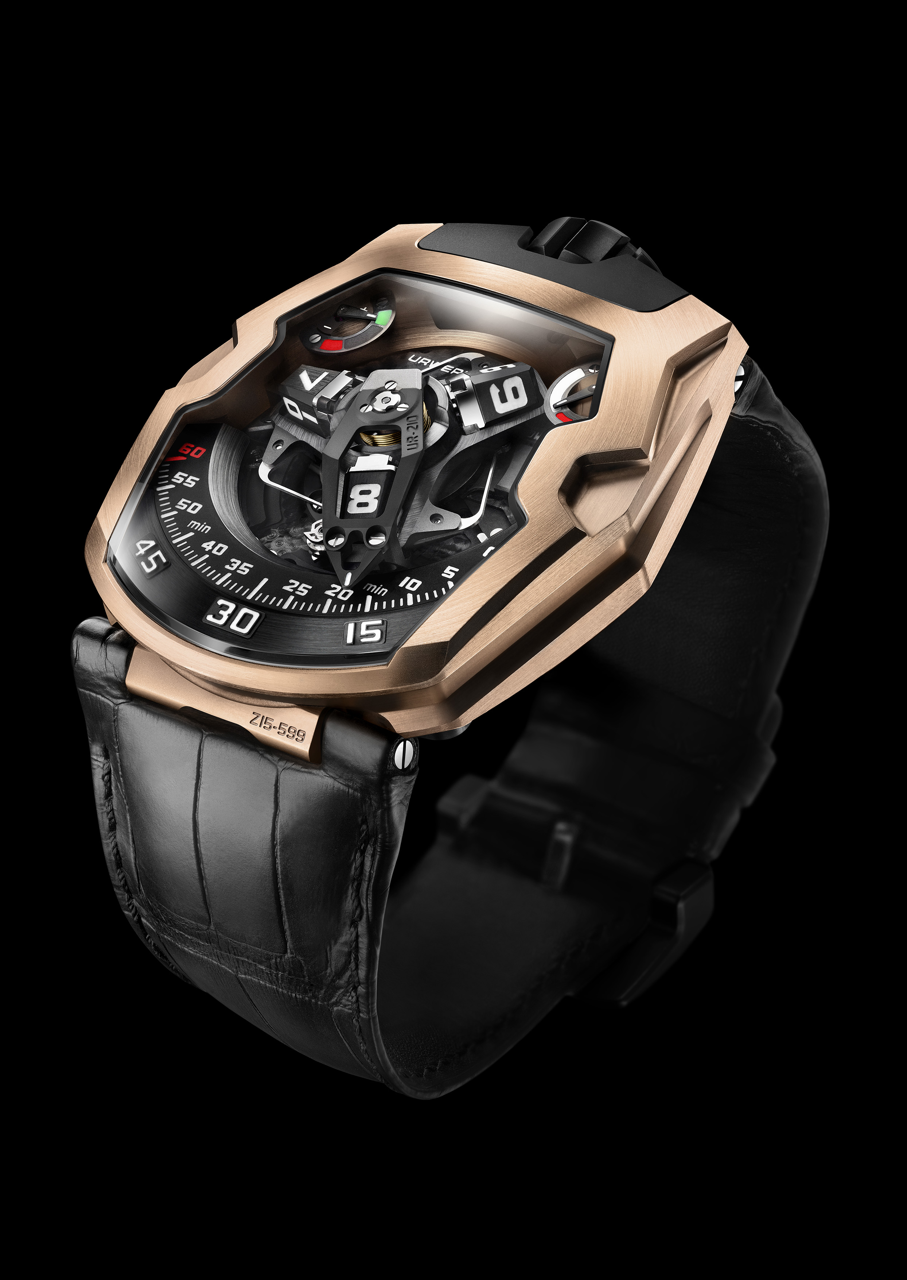

The UR-210’s satellite complication with retrograde minute is both highly original and totally explosive. The principal feature is a high-tech, oversized, three-dimensional retrograde minute hand. Its function is to enclose the hour satellite and indicate the time as it transverses the 0-to-60-minute scale. This one-hour journey through time, tracing an arc of 120°, is smooth and fluid. But the true nature of the piece is revealed at the end of the 59th minute. Then a sharp distinct “click” signals the return of the minute hand to its starting point. In less than 0.1 of a second the hand flies back to dock with the next hour satellite. This lightning fast retrograde system is based on three key elements:
- A central axis set in ruby bearings provides excellent stability for the satellite/retrograde complication. A cylindrical marine chronometer type spring runs vertically around the axis and generates the optimal tension required for the retrograde minutes flyback.

- A minute hand, which also forms a frame for the hour satellites, displays the time in an extraordinary way. Milled from aluminum to exacting tolerances of approximately 3 microns, the whole structure has a total weight of just 0.302g and is counter balanced by a brass weight. This three-dimensional cage offers rigidity as it transfers energy from the cylindrical flyback spring in the top center of the carrousel to the double-star gear underneath.

- A double coaxial star-shaped cam regulates the retrograde mechanism through its gearing and its rotation defines the trajectory of the minute hand. When the minute hand reaches 60, the double star trips a (one of three) hockey-stick shaped spring under the mechanism, which liberates the minute to fly back to the next hour satellite at 0-minutes.
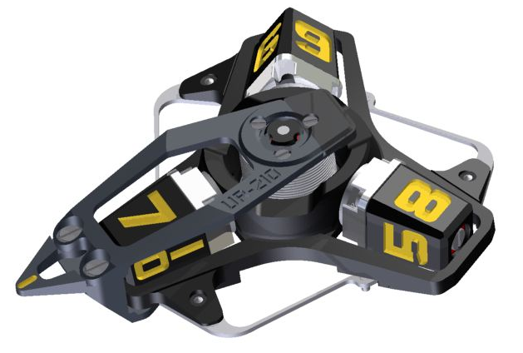

UR-210 RG - Technical Specifications

Case
Material: | Titanium and red gold
Dimensions: | Width 43.8mm, length 53.6mm, thickness 17.8mm
Glasses | Sapphire crystal
Water resistance | 30m/100’/3ATM
Surface finishes | Satin finish

Movement
Caliber | UR-7.10
Jewels | 51
Escapement | Swiss lever
Balance | Monometallic
Frequency | 28,800v/h, 4Hz
Balance spring | Flat
Power source | Single mainspring barrel
Power reserve | 39 hours
Winding system | Self-winding coupled to turbines
Materials | Plate in ARCAP P40; 3D minute hand in aluminum with brass counterweight; central cylindrical spiral in spring-steel; hour satellites in aluminium; central carrousel and screws in Titanium Grade 5.
Surface finishes | Circular graining, sandblasted, circular and straight satin-finished plate; satin-finished and diamond-polished satellites; beveled and polished screw heads.
Indications | Patented revolving satellite complication with wandering hour and three-dimensional retrograde minute hand; power reserve indicator; winding efficiency indicator (patent pending).  Super-LumiNova treatment on markers, dials, indexes, hands, and satellites
Controls | Two-position winding crown  On the back: winding efficiency selector

Media contact:
Ms Yacine Sar press@urwerk.com
Tel: +41 79 834 4665

