THE UR-203, ON THE RAZOR'S EDGE

Geneva, January 2010
Cam, transporters, telescopic hands, black platinum; for those already familiar with URWERK's creations, these words are the precursors to a shot of adrenaline. And with reason, the URWERK team, remaining loyal to their über-futuristic creed, have returned with more robotic hour indications. Robotics? Judge the dial for yourself, the UR-203 reveals its micro-mechanics for all to see. The mesmerizing theatre unfolds both on stage and in the corridors. Pistons are actuated to indicate the hour and wheels turn in their wake. Time is translated into a metallic choreography of sublime fluidity.
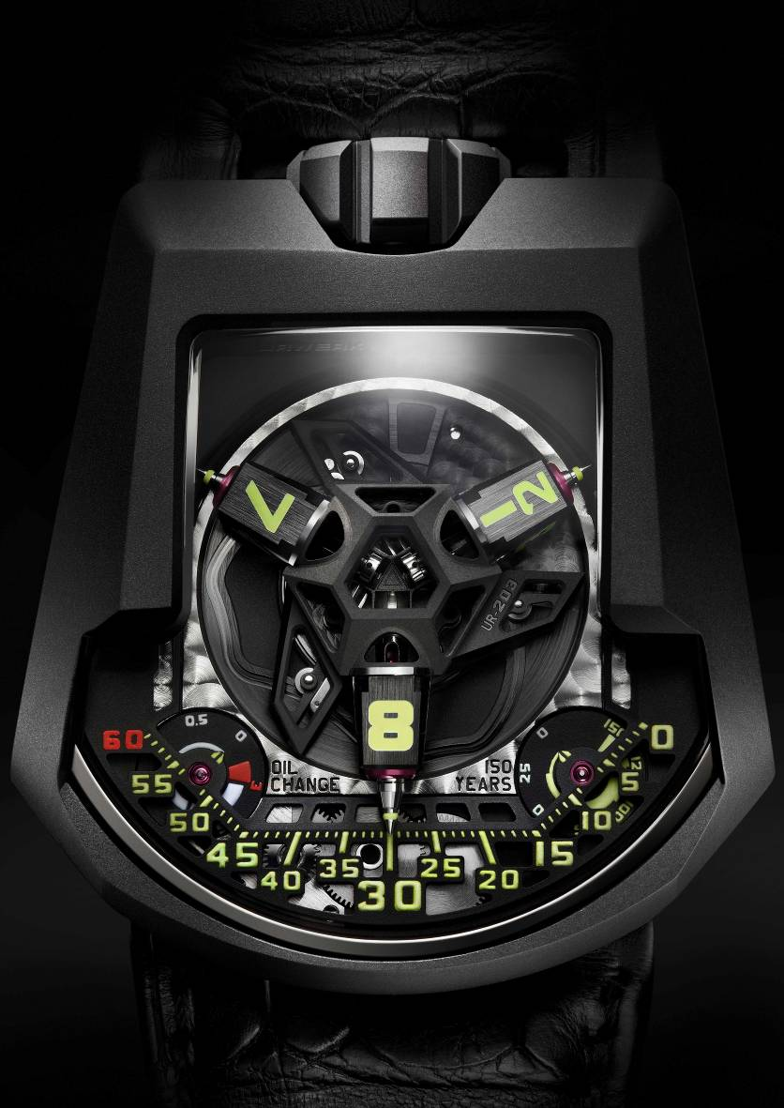

The satellite complication is the nerve centre of the UR-203, crafted from ARCAP P40, a stable non-ferrous and non-magnetic alloy. The intricate structure is milled with micron-precision and then CNC machined to reveal the internal clockwork. Within the UR-203 the cams, the rubies and the transporters that ensure the ultra-precise alignment of the telescopic hands indicating the minutes, are all revealed. The precision of manufacture is incredibly demanding, e.g. the thickness of each transporter is down to 1/1000th of a millimetre, 0.895mm to be precise, to allow for an ultra-fine 0.005mm lubricating layer of MOVIC. "This UR-203 is a wild idea of Martin Frei (URWERK co-founder and designer)", explains Felix Baumgartner, URWERK co-founder and master watchmaker. "Martin imagined a stripped down model distilled to its pure essence. We had to start again at the beginning to develop this model, we sat down at the drawing board and completely reconsidered the satellite module. The horological challenge with this complication was to develop a complex mechanism with the minimum of components to ensure its reliability and longevity." The carousel, hour satellites, telescopic minute hands and dial weigh 65% less than the proceeding model (UR-202). The satellite complication now tips the scales at a feather-light 3.57 grams.
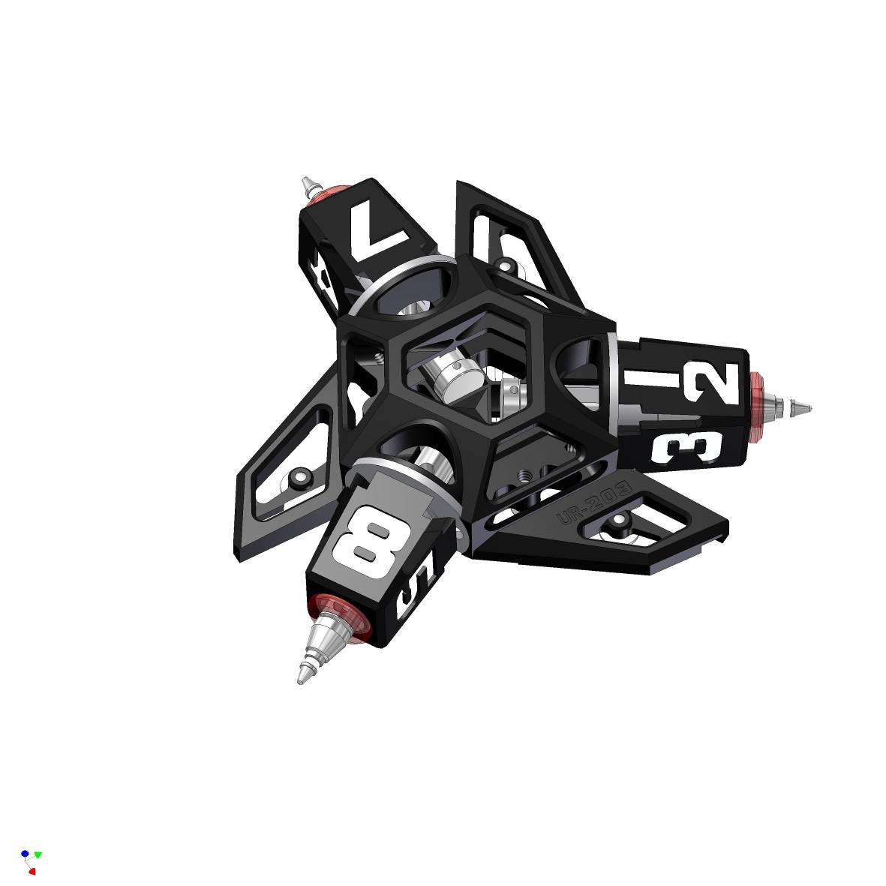
The telescopic minute hands precisely adjust their length to follow the three vectors marking the minutes: 0 -14; 15 – 44; 45 - 60. Extended, they enable the UR-203 to display the time across a large easy-to-read, dial. Retracted, they allow for a smaller, comfortably sized case providing the wearer with the best of both worlds.

An «Oil Change» indicator and a «Horological Odometer» spanning 150 years complete the open dial, both original URWERK developments. The «Oil Change» indicator informs the wearer when a service is due; an operation recommended every three years of movement operation. Similar to the odometer of a car, the UR-203's «Horological Odometer» keeps track of the total number of years of operation of the movement.

The UR-203 is also equipped with an innovative automatic winding system that is regulated by URWERK's double turbine system. The turbines are mounted on rubies and are controlled by a three-position lever offering the choice of « FREE », « SPORT » or « STOP ». The position determines the force available from the automatic rotor to wind the mainspring. FREE, where the turbines spin freely; SPORT, where the air pressure generated by the turbines reduces the winding rate by approximately 35%; and STOP, where the turbines and rotor are fully blocked. The speed of the turbines can reach a maximum 16,500 RPM.

Technical Characteristics
Model: UR-203 – Edition spéciale of 20 pieces
Case: black PE-CVD coated platinum; case micro-sanded; titanium back plate
Movement: calibre UR 7.03 ; mechanical automatic winding movement regulated by double turbines; 39 jewels
Functions: satellite complication; telescopic minute hands
Dimensions: 45.7mm X 43.5mm X 15mm.
Dial: ARCAP P40.
Indications: hours by satellites, minutes by telescopic hands, Oil Change, 150 year Horological Odometer

_____________________________
Press contact :
Yacine Sar press@urwerk.com
Direct line +41 22 900 2027
Mobile +41 79 834 4665
www.urwerk.com

