The UR-202S - «The Hammerhead » - Full Metal Jacket

Basel – March 2011
"Since the beginning of URWERK, our creations have always been presented on a leather strap," says Martin Frei, artist and URWERK's creative designer. "I love the timeless noble character of leather and the juxtaposition of the hyper-modernism of our watches and the classicism of their straps, but I am also a lover of the solid substantial objects. I felt therefore that this all-metal UR-202S with matching metal bracelet was an option we just had to offer. "
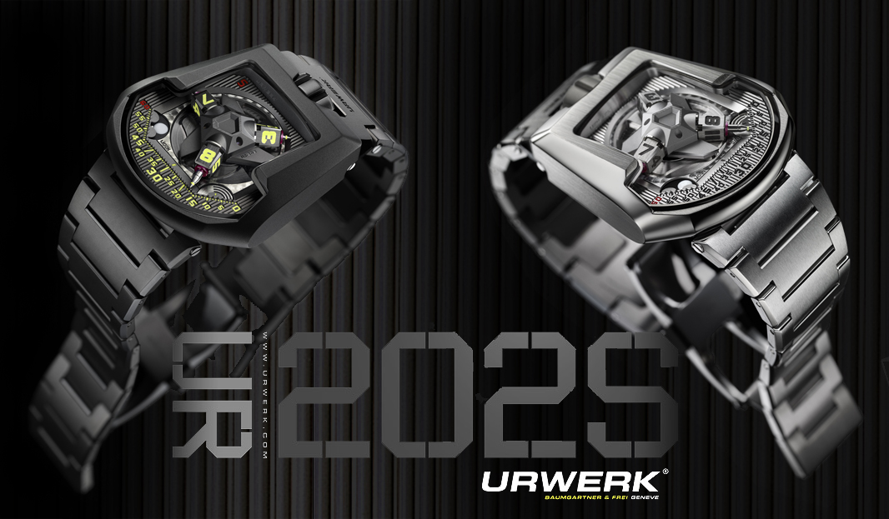

The UR-202, aka "The Hammerhead", is reborn in this radical full metal body and bracelet. A rebirth only made possible through close collaboration between URWERK and the high-end bracelet manufacture, Maspoli.

Maspoli has been an integral part of the haute horlogerie scene since 1951; their speciality, the metal bracelet. Mr Maspoli and Mr Moscatello run their business with the souls of artisans and when URWERK approached them to create just 50 high quality bespoke bracelets, they jumped at the chance to do something very special.
"We were attracted by the philosophy of URWERK which is similar in many respects to our own. We had a common ambition to create the Rolls Royce of bracelets and we made no concessions to reach that goal. We manufactured every component ourselves, including the tools to make the components. The bracelet requires 11 separate steps to attain the required level of refinement. Of the 22 links comprising each bracelet, only 6 are identical, "says Mr. Maspoli proudly, having used all of his 43 years of experience in the project.
The UR-202S - S for "Stripe" - is also differentiated from other members of the 200 collection by the eye-catching three-dimensional vertical lines running along its dial. The creative freedom to make these lines was possible due to the recent acquisition by URWERK of their first 5-axis CNC machine. This new machine enables URWERK to machine 80% of the components of the UR-202S themselves. As Felix Baumgartner says: "Given the small number of pieces that we create every year this (CNC machine) is a huge investment for us, but it provides us with priceless flexibility and quality control." URWERK can now fabricate complex components in-house, including those made in platinum, central carousels, telescopic hands and all of the parts in the satellite complication.
The Satellite Complication
Time on the UR-202 is displayed using telescopic minute hands operating through the middle of three orbiting and revolving hour satellites. These hands precisely adjust their length to follow the three vectors marking the minutes: 0 -14, 15 - 44, 45 - 60. Extended, they enable the UR-202S to display the time across a large easy-to-read, dial. Retracted, they allow for a very wearable and comfortably sized case.
The patented carousel is the critical component of the revolving satellite complication. It is responsible for both the rotation of the hour satellites and the integral telescopic minutes hands. This rotating central hub is an extremely complex part to manufacture due to the extreme precision and tight tolerances required. Many of the carousel's intricacies have to be machined to tolerances of just 3 microns. After machining, the carousel - including the hour guide - is adjusted manually. A surface treatment of PE-CVD "blacktop" is applied, which provides the final colour and hardens the surfaces, thereby reducing the friction coefficient.
High precision 'transporters' are used to control the variable length of the minute hands as they traverse the dial. One end of each transporter follows a cam - calculated from 380 reference points - plotting the path of the minute indication, while the other controls the precise length of the minute hand.

Each transporter has an exact thickness of 0.895 mm, which is coated in a 0.005mm MOVIC lubricating treatment, giving a total height of 0.900 mm. As the height of the carousel is 0.905mm, the margin of error in the mechanism is less than 0.005mm.

A Moon Phase and Day/Night indicator complete the complications displayed on the dial.

The telescopic minute hands
The three telescopic minute hands measure 4.8 mm when fully extended and permit comfortable reading of the time. Retracted they measure just 1.8 mm.
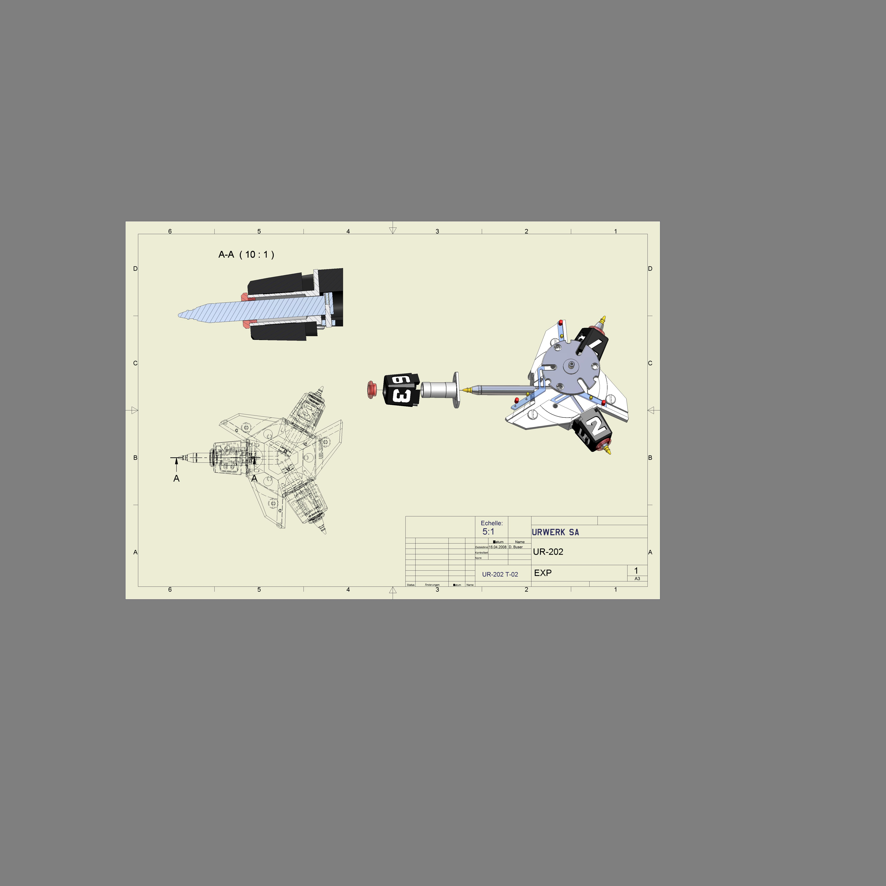

TECHNICAL SPECIFICATIONS - UR-202S

Movement
Calibre | UR 7.03 automatic winding
Jewels | 34
Balance | Mono-metallic
Frequency | 28,800 v/h, 4Hz
Balance spring | Flat
Power reserve | 39 hours
Mainspring | Single mainspring barrel
Winding | Uni-directional winding rotor regulated by twin air turbines

Finishing
Bridges spotted and rhodium plated
Screw heads bevelled and polished
Pins with polished convex tips

Indications
Satellite complication – patented – with orbiting hours and telescopic minute hands
Day/Night indicator
Moon phase

Features
Bridge and hour satellites in ARCAP P40; transporters in beryllium bronze treated with MOVIC; telescopic minute hands in titanium.
Back: Adjustment lever for the winding regulation

Finishing
Carousel diamond cut mirror polish
PE-CVD (plasma-enhanced chemical vapour deposition)
Super-LumiNova treated hours and minute markers

Case
Metal: Gold, AlTiN (Titanium Aluminium Nitride) stainless steel or polished stainless steel ,all with matching metal bracelet; titanium base.
Dimensions: 45.7mm x 43.5mm x 15mm
Water resistance: 3ATM/30m/ 90'

