URWERK presents
the UR-202 Turbine Automatic

URWERK, the rebel of contemporary horology, climbs yet another rung up the ladder of fine watchmaking by unveiling their latest audacious creation, the UR-202.
This brand-new addition to the URWERK stable features their patented revolving satellite complication with the added bonus of an innovative new winding system regulated by compressed air. Presenting the UR-202 Turbine Automatic …

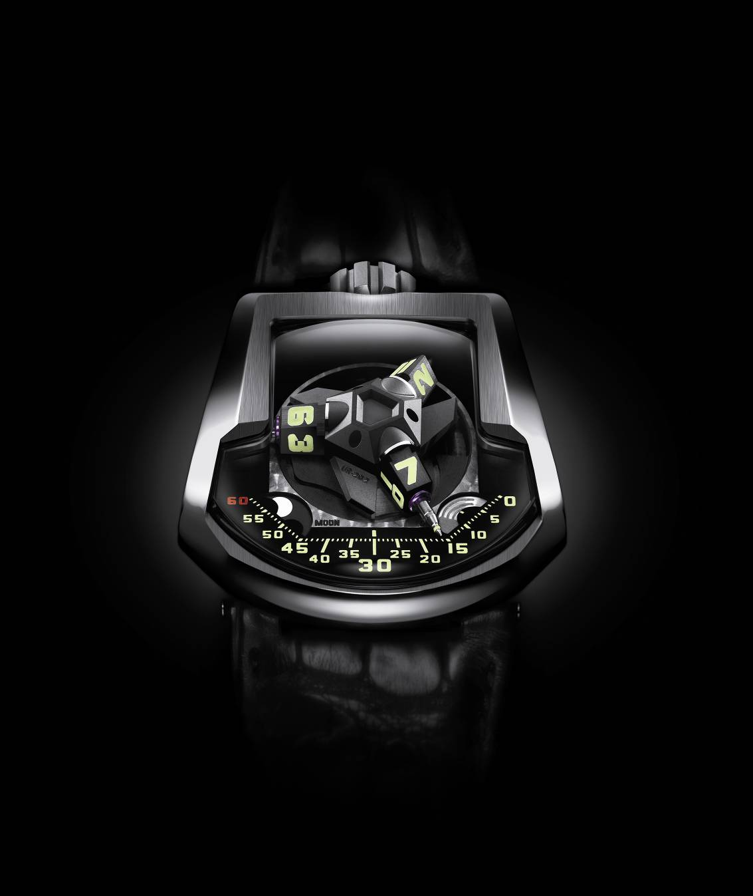

Twin Turbines
The UR-202 is the world’s first watch with the winding rate regulated by fluid dynamics. As long ago as the 18th century, clockmakers were using air friction to regulate the speed of chiming clocks, and their techniques evolved to become the preferred method of regulating the rate of chimes on minute-repeaters.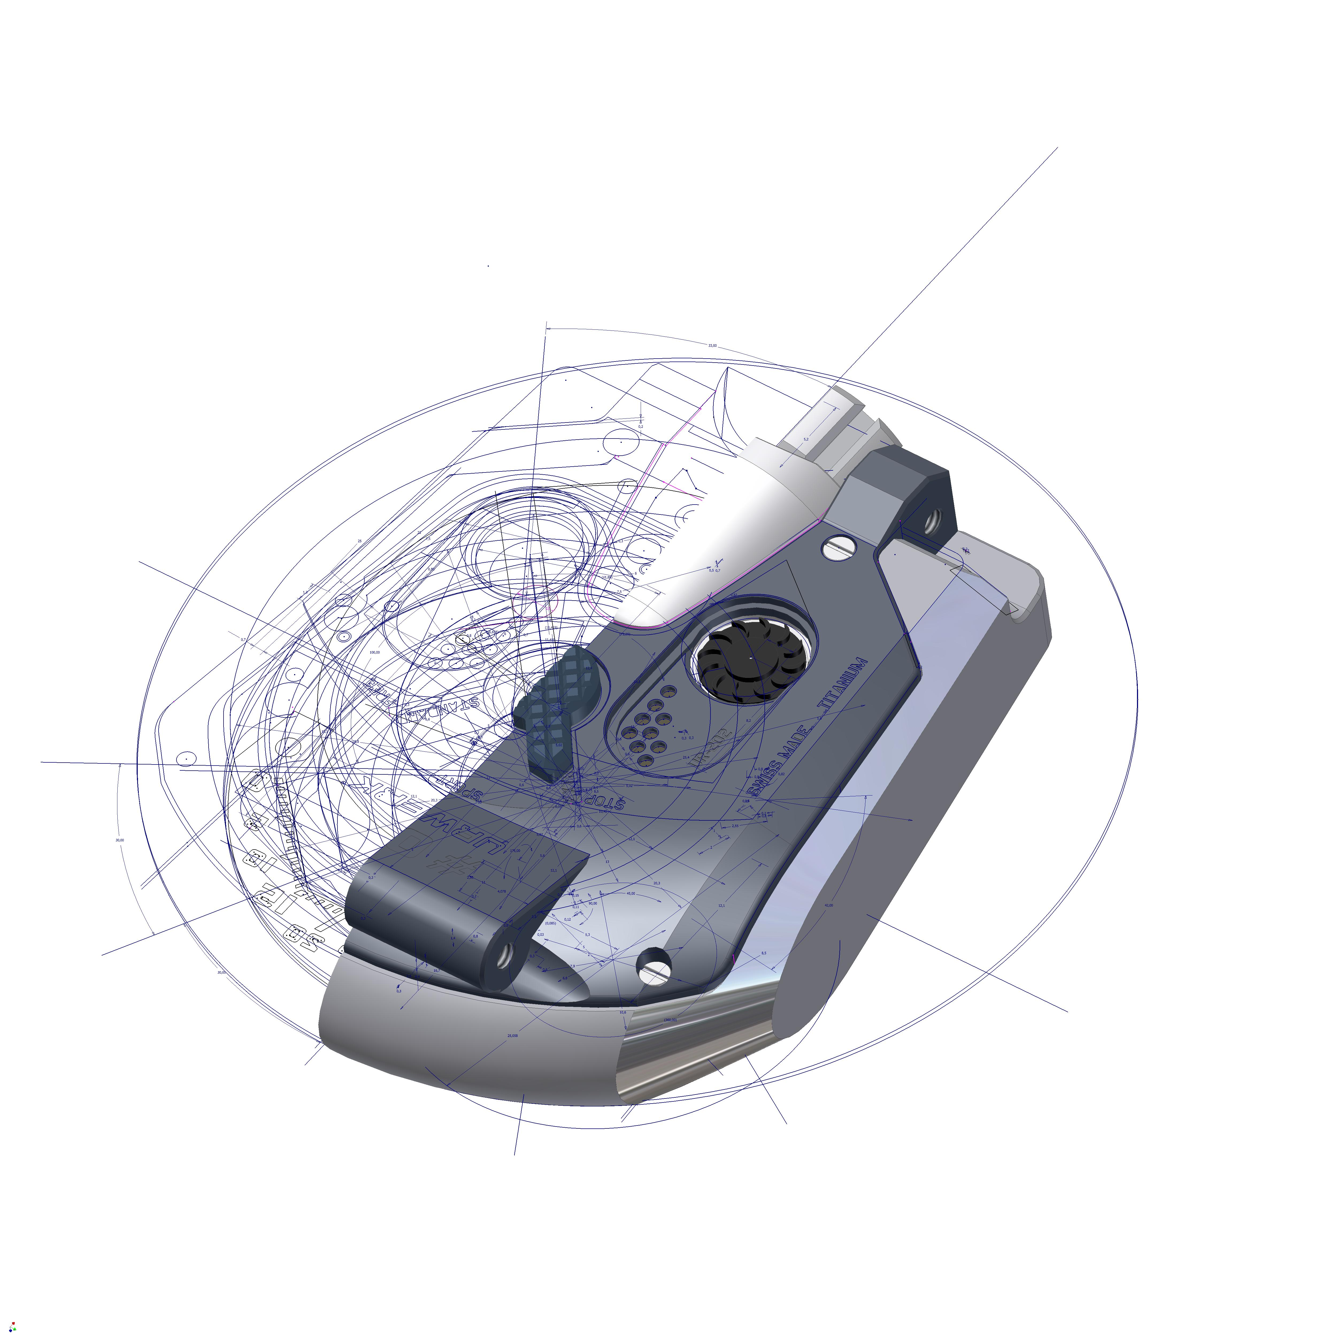

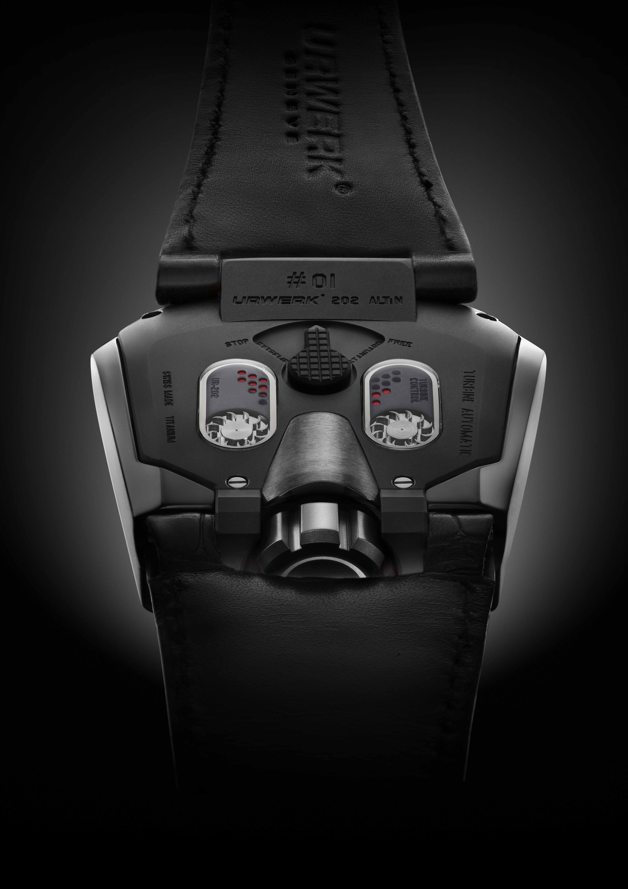

With the UR-202, URWERK have taken the traditional idea of using air friction and refined it to control the rate of automatic winding. The traditional rotating vanes of the past have been replaced by cutting-edge miniature twin turbines - miniature air compressors - which can be seen spinning on the back of the watch.

The UR-202’s twin turbines are coupled with the winding rotor. According to the position of the selector lever, the turbines act as shock absorbers. In normal activity they cushion sharp movements of the rotor. This reduces wear and increases the lifespan of the movement.

While the selector position is continuously variable, the three principal positions are: normal activity, where the turbines spin freely; vigorous activity, where the air pressure generated by the turbines reduces the winding rate by approximately 35%; and extreme activity, where the turbines and rotor are fully blocked.

The turbine system is totally self-contained within the waterproof case.
The air flows from under the turbines and is channeled up past them under a sapphire plate and down through holes leading to a tiny air chamber.

The turbines are controlled by a 3-position selector switch. This functions by adjusting the level of air compression the turbines generate by selectively regulating the amount of air flowing from inside the case.
The spinning turbines force air through holes into a tiny air chamber. The selector switch controls the amount of air escaping from the turbines. By restricting the airflow, it increases the air pressure and slows down the turbines and the winding rotor.

Revolving Satellite Complication
The UR-202 also features URWERK’s patented Revolving Satellite Complication with telescopic minutes hands. The Revolving Satellite Complication displays time using telescopic minutes hands operating through the middle of three orbiting and revolving hours satellites.

The telescopic minutes hands precisely adjust their length to follow the three sectors marking the minutes: 0-14, 15-44, 45-60. Extended, they enable the UR-202 to display the time across a large, easy-to-read dial. Retracted, they allow for a very wearable and comfortably sized case.

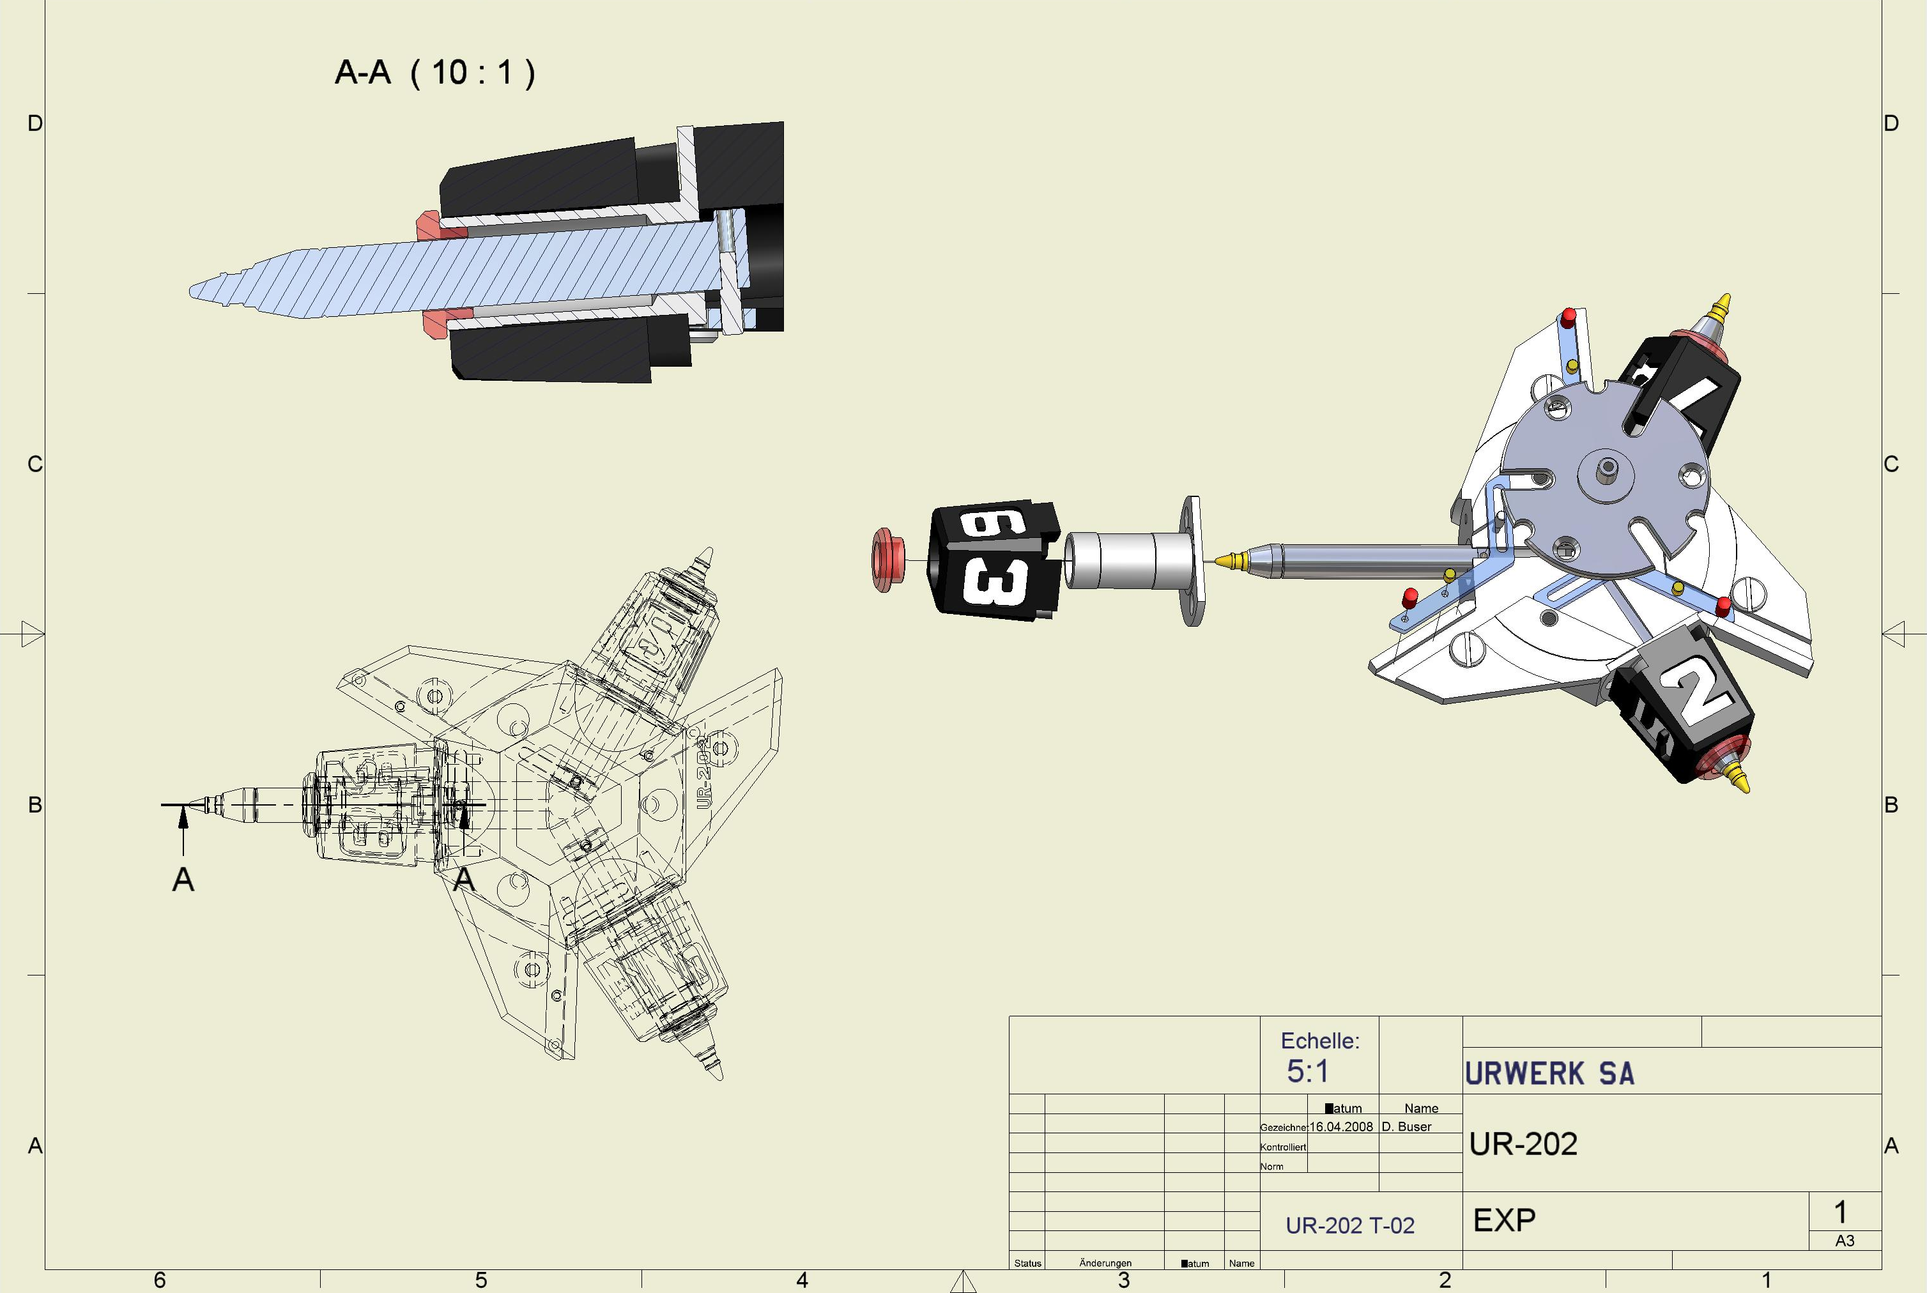

The patented carousel is the critical component of the revolving satellite complication. It is responsible for not only the rotation of the hours satellites but also the integral telescopic minutes hands.
This rotating central hub is an extremely complex part to manufacture due to the extreme precision and tight tolerances necessary. Many of the carousel’s intricacies have to be machined and finished to tolerances of 1/1000mm.

Technical Characteristics
Model: URWERK UR-202
Case: available in white gold, red gold, black PE-CVD platinum and AlTiN
Movement: calibre UR 7.02; automatic winding with world’s first twin turbine regulation
Functions: patented revolving satellite complication with integral telescopic minutes hands; moon phase indicator; day/night indicator.
Dimensions: 45.7mm x 43.5mm x 15mm; micro-sandblasted; satin finish; back in titanium.
Dial: ARCAP P40. Carousel mirror polished by diamond cutter. SuperLumiNova treatment on hours and minutes markers.
Indications: Dial featuring: hours and minutes; moon-phase indication; day/ night indicator.

______________________

Media contact:
Ms Yacine Sar
press@urwerk.com
direct line +41 22 9002027
cell phone +41 79 834 4665

