URWERK UR-150 Golden Scorpion
A radiant material dedicated to time in motion

Geneva, 2 September 2026.
URWERK unveils a new interpretation of the UR-150. And in this edition, yellow gold has taken control!
Clad in the queen of precious metals – timeless by nature, yet entirely unexpected on such a technical creation – the UR-150 reveals another side of its character: less armour, more sculpture; more precious object than machine. The UR-150 Golden Scorpion does not seek to soften URWERK’s mechanics. It illuminates their lines and volumes with an intensity never seen before.

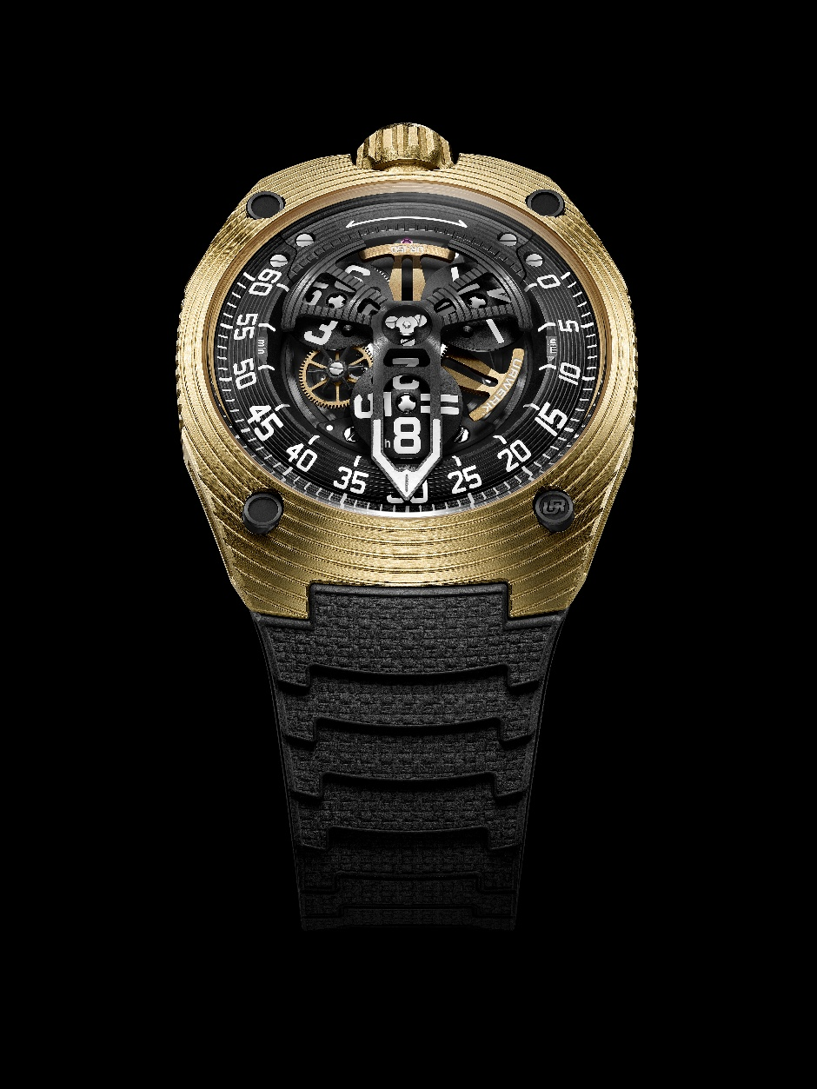

Yellow gold, reimagined.
Since 1997, URWERK has been exploring new ways of reading and experiencing time. Not through the circular language inherited from classical watchmaking, but through an orbital, mobile and intuitive progression. With the UR-150, this vision achieves a new degree of kinetic maturity. Three-hour satellites rotate on a central flying carousel, while a retrograde hand tracks the minutes across a 240-degree arc before snapping back to its starting point in one hundredth of a second.

In its Golden Scorpion outfit, this movement acquires an entirely different character. Yellow gold introduces a particular tension into the architecture. The most traditional of precious metals is set against a radical construction: taut, ergonomic and shaped by sweeping curves interrupted by sharply defined breaks.
The case retains the unmistakable presence of the UR-150, yet light transforms the way it is perceived. Its surfaces capture, absorb and intensify the radiance of the gold, revealing both the density of the case and the fluidity of its lines.
Within the traditional vocabulary of watchmaking, yellow gold often speaks of heritage, transmission and permanence. On the UR-150, it assumes a different role. Rather than anchoring the watch in the past, it amplifies its contemporary character.

“I never design a watch as a static object,” explains Martin Frei, Chief Designer and co-founder of URWERK. “I seek to create a form that changes with the angle, the light and the movement of the wrist. With the Golden Scorpion, yellow gold behaves almost like an optical material. It reveals certain lines, makes others disappear and constantly renews the perception of the watch. Depending on how it is viewed, it can appear compact, fluid or almost organic. That visual instability is what interests me: the object remains the same, yet it never presents itself in quite the same way.”

The radiance of yellow gold interacts with the depth of the display, the path of the hand and the rotation of the satellites. It gives the case a vivid, almost animate beauty, as though the material itself were making visible the energy contained within the mechanism.
The UR-150 Golden Scorpion confirms one simple truth: gold elevates everything it touches.

Time under tension.
At the heart of this creation beats the automatic UR-50.01 calibre. Designed to orchestrate in unison the satellite display and retrograde minutes, the movement comprises
38 jewels, beats at a frequency of 4 Hz and delivers a 43-hour power reserve.
It is one of the most ambitious mechanisms ever conceived by URWERK. Its construction relies on a discreet but decisive technical feat: a cam-and-rack system, coupled with a speed regulator more commonly associated with minute repeaters, replaces the conventional Maltese cross mechanism.
This architecture synchronises the progression of the satellites with the lightning-fast return of the retrograde hand. Together, they create a display that remains in a state of permanent mechanical tension. Its construction captures the essence of URWERK’s approach to watchmaking: immediately legible in its intention, uncompromising in its execution, spectacular in its effect and deeply complex beneath the surface.

“What interests me in a watch is not only what it indicates, but what it provokes,” says Felix Baumgartner, master watchmaker and co-founder of URWERK. “A true creation must have presence, energy and almost a character of its own. That is exactly what the Golden Scorpion possesses. Its name alone suggests a strong, almost aggressive personality. That force is reflected in the kinetics we have created, in the constant tension between the trajectory of the satellites and the lightning return of the retrograde hand. The UR-150 always appears poised and alert, ready to strike.”

UR-150 Golden Scorpion – Technical specifications.

Movement
Calibre | UR-50.01 self-winding calibre, regulated by a double turbine system
Jewels | 38
Frequency | 28,800 vibrations per hour (4 Hz)
Power reserve | 43 hours
Materials | Aluminium satellite hours  Brass flying carousel, finely sandblasted and microbead-blasted, with 3N gold PVD coating  Aluminium retrograde hand, finely sandblasted and satin-finished  Wheels manufactured using LIGA technology  Brass rotor, sandblasted and circular-grained, with 3N gold PVD coating
Finishing | Grade 5 titanium screw heads, flat-polished  Hour and minute markers, flying carousel and counterweight hand-painted with Super-LumiNova
Display | Satellite hours.  Retrograde minutes indication over a 240° arc
Case
Materials | 2N yellow gold case middle, sandblasted, microbead-blasted and satin-finished across the upper surface and flanks  Grade 5 titanium caseback, black PVD, sandblasted.  2N yellow gold massive crown, sandblasted, satin-finished.
Dimensions | 42.50 mm wide × 51.00 mm long × 14.80 mm thick
Crystal | Domed sapphire crystal
Water resistance | Pressure-tested to 5 ATM, with screw-down crown
Strap | Adjustable high-performance hybrid rubber strap with folding clasp
Price | CHF 105,000 excluding taxes  Limited edition of 25 pieces

Media contact:

Ms Yacine Sar press@urwerk.com
www.urwerk.com/press +41 22 9002027

ABOUT URWERK

As URWERK co-founder and master watchmaker Felix Baumgartner explains: “Our aim is not to offer yet another reinterpretation of a familiar mechanical complication. Our watches are unique because each model has required an original design process. Our ambition is to rethink the traditional boundaries of fine watchmaking and push them aside to forge our own path,” he concludes.
This spirit is echoed in the words of Martin Frei, the company’s artistic director and co-founder: “My artistic roots lie in boundless creativity. Freed from the constraints of classical watchmaking, I draw on my cultural heritage to forge a new aesthetic language.”

Although URWERK is a young company founded in 1997, it is regarded as a pioneer in the world of independent watchmaking. With an annual production of around 200 watches, URWERK is an artisan workshop where traditional craftsmanship and avant-garde aesthetics coexist to the full. URWERK designs complex, contemporary watches, unlike any others, which meet the most exacting criteria of Haute Horlogerie: independent research and creation; cutting-edge materials and hand-finishing.

The name URWERK has its roots in 6000 BC in the city of Ur in Mesopotamia. The Sumerians, observing the shadow cast by the sun on their monuments, were responsible for defining the unit of time as we still know it today. Whether by coincidence or as a sign of the times, the word ‘Ur’ also means ‘the beginning’ or ‘origins’ in German. The final syllable of the URWERK signature is also borrowed from the language of Goethe, the verb ‘werk’ meaning to create, to work, to innovate. A tribute to the tireless work of the master watchmakers who have succeeded one another right up to the present day, shaping what we now call Haute Horlogerie.

