**URWERK reveals the innermost parts of its**

**UR-150 “Scorpion”**

Geneva – April 2025.

The new UR-150 “Scorpion” from URWERK pushes the boundaries of mechanical watchmaking even further by offering a unique kinetic sight. This latest UR-150 reveals a flying carousel with three satellites as well as a particularly ambitious retrograde hand, staging a guaranteed mechanical show! URWERK proudly invites you to enjoy a backstage view of this performance, orchestrated to the nearest hundredth of a second. Beware the fierce mechanism as you plunge into the inner workings of the UR-150 “Scorpion” !

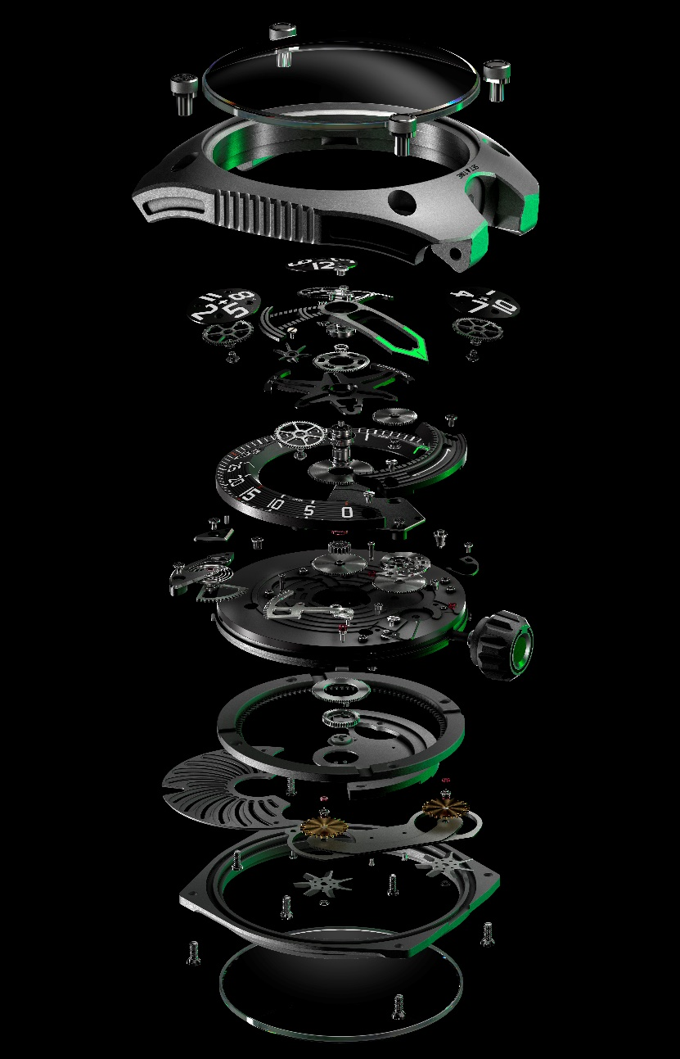

The dial of the UR-150 “Scorpion” is enlivened by lightning-fast flying and spinning elements. On the stroke of every 60th minute, the three hours satellites pivot on their axes – in perfect synchronicity with a retrograde hand that literally flies from the 60-minute index to its opposite extreme, 240° further along. This offers a veritable visual firework display, aptly described by URWERK’s master watchmaker and co-founder Felix Baumgartner as a “Perfect Storm”. Behind the scenes of this show that plays out in a hundredth of a second are two mechanisms responding to and interacting with each other, exchanging a continuous flow of energy.

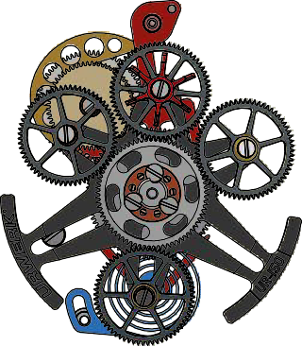

Let's first take a look at the new URWERK-style challenge: a flying carousel bearing three hours satellites and a flywheel with a speed-regulating governor identical to the one found on chiming mechanisms. All of which means wheel-mounted satellites – and not a Maltese cross in sight. Every hour, they spin 270° in the blink of an eye: “We have pushed the limits of display complexity to offer exceptionally clear time readings. Each satellite is inclined at a 10° angle to face the wearer, thereby guaranteeing optimal readability. While this particular degree of inclination complicates the assembly of our going train, no effort is too great when it comes to striving for watchmaking excellence”, says Felix Baumgartner.

The carousel’s revolution around the dial and the rotation of each satellite on its own axis place the active hour satellite in exactly the right place at the right time. It is then up to the flywheel with its speed-regulating governor to ensure the consistency and perfect harmony of this performance where the weights being carried have never been so great, nor the mechanism’s speed and inertia so extreme: “It's a bit like a magic trick, through which the new hour appears: every 60 minutes, the following hour is reset in a dazzling rupture of the space-time continuum”, explains Martin Frei, artistic director and co-founder of URWERK. “All the cards in the hours deck are shuffled and redealt in a hundredth of a second. The dial transforms before our eyes, so fast that it is barely perceptible to the naked eye. Just below the curved sapphire crystal, the mechanism seems almost within reach – and the scorpion's sting lurks in silence. Yet the markers dissolve and reorganise with each change of hour, escaping our perception by their sheer speed. Each time, there is a brief moment of uncertainty, a slight sense of unease, a silent tension that whispers: maybe this time, the right number won't appear... Yet, the magic happens – and the wonderment it stirs is reborn.”

The other mechanical feat of the UR-150 “Scorpion” is the openworked retrograde hour hand that takes charge of the active hours satellite and “carries” it from minute 0 to 60 before flying 240° to find the next active hour. This mechanism is controlled by a cam and a toothed rack, a device notably found in chronograph movements and automatons. This mechanism serves a triple function: to mark out the entire path travelled by the retrograde hand; to generate and synchronise the various jumps performed by the different elements; as well as to multiply the influx of energy that will enable the satellites to rotate. In this way, one mechanism feeds the other in a closed loop: “The complexity of this creation is not so much measured in terms of the number of components as by the ingenuity we had to employ to ensure the smooth operation of a mechanism that is one of the most ambitious we have ever built in terms of moving parts, speed of execution and the precise consumption of the available energy. We leveraged all the available force in an extremely parsimonious manner and even found a way of multiplying it. We thus shaped the springs and gear trains in our workshops to guarantee optimal performance”, says Felix Baumgartner.

You have been warned: beware the fierce mechanism of the UR-150!

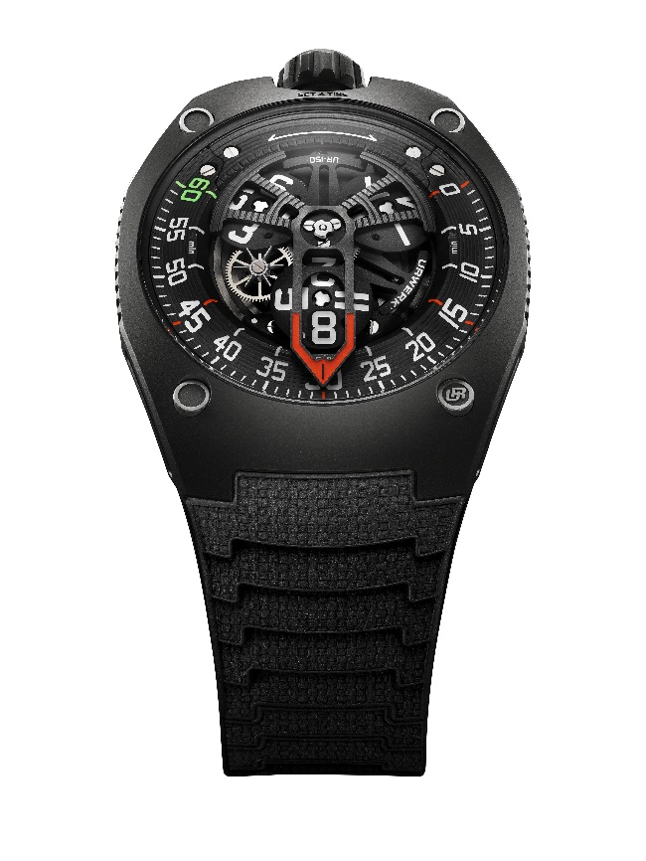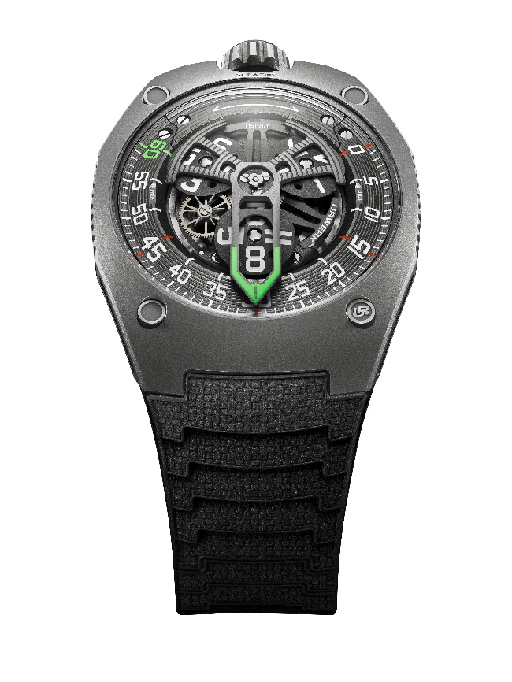

Technical specifications.

|  |  |
| --- | --- |
| **Movement** |  |
| Calibre | UR-50.01 with automatic winding system governed by a double turbine |
| Jewels | 38 |
| Frequency | 28,800 vph - 4Hz |
| Power reserve | 43 hours |
| Materials | Aluminium hour satellites on a brass carrousel; aluminium retrograde hand |
| Finishes | Circular graining, sandblasting, shot-blasting, circular satin finishing  Chamfered screw heads  Hours and minutes markers painted with Super-LumiNova® |
| Indications | Hour satellite; minutes |
|  |  |
| **Case** |  |
| Material | Sandblasted and shot-blasted titanium and steel for the Titanium version  Sandblasted and shot-blasted titanium and anthracite PVD-treated steel for the Dark version |
| Dimensions | Width 42.49mm x length 52.31mm x  thickness: 14.79mm |
| Glass | Sapphire crystal |
| Water resistance | Screw-lock crown. Pressure tested at 5ATM (50m) |
| Strap | KISKA rubber strap |
| **Prix** | *Titan* version CHF 88,000 (Swiss francs/excl. tax)  *Dark* version CHF 89,000 (Swiss francs/excl. tax)  Limited series of 50 each. |

Press contact

Ms Yacine Sar +41 22 900 2027

[press@urwerk.com](mailto:press@urwerk.com) <https://www.urwerk.com/press/ur-150-scorpion>

URWERK

*“We don’t try to bring out new versions of existing complicated mechanisms”,* explains watchmaker Felix Baumgartner, master-watchmaker and co-founder of URWERK. *“Our watches are unique because they are all designed as original works, which makes them rare and priceless. Our main aim is to go beyond the traditional horizons of watchmaking and to overturn them so as to blaze our own trail”,* he concludes.

The original styling of each URWERK model is signed by chief designer Martin Frei, the company’s other co-founder: *“I come from a background where creativeness has no limits. I am in no way prisoner of the traditional constraints of watchmaking, and I can therefore be freely inspired by my cultural heritage.”*

Although URWERK is a young company established in 1997, it is recognized as a pioneer among independent watchmakers. Producing just 150 watches a year, the company sees itself as a craftsman’s studio where traditional expertise coexists with avantgarde styling. The company manufactures modern and complex watches that are unprecedented and in keeping with the most demanding criteria of fine watchmaking: independent design and research, advanced materials and handcrafted finishes.

The name URWERK comes from the ancient city of Ur of the Chaldees in Mesopotamia, founded nearly 6,000 years ago where the Sumerian inhabitants first established units of time based on the shadows cast by its monuments. Ur in the German language also means primeval or original and Werk means an achievement or a mechanism. Thus, URWERK can be translated as an original movement – a tribute to generations of watchmakers whose work has resulted in what we know today as *haute horlogerie*, or superlative watchmaking.