The UR-112 Aggregat Odyssey
URWERK’s latest flash of brilliance

Geneva – 23 February 2022.
Amid the calm and serene skies of Haute Horlogerie, an unidentified flying object is looming on the horizon. Could it be the announcement of an imminent upheaval? The intuition of an emotional cataclysm?
Flashing across the night sky, the new UR-112 Aggregat Odyssey appears in a shower of metal! The latest evolution of the UR-112 features a new titanium and steel fuselage. With this limited edition, URWERK – creator of ‘space opera’ watches – pushes its limits further than ever… to infinity and beyond!

Gleaming like Padme Amidala's J-type 327; equipped with two large round eye-like windows like Archie; the ‘owl ship’ from Watchmen. Streamlined like a Klingon Bird of Prey. Grooved like the hull of the Battlestar Galactica. The UR-112 Aggregat Odyssée emerges from the URWERK shipyard in a limited edition, featuring an infinite number of flat, curved, grooved, sculpted, screwed and bonded surfaces, all incorporating advanced finishes alternating between matt and glossy, sandblasted and polished. This painstaking, meticulous work contributes to enhancing the two large cockpits where the rotating prisms representing the UR-112's unique signature operate, akin to two advanced observation posts.

Sophisticated textures
The UR-112 Aggregat Odyssey is the successor to the UR-112 Aggregat Two-Tone. The upper part of this wrist spacecraft is suitable for polishing. The grooved steel cover opens vertically to give access to the secondary power reserve and digital seconds indications. It is mirror-polished on the top with a beadblasted edge. Its central titanium body is satin-brushed, grooved, sandblasted and beadblasted, thereby forming a field of functional microdots. The two steel wings of the UR-112 Odyssey fit into this central body.

Each zone, each space, each element has its own texture, its own finish, its own language. Martin Frei, co-founder of URWERK and head designer, said: "I am lucky enough to experience the birth of our creations first-hand – in the workshops and in close proximity with our watchmakers. I witness the final assembly. I see the material come to life, and even more importantly, finishes that existed only in my mind materialize before my eyes. Like the pencil strokes that draw and refine the outlines of the watch on paper, the traces of machining on the titanium and steel render its creative process visible. It then takes all the magic and mastery of the craftsman's hand to transcript this emotion in the finished product, which is beadblasted, satin-brushed and polished. In the case of the UR-112, this was a particularly long and trying process, a real odyssey, which enabled us to convert the strength of the raw material into the refinement of the finished product. “

Digital sequence
The UR-112 belongs to the Special Project line. This is a departure from the founding concept of URWERK's wandering-hour indication, on a whole new scale. There are no cubes, no carousel with arms, no 120-degree sector-type indication like on so many models that have marked the history of URWERK over the last 25 years. The UR-112 Aggregat Odyssey displays jumping hours and trailing minutes on prisms. Shifted to the front of the watch, they are visible in their large sapphire crystal housings. As the hours jump on one side and the minutes advance in five-minute increments on the other, an additional trailing indicator shows the precise minutes. Felix Baumgartner, co-founder of URWERK and master watchmaker said: "Once again we have let our guts speak for us in making a spaceship, a UFO that is a technical challenge. This UR-112 is pure madness in terms of the mechanics and the finishes. We will only be able to make a very limited number and there may be just five of them, but this is sheer unadulterated watchmaking pleasure!”

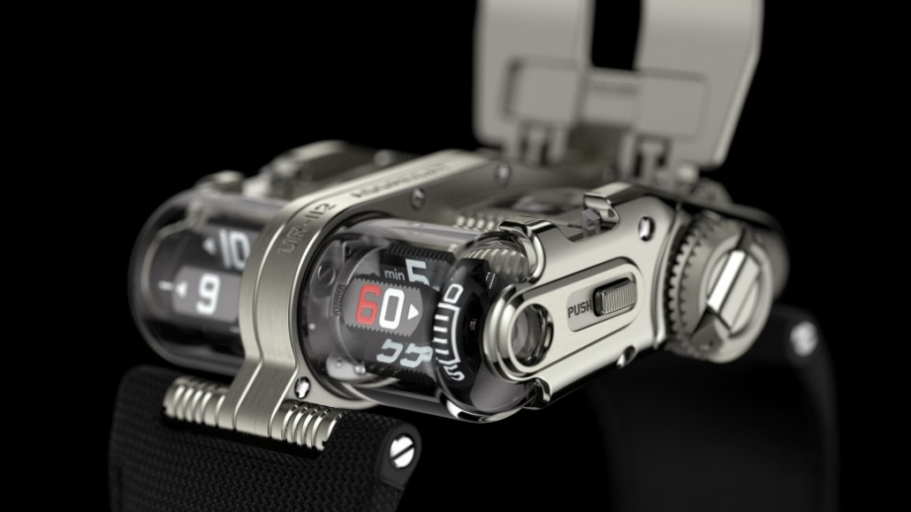

Heart of the reactor
The central body of the case contains the driving and regulating components of the UR-13.01 caliber: a large barrel providing 48 hours of power reserve, coupled with an automatic-winding rotor. Pressing the two pushers on the sides of the watch opens the cover to reveal the power-reserve indicator and the spectacular small seconds. The latter is composed of a skeletonized silicon disk attached to a red anodized aluminum bridge, a typical URWERK design feature.

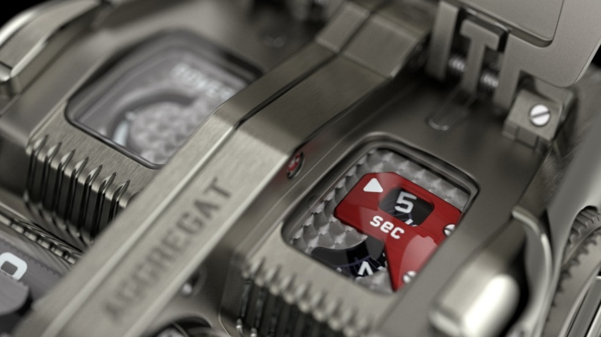

Spatio-temporal module
A long, thin rod stands out in the middle of this incredible vessel. Measuring several centimeters in length, it is possibly the longest component in contemporary watchmaking. To guarantee its lightness and rigidity, this cardan shaft is made of titanium and ensures the coupling with the display module, located at the front of the shell. It establishes this link thanks to a new succession of gears that drive the hours and minutes prisms via two 90° bevel gears. The black aluminum prisms featuring grooved sides are enhanced with Super-LumiNovaTM and are secured by planetary systems that ensure they rotate both on their axis and in space. This kinematic approach calls for absolute precision and contributes to endowing the UR-112 Aggregat Odyssey with a totally unique and unconventional design. So URWERK!

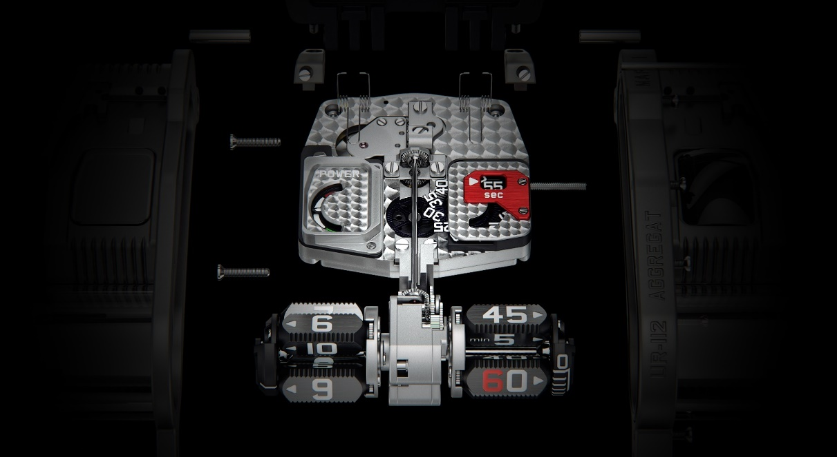
UR-112 Aggregat Odyssey
Limited edition
Price: CHF 250,000.00 (Swiss francs / excluding tax)

MOVEMENT
Caliber: | UR-13.01 automatic
Jewels: | 66
Escapement: | Swiss lever-type
Frequency: | 4 Hz; 28,800 vph
Power reserve: | 48 hours
Materials | Aluminum hours and minutes satellite prisms; titanium cardan shaft, silicon second wheel
Surface finishing: | Circular graining, sandblasting, Côtes de Genève, polished screw heads
INDICATIONS | Jumping digital hours and trailing digital minutes on satellite prisms; silicon digital seconds; power-reserve indicator
CASE
Dimensions: | Width 42mm; length 51mm; thickness 16 mm
Materials | Titanium, steel
Glass | Sapphire crystal
Water resistance | Pressure tested to 3 ATM / 100 ft / 30 m

___________________________

Contact media
Ms Yacine Sar :
press@urwerk.com
+41 22 900 2027
www.urwerk.com
https://www.instagram.com/urwerkgeneve/

