THE UR-10 SPACEMETER BLUE
FINAL EDITION

Geneva – May 12, 2026.
Every idea harbours its own conclusion. With the UR-10 SpaceMeter Blue issued in a 25-piece final edition, URWERK is not merely closing a chapter, but rather sealing the culmination of a horological exploration in which time ceases to be measured and instead merges with space.

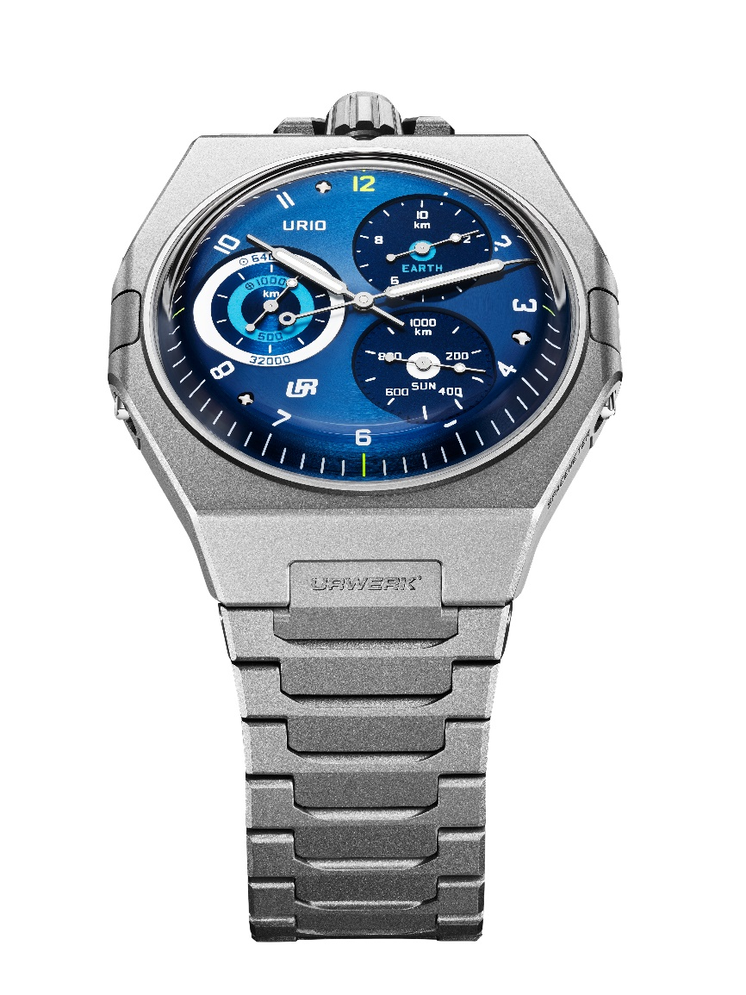

The UR-10 by URWERK has never been a watch in the conventional sense of the term. It is an instrument of cosmic awareness. A mechanical object reminding us that our Earth does not merely set the rhythm of our existence but also lives at its own pace: rotating on its axis, orbiting the Sun and hurtling through the cosmos. The UR-10 sets out to reveal its every quiver, linking time to the invisible movement sustaining all human existence. It brings to the wearer’s wrist not the time of the world, but the world itself in its actual motion. Second by second. Kilometre by kilometre.

A ROUND DIAL REFLECTING URWERK’S THINKING
The UR-10 SpaceMeter occupies a unique place in URWERK’s history. At first glance, its round dial endows it with an almost classic appearance - and that is precisely the essence of its subversive nature. The shape offers momentary reassurance, while the function immediately draws the gaze elsewhere. For the UR-10 is all about contrasts: it is simultaneously the least and the most resolutely URWERK watch of all the collections. The most bewildering in appearance. The most faithful at its core.

With its main dial enhanced by three subdials, the UR-10 is a machine for measuring the distances our planet travels through space-time.
At 2 o’clock – the EARTH counter measures every 10 km travelled by the Earth in its daily rotation, graduated in 500 m increments.
At 4 o’clock – the SUN counter records every 1,000 km travelled by the Earth in its solar orbit in 20 km increments.
At 9 o’clock – the ORBIT counter combines the two trajectories, translating 1,000 km of Earth’s rotation and 64,000 km of solar revolution onto two synchronised scales.

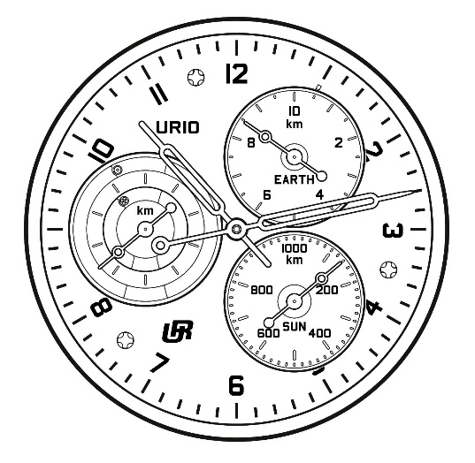

The UR-10 does not only indicate the hours and minutes; it articulates a vision, transforming the watch into a system for representing Earth’s motion. Reading the time thus becomes almost secondary. The wearer of the UR-10 is no longer merely faced with a succession of moments and is instead placed within a larger overall movement. The watch no longer simply says “It’s 10 o’clock”, but rather “Here’s where you are within the grand mechanism of the world.”

According to URWERK’s co-founder and artistic director Martin Frei: “Time is not something we observe. It is something we inhabit. With the UR-10, we wanted to broaden the perspective, to remind us that we live aboard a celestial body in constant motion. This final blue edition seemed the most fitting to us, because it naturally places this timepiece in its true setting: space.”

THE EARTH ON THE CASEBACK
On the reverse side of the watch, a peripheral hand traces the hours along a 24-hour scale, evoking the Earth’s complete rotation. The caseback is engraved with pictograms representing “Rotation” (Earth) and “Revolution” (Sun): Rotation is read clockwise, whilst Revolution is interpreted counter-clockwise.
The caseback of the UR-10 SpaceMeter thus becomes a portable cosmography on a 24-hour scale. These three indications - Hours, Rotation and Revolution - invite a reading as poetic as it is rigorous. Three fundamental units. Three physical realities translated into watchmaking mechanics.

Another horological development relating to the UR-10 is the addition of a Double Flow Turbine, an evolution of URWERK's one-way self-winding system. This patented turbine comprises two stacked propellers which rotate in opposite directions. When a self-winding mechanism isn't spinning in the winding direction, the rotor's high speed exerts significant constraints on the system. The double turbine creates air flow between the two sets of blades, which slows them down and preserves the mechanism. These blades also create a hypnotic spectacle.

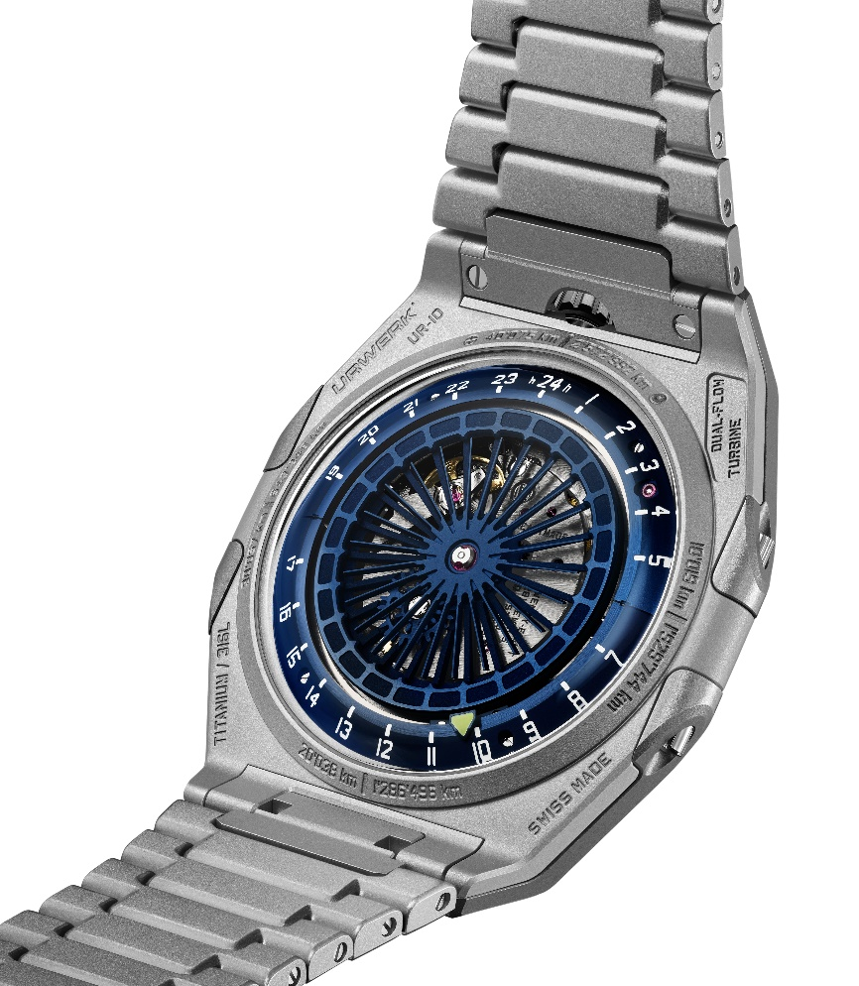

A REINTERPRETED HERITAGE
The UR-10 draws inspiration from the masters of the past, and from a more intimate legacy, that of Felix Baumgartner’s father, Gérard, a restorer of antique clocks who discovered and refurbished a mysterious Gustave Sandoz clock featuring three astronomical dials. The soul of the UR-10 is derived from this legendary clock passed down from father to son.

As always at URWERK, the mechanics are never decorative, instead serving an idea and rendering tangible that which would otherwise remain purely abstract.

THE END AND THE BEGINNING OF A LEGEND.
The UR-10 SpaceMeter Blue is thus the final edition, the natural culmination of an idea pushed to its maximum density, where time is no longer just measured but unfolds in space. This model rounds off the “10” collection – and at URWERK, when a creation leaves production, it does not disappear, instead directly entering the Maison’s “The Legends” archive collection.

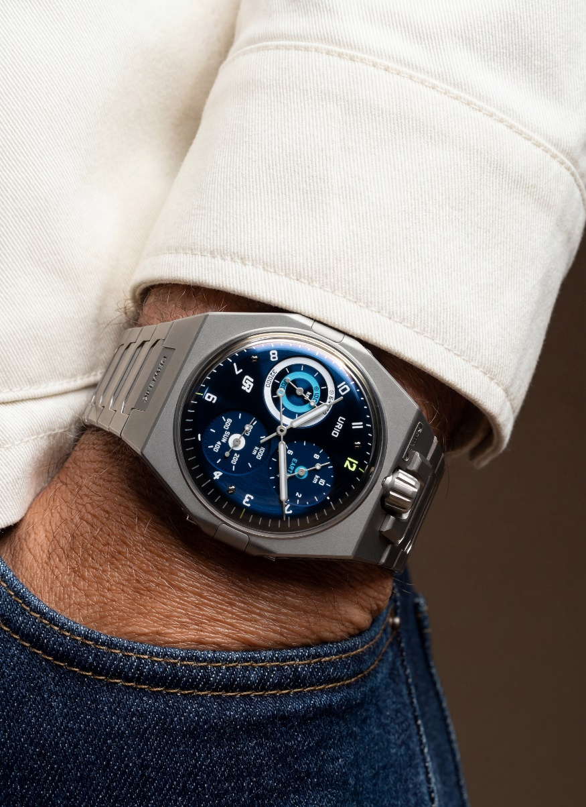

UR-10 SPACETIME BLUE – FINAL EDITION

MOVEMENT
Calibre | UR-10.01, self-winding
Rotor | Dual Flow Turbine with two counter-rotating propellers – patented model
Jewels | 44
Escapement | Swiss lever escapement
Frequency | 4 Hz; 28,800 vph
Power reserve | 43 hours
Material | Steel, brass, ARCAP, CuBe, Durnico, Nickel (LIGA)
Surface finishes | Circular graining, straight graining, sandblasting, polished screw heads
INDICATIONS
Analog central hours and minutes
2 o’clock counter displaying Earth’s daily rotation measured at the Equator / 10 km
4 o’clock counter displaying Earth’s daily orbit around the Sun/ 1000 km
9 o’clock double concentric counter displaying Earth’s rotation and solar revolution
Hours on a 24-hour scale, on the back
Rotation and Revolution on a 24-hour scale, on the back
CASE
Dimensions | Width: 45.40 mm; length: 44 mm; thickness (apart from the crystal): 7.13 mm
Material | Sandblasted titanium case middle, sandblasted steel caseback
Crystal | Glare-proofed glass-box sapphire crystals
Water resistance | Pressure-tested at 3 ATM / 30 m
DIAL
Finishes | ADL treated blue dial, curved, circular satin-finished  Finely sandblasted counters at 2 and 4 o’clock  Circular satin-finished counter at 9 o’clock
Hands | Produced in-house. Syringe-shaped and enhanced with Super-LumiNova for hours-minutes indications; open-tipped for distance indications
BRACELET | Sandblasted titanium, single link, secured by a titanium folding clasp
PRICE | CHF 70,000 (Swiss francs / excl. tax)  Limited edition of 25 timepieces

About URWERK
Founded in 1997, URWERK is widely recognised as one of the pioneers of contemporary independent watchmaking. Right from the outset, its founders Martin Frei and Felix Baumgartner chose not to revisit traditional grand complications, but instead to invent new ways of thinking about and representing time. Each of their creations is conceived as an original horological artwork.

The name URWERK draws on several roots: “Ur”, a Mesopotamian city associated with the earliest measurements of time using the shadows of monuments, as well as a German prefix evoking origin; and “Werk”, meaning work, mechanism or movement. URWERK can thus be understood as an “original movement”.

Today, the brand organises its universe around three areas: Hour Satellite, the iconic expression of its time display; Chronometry, a field of exploration into precision and mechanical performance; and Special Projects, a space of freedom where the most experimental concepts are born. As a resolutely independent brand, URWERK produces around 200 watches a year, between its Geneva headquarters and its development and manufacturing centre in Zurich.

