UR-106 Flower Power. Crazy love at first sight

Geneva, January 2017
Le coup de foudre, that instantaneous love, the love that makes your eyes shine, your heart beat faster, heightens your senses and makes your life more intense. This is what UR-106 is talking about in its Flower Power version, a limited edition of only 11 pieces. Of course, it is an URWERK. Of course, it is complicated. Of course, it is an example of Haute Horlogerie. But above all, this UR-106 is beautiful, desirable and addictive.
Focus on an example of poetic mechanical jewellery.

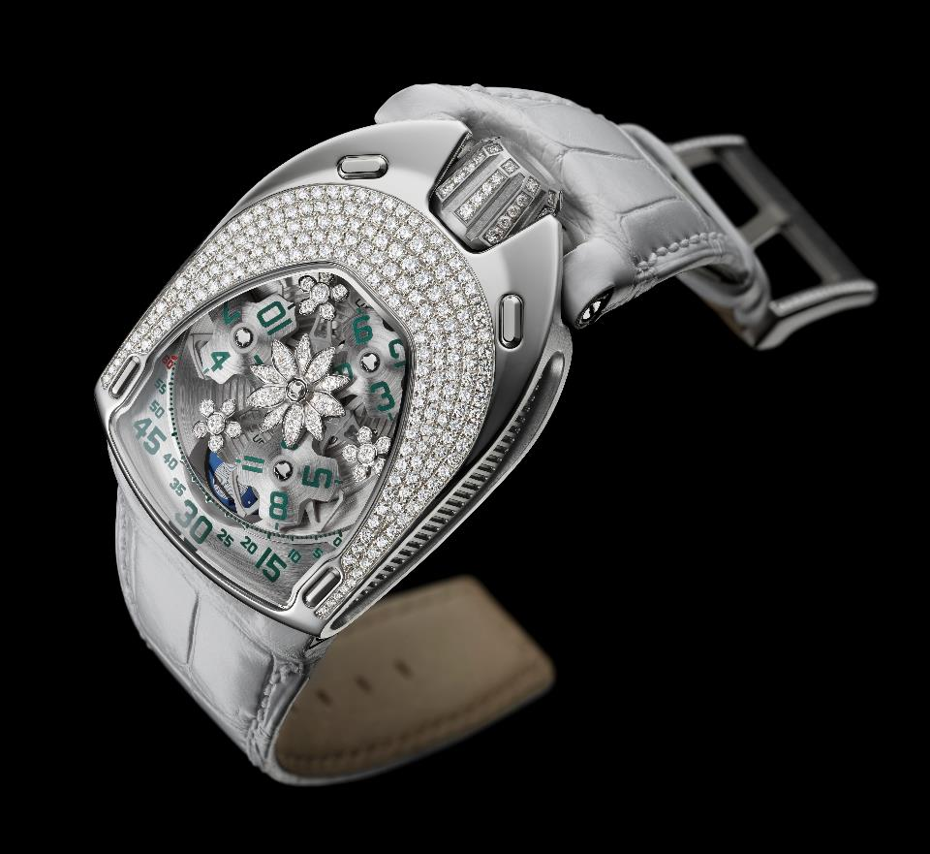

Finding the right adjectives to describe the URWERK watches is always a challenge. Creations of luxury watchmaking, original to say the least. What is certain is that they all have a touch of eccentricity that sets them apart from the rest. The UR-106 Flower Power is no exception. Here is a happy marriage between steel and diamond, technique and gentleness, manual dexterity and mechanical precision.

The UR-106 Flower Power casing houses no fewer than 239 Top Wesselton quality diamonds making a total of 2.53 carats (crown included). Its execution was supervised by the house of Magnin located in Geneva, who have specialised in watchmaking assembly since 1959. “One of the biggest problems in mounting arises from the complexity of the casing. We began with a single block of steel, a metal that is exceptionally hard and difficult to work with. We had to pave the perimeter of the glass, a rounded, convex curve, and its outer frieze. We then sourced, cut and ordered the appropriate stones for a paving in a crescendo fashion, as in a mandala,” explains Patrick Magnin, the CEO.
Run a piece of fine silk over this part encrusted with diamonds and the fabric slides smoothly over the casing. This is the cruellest and most uncompromising of tests, which the UR-106 Flower Power passes with flying colours. Because every piece of jewellery must meet draconian criteria. The effort, the hours of work, must be imperceptible. The gemstones fit neatly into the material. They are not constrained, but held in place, highlighted in the hollow of the metal.
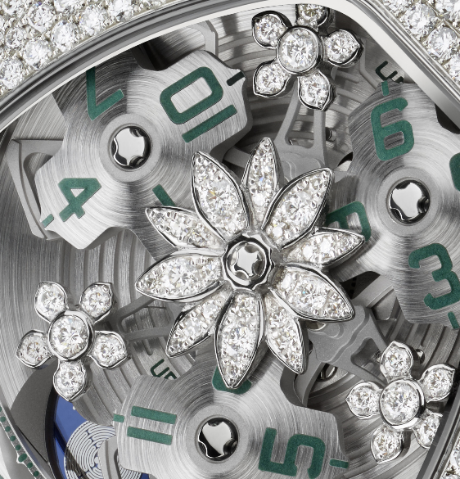

Added to this decorative work on the casing is the beautiful workmanship carried out on the UR-106 Flower Power carousel itself. Martin Frei, co-founder of the URWERK house and chief designer, says: "Ever since the launch of the 106 line in 2015, I have been dreaming of its different variations. Playing with diamonds and light is one of my greatest pleasures. We worked extensively with our engineer on the sketches of the flowers in this piece. We ran various tests on wax models before finally achieving the desired result. Each flower was then cast in white gold before being set and mounted on the carousel.”

A Lotus flower acts as a pivot to the satellite indication of this UR-106. A delicate flower that houses no fewer than 30 diamonds, all adapted to fit by the expert hand of the jeweller. The only indication that this is a technical as well as an anaesthetic item is hidden in the heart of the motif, a watch screw with a perfect finish. Three ornaments in gold and diamonds complete this bucolic picture. Each is composed of five mounted petals; they fit delicately in between the hour satellites. These three flowers are like a pause in this perpetually-moving carousel. Flowers that the watchmaker gently affixes to his mechanism, ensuring a fragile balance.

This indication of the wandering hours, so dear to URWERK, consists of three satellites, each one carrying 4 indexes. One after another, they parade along the path of the minutes, showing the time in both analogue and digital fashion. A phase of the moon completes the UR-106 dial. “We have paid particular attention to the smallest details of the UR-106. We have taken 18 years to perfect this idea, and made no concessions. The carousel and its satellites have been patiently satin-finished and sanded by hand. Each hour and minute index is painted by us. The cutting of the minute track of extreme delicacy is performed in our workshops. The blue of the lunar phase borrowed from lapiz lazuli was chosen from hundreds of others; the cutting of the lotus at the back of the piece is just as Martin designed it. “

The result is in keeping with the amount of effort made. Will this bring about that hoped-for instantaneous love, that makes your eyes shine, your heart beat faster, that heightens your senses and makes your life more intense?

UR-106 Flower Power - Limited edition 11 copies

Technical Specifications
Mechanism
Calibre: | UR 6.01 self-winding, 48 hours of reserve power
Finishes: | Beading, sanding, satin-finishing  Bevelled screw heads
Dial | Central flower in white gold set with 30 brilliant-cut diamonds (0.184 ct); 3 small flowers in white gold set with 6 brilliant-cut diamonds (0.522 ct)  Sanded and satin-finished platinum  Hour satellites and carousel in titanium sanded and satin-finished by hand  Serrated minute track  Phases of the moon  Handed-painted hour and minute indications - SuperLuminova
Indications | Hour satellite; minutes, lunar phases
Casing
Materials: | UR-106 Flower Power steel casing and diamond set titanium crown
Dimensions: | Width 35 mm; length: 49.4 mm; thickness: 14.45 mm
Glass: | Sapphire crystal
Water resistance: | Pressure tested to 30 m / 3 ATM

Contact:
Mrs Yacine Sar
Tel + 41 22 900 20 27
Mobile: +41 79 834 46 65
press@urwerk.com

URWERK

On the watchmaking scene since 1997, URWERK has shaken up the world of luxury watchmaking by imposing its own vision of time upon it. Revolutionary and anti-conformist at will, URWERK is nonetheless rooted in tradition and ancestral know-how. All the better to break free.

URWERK is a certainly young organisation, but its roots date back to 6000 BC, in the town of Ur in Mesopotamia. Observing the shadows cast by the sun on their monuments, the Sumerians are the source of the definition of time as we know it today.
Whether coincidence or a sign of the times, the word “Ur” also means the beginning, or the origins, in the German language.
The last syllable of the name URWERK is also borrowed from the language of Goethe, the verb “werk” meaning to fashion, to work, to innovate. A tribute to the hard work of the master watchmakers who have succeeded one another until the present time, shaping what we now call luxury watchmaking.

URWERK is also two strong minds, two well-tempered personalities. Felix Baumgartner, master watchmaker, is the son and grandson of watchmakers. Which is why craftsmanship is in his soul. Whereas others talk about timepieces as one talks about a hobby, for him, they are at the centre of his life.
Martin Frei, artist designer, is the alter ego of Felix Baumgartner. In 1987, as an art student at the Hochschule fur Gestaltung und Kunst in Lucerne, he successfully experimented with all forms of creative expression: sculpture, painting and video.
He is particularly fascinated by the definition of time and its manifestation through the ages.
A friendship quickly arose between the two men, who naturally spent long hours discussing the gulf between watchmaking as they imagined it and the one they saw displayed in shop windows.

In the 1990s, they embarked on the creation of their first model, a timepiece freely inspired by the Campanus brothers’ night pendulum. The time is read in a circular arc that tracks the course of the sun from East to West. The rest of the story is well-known. Next came the 103, 200 and 110 and 105 collections, watch pieces with original aesthetics and the complexity of extreme technicality.

“Our goal is not to offer yet another version of a known mechanical complication,” explains Felix Baumgartner. “Our watches are unique because each model required an effort of original design. This is what makes them rare and precious. “

Martin Frei, who designs the aesthetic signature of each URWERK model, makes the same statement of faith: “I come from a world of total creative freedom. I am not cast in the watchmaking mould, so all my cultural baggage serves as a source of inspiration.”

In 2017, URWERK is celebrating its twentieth anniversary! The watch company is the oldest independent house in the New watchmaking movement. URWERK is now 16 employees strong, of whom 12 are watchmakers, producing fewer than 150 watches per year.

WATCH THIS SPACE !

www.urwerk.com ; www.facebook.com/urwerk ; https://instagram.com/urwerkgeneve/
https://twitter.com/URWERK_Geneve

