The UR-105 TA a.k.a. URWERK Knights

Singapore – April, 2015
The UR-105 TA (TA for Turbine Automatic) isn't round, has no hands, and no tourbillon: It is 100% pure URWERK. It is the watch that the team had the most fun in designing, the most pleasure in developing its mechanisms, and the most satisfaction in its hand finishing and assembly. The UR-105 TA is a real watchmaker's watch that explodes with creativity with a palette of zesty colors thanks to URWERK’s unconventional chief designer Martin Frei.
URWERK presents the UR-105 TA a.k.a. the "URWERK Knight".
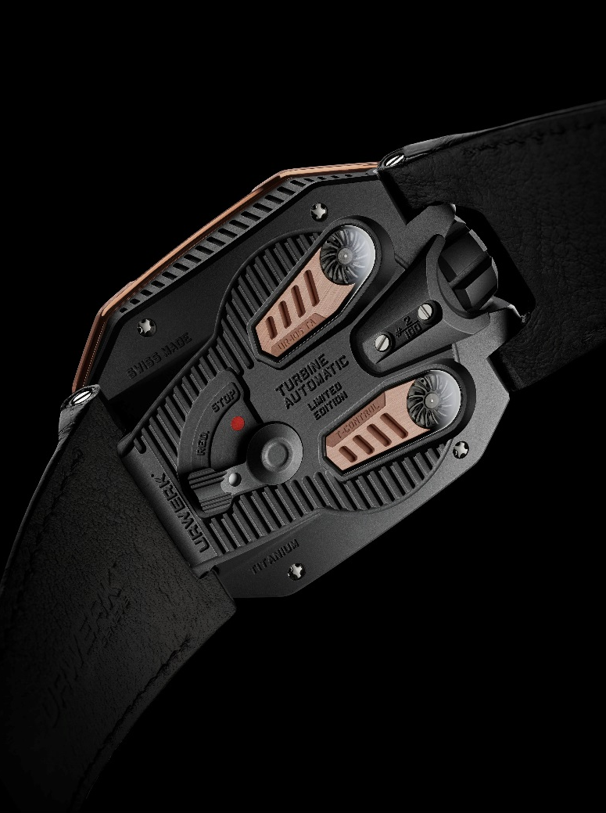
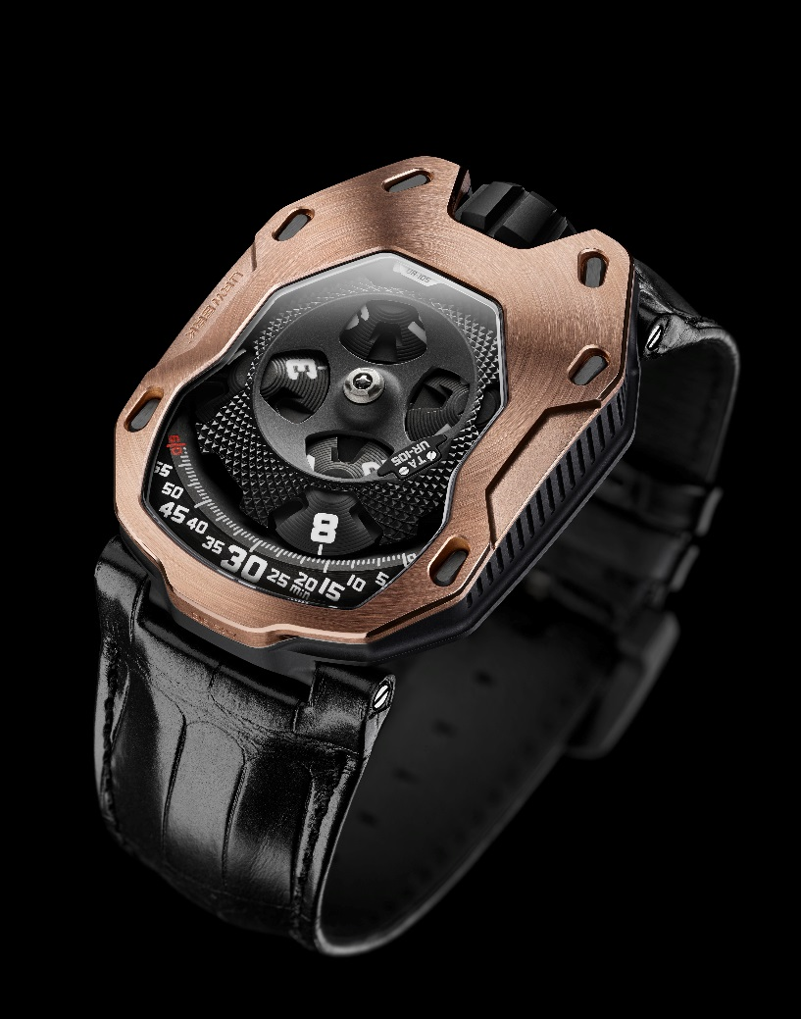

The UR-105 TA revisits URWERK's iconic satellite indication, which has been an emblematic and instantly recognizable signature element of the brand for 18 years. Four satellites, each bearing three hour numerals, successively reveal themselves from under a sublime guilloche black cover in PEEK (polyetheretherketone) as they parade past the minute rail to display the time. Everything exudes precision and refinement, from the carrousel chassis to the dial, from the touches that are invisible to those on full display through the large sapphire crystal. For example, the hidden ARCAP satellite carrousel has been treated with ruthenium then micro bead blasted to a finish meeting the very highest standards of haute horlogerie.

“With the UR-105 TA we wanted to get the best of two worlds. We have enjoyed demonstrating the extent of our savoir-faire, from the micron-precision mastery of our CNC machines, to the superb hand finishing carried out in our ateliers. It is a piece that delights the eye. Observed under the loupe, it reveals all the little subtleties that we have incorporated into it,” says Felix Baumgartner, and URWERK co-founder and chief watchmaker.
The UR-105 TA also embodies all the years of research invested into URWERK’s wandering hour satellites. Here, the ingenuity of this mechanism lies in the invisible carousel responsible for the operation of the satellite hours. The carousel operates precisely, silently, subtly and in harmony with the rest of the timepiece.
“With our previous timepieces, our satellites were supported by an orbital cross at the top. We rethought this concept and made some refinements. The fruits of this can now be felt when setting the time on the UR-105 TA: There is virtually no friction, no jerking movement, just the ballet of satellites. It is the fluidity of the gears that quietly reveals all our hard work,” continues Felix Baumgartner.

The “TA” of the UR-105 TA stands for “Turbine Automatic”. That is because the movement’s automatic winding is optimally regulated by dual air turbines on full show on the back. These turbines are bead-blasted, satin-finished and treated with black PVD for perfect aesthetics. The winding mode is selected by a small lever.
In the “FULL” position, only the slightest movement is needed to wind up the mainspring. "RED." (for “REDUCED”) moderates the winding so as to minimize excessive tension on the mainspring. On "STOP" mode, the winding system is disabled and the UR-105 TA can then be hand-wound if necessary by the crown.

“The UR-105 TA is our URWERK Knight,” says Martin Frei, artistic director and co-founder of URWERK. “The bezel evokes the breastplate of a knight’s armor, protecting the mechanism from the ravages of time. The UR-105 TA is an haute horlogerie creation, with all high-end codes respected, but in the Black Orange or Black Lemon versions, it's their zesty appeal that really arouses the senses.”
While the UR-105 TA is available in two "classical" versions – "All Black" in titanium and steel, and "RG" in titanium and red gold − and in a first for the brand, the UR-105 TA also comes in more vibrant hues.
"Black is one of the signatures of URWERK aesthetic. However, with the UR-105 TA we decided to push much further with color. While the black is still there, it no longer dominates; the vivid colors inspired by our SuperLuminova really announce their presence,” explains URWERK's chief designer Martin Frei.

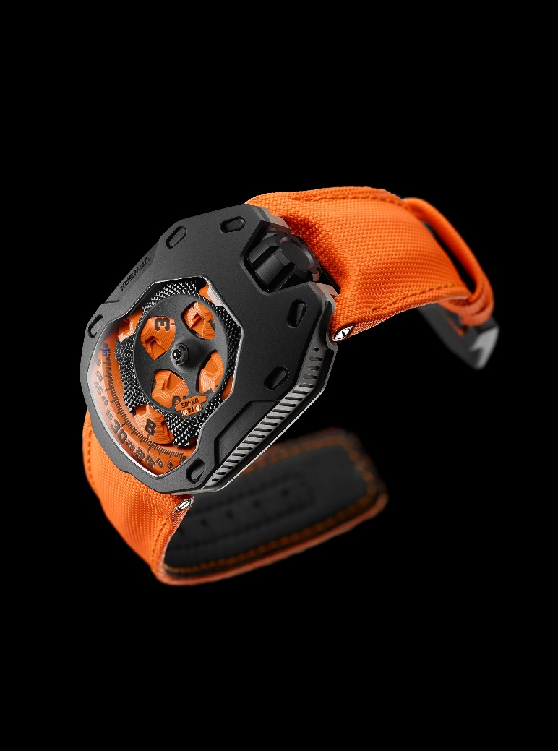
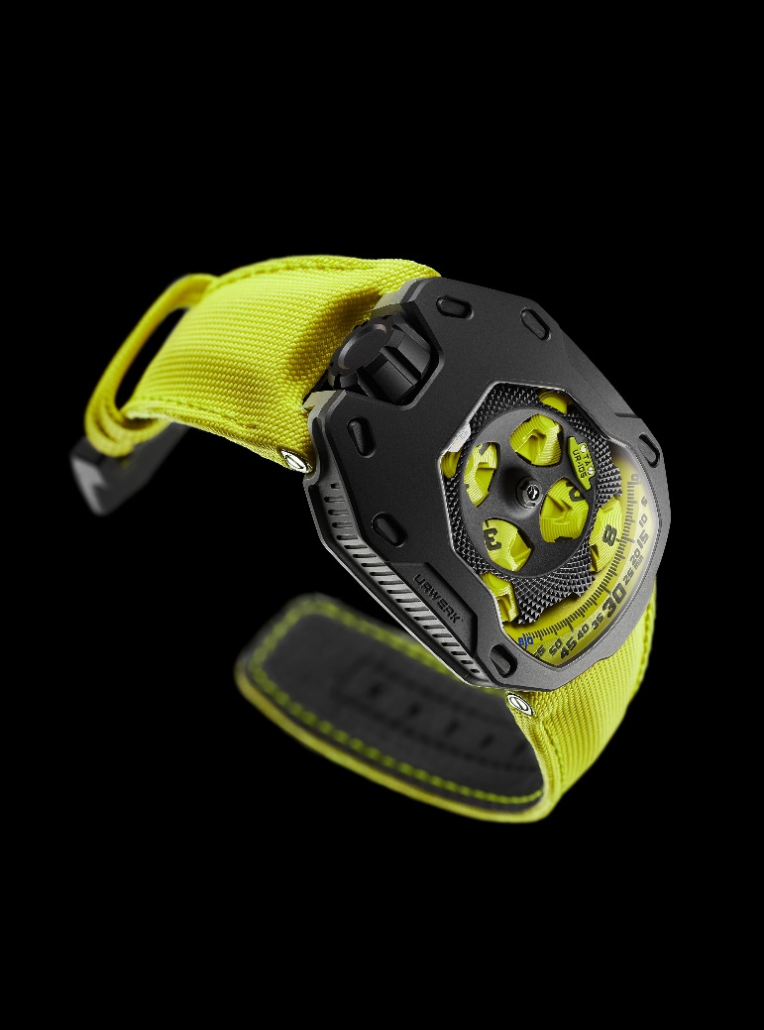

The UR-105 TA "Black Orange" and the UR-105 TA "Black Lemon" are timepieces with a joyous attitude. Sand blasting and micro bead blasting are applied with the same care as with more classical timepieces. However, the addition of bright colors has these watches bursting into life, and infusing them with real energy.
Red Gold, All Black, Black Lemon or Black Orange, the UR-105 TA collection cannot help but please.
UR-105 TA a.k.a. "URWERK Knights"

Movement
Caliber: 5.02 UR automatic winding regulated by a double turbine
Jewels: 52
Frequency: 28,800v / h – 4 Hz
Power reserve: 48 hours
Materials: Satellite hours driven by Geneva crosses in beryllium bronze;
Orbital structure of PEEK (polyetheretherketone)
Carrousel and triple mainplates in ARCAP
Surface finishes: Perlage, bead-blasting, satin-finishing
Beveled screw heads
Indications Satellite hours; minutes – hour and minute markers treated with Super-LumiNova

Case
Materials: UR-105 TA RG – black PVD titanium case, red gold bezel
UR-105 TA "All Black" – black PVD titanium case, black PVD steel bezel
UR-105 TA "Black Lemon" – titanium case, black PVD steel bezel
UR-105 TA" Black Orange" – titanium case, black PVD steel bezel

Dimensions: width: 39.50mm; length: 53mm; height: 16.80 mm
Crystal: Sapphire Crystal
Water Resistance: Pressure tested to 30m / 3ATM

Press contact:
Ms. Yacine Sar
press@urwerk.com
+41 22 9002027
+41 79 834 4665

