The URWERK UR-105M: An iron knight ready to conquer time

Geneva, April 2014
URWERK’s UR-105M is inspired by the Middle Ages, an era of lances, legends, chivalrous conduct and noble deeds. An era when knights in shining armor would risk their lives for honor and glory, with only their faith and shield for protection. The UR-105M embodies their gallant valor in a titanium and steel arena, the satellite hours conquering time in an eternal jousting tournament.

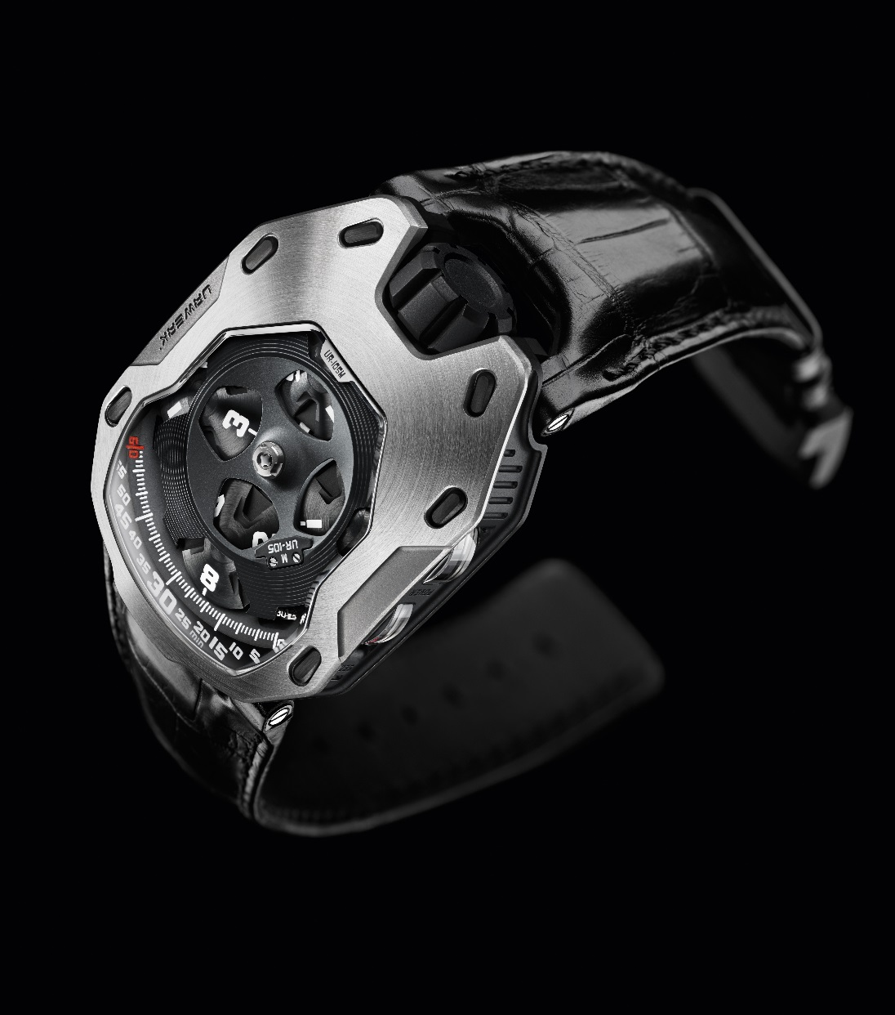

All of URWERK's iconic codes are present in the UR-105M. Satellite hours gliding slowly along the minute scale, darkened over-sized crown at 12 o’clock and a subtle technical feel.

The UR-105M features an impressive titanium body reinforced by steel armor. At the heart of its time display four satellites slowly orbit. Each of these satellites is visible during their 60-minute journey along the minute scale. A circular PEEK (PolyEtherEthercetone) canopy with openings enhances the current hour. Once the hour has elapsed, the satellite – guided by a Geneva cross – rotates and continues around its orbit for another three hours before returning to the center stage. Completing the indications, running seconds and power reserve are displayed laterally on the case band.

At the back of the UR-105M, URWERK’s signature ‘Control Board’ houses additional displays and functions: an ‘Oil Change’ indicator alerting when it is time for a service; 42-hour power reserve indicator; plus the fine-tuning screw allowing adjustment of the rate.

Martin Frei, URWERK’s co-founder and artistic director, explains: “The case of UR-105M was developed as an armor. The visible screws on the bezel not only bring a distinctive esthetic to the watch, but also tack the steel armor onto its titanium body. This shield protects the movement (the heart of the watch) from the outside world’s aggressions. For me, the parallel with the chivalrous imagery is obvious. You have the power of the bezel-armor generating a feeling of invincibility.”

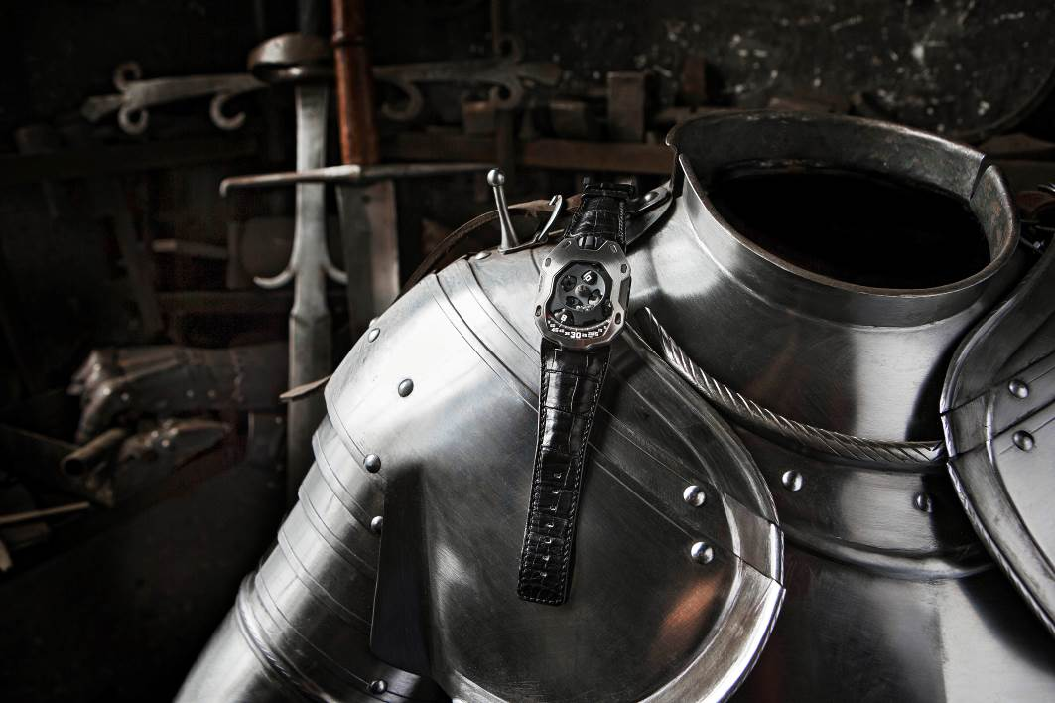

“With UR-105M, we’re not trying to show off, but rather ignite a calmer and mellower dimension,” adds Felix Baumgartner, URWERK’s co-founder and master watchmaker. “We offer an intuitive time display, with playfully ergonomic time setting. Technical challenge is at the heart of all our creations, and the performance here is subtle.

“First of all, the aluminum and PEEK structure has to rotate with absolute chronometric precision. We needed the lightest materials to achieve a high level of precision and PEEK was ideal: The PEEK polymer is used in surgery because its excellent mechanical properties and chemical resistance. The other challenge accomplished by UR-105M is of another type entirely: A honeycomb seconds disk on the right side of the case underneath the minute dial indicates the passing of each 10 seconds. This indicator is synchronized to another seconds indicator situated on the side of the case.”

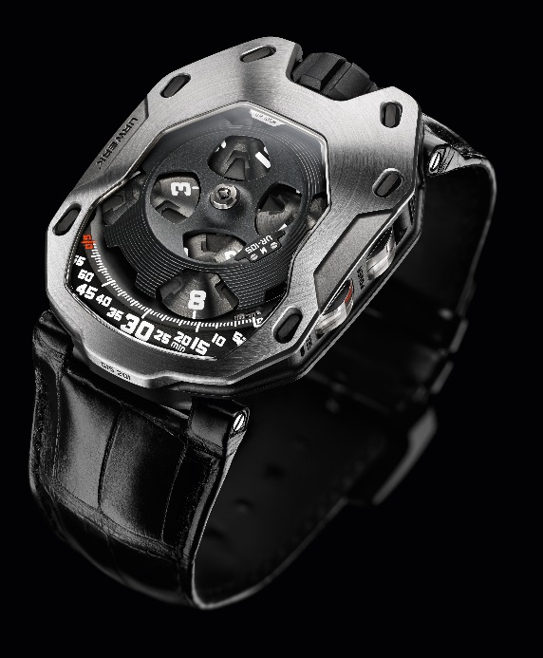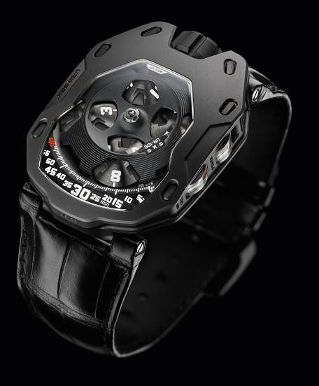

The UR-105M is available in two versions: the ‘Iron Knight’ with a titanium case and steel bezel and the ‘Dark Knight’ with a titanium case and AITiN-treated steel bezel.

UR-105M - Technical Specifications

Movement
Caliber: | UR 5.01 manual-winding mechanical movement
Jewels: | 38
Frequency: | 28,800v/h - 4Hz
Power reserve: | 42 hours
Materials: | Satellite hours driven by bronze beryllium Geneva crosses  Orbital structure in PEEK (PolyEtherEthercetone)  Carrousel and three main plates in brass  Digital skeletonized seconds display in nickel (LIGA process)  Seconds indications and lateral power reserve in aluminum
Surface finishes: | Perlage and bead-blasting  Countersunk screw heads
Indications | Dial: Hours, minutes and 10 seconds  Case band: Lateral seconds and power reserve indications  Control board: ‘Oil Change’ and power reserve indications, timing adjustment screw
Case
Materials: | UR-105M 'Iron Knight': titanium and steel bezel  UR-105M ‘Dark Knight': titanium and AITin-treated steel bezel
Dimensions: | 39.50mm x 53mm x 16.65mm
Crystal: | Sapphire crystal with anti-reflective coating
Water resistance: | Pressure tested to 3ATM / 30m
Surface finishes: | - UR-105M ‘Iron Knight’: sand-blasted bezel; circular graining; and vertical graining  - UR-105M ‘Dark Knight’: AITiN-treated with bead-blasted bezel

____________________

Press contact:
Ms Yacine Sar
press@urwerk.com
+41 79 834 4665
+41 22 9002027

