THE UR-101 DIAMOND SKY BY URWERK.
WANDERING HOURS BENEATH A GEM-STUDDED CANOPY

GENEVA - 8 APRIL 2026.
Some watches never leave the URWERK workshop even though they are neither lost items nor rejects. These one-of-a-kind creations exist for the sheer beauty of their existence, preserved from everything, sheltered from media hype and trend cycles. They are safeguarded at the very heart of the watchmaker's house, in the strongbox of memory. This is where the founding ideas are kept, the original timepieces, those that were not intended to please but simply to exist.

Among them is a singular, luminous watch that – long before contemporary horology took the liberty of writing mechanical poetry – slid time from left to right, from sunrise to sunset, on a 180-degree arc beneath a diamond-studded celestial vault. Today, URWERK is reviving this little-known icon through a series of 25 gemset timepieces bearing a self-explanatory name: Diamond Sky.

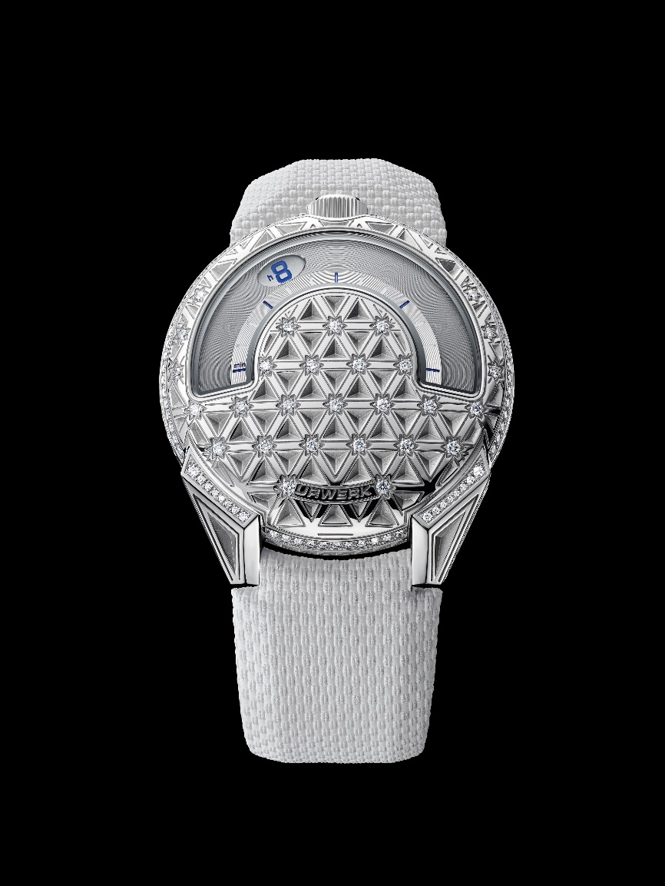

The UR-101 Diamond Sky is not a nostalgic reinterpretation but rather a resurgence. A timepiece designed for those who see time as a trajectory and light as a language. “The UR-101 is our starting point”, explains URWERK co-founder and master-watchmaker Felix Baumgartner. "It contains everything that has become emblematic of URWERK: the satellite display, time’s motion expressed as a path, along with the desire to offer a dial representing a break with traditional norms. We are not looking back with this Diamond Sky edition, but instead extending an intuition. The steel of the case creates a striking contrast with the diamonds, resulting in a model combining technical excellence and aesthetic sophistication."
Through this brand-new UR-101 interpretation, URWERK is exploring territory where it has rarely ventured before, where watchmaking mechanics engage in a direct dialogue with the art of jewellery – free of any compromise or hierarchy. The steel case becomes a cosmic chart, mechanically engraved with a geometric network evoking an abstract constellation. Every intersection features a diamond, not merely placed, but instead integrated as a reference point, a fixed star within a perpetually moving universe.
The result is structural rather than decorative. The light fragments, reflects and scatters with every wrist movement. Time slips by and the stars twinkle. The mechanics remain legible, accurate and relentless, while the light is resolutely free.
"The stars are pinpricks in the veil of night, wrote Christian Morgenstern, the German poet. Our Diamond Sky draws from that same source," says Martin Frei, co-founder of URWERK and the brand's artistic director. "The diamonds are points of light, guiding us as the stars do. Their hexagonal arrangement follows a clear principle: in space, stars bear witness to the laws of nature; on our dial, they create balance, connecting top and bottom, and translate a design vision into a simple, harmonious structure”.

The UR-101 Diamond Sky is a direct descendant of the very first URWERK creations presented in 1997. It retains their uncompromising DNA: satellite display, crown at 12 o'clock, angular lugs and radical legibility. It adds a precious dimension, not designed to merely appeal but rather to amplify the message. The 41 mm steel case acts as a technical showcase, providing the necessary contrast with the depth of the engraving and the intensity of the gemsetting. Nothing is there by chance and the very choice serves a purpose: to create a dialogue between matter, light and time.

Issued in a 25-piece limited edition, the UR-101 Diamond Sky is intended for collectors who view a watch as an idea in motion rather than a static object. It reminds us that time is naturally staged, as is admirably illustrated in this watchmaking approach that does not follow existing constellations, but rather traces its own.

UR-101 Diamond Sky
25-piece limited edition

Movement
Calibre | UR-1.01V, self-winding
Jewels | 28
Frequency | 28,800 vph – 4 Hz
Power reserve | 48 hours
Materials | Copper, brass, ARCAP P40
Finishes | Snailing, sandblasting, satin-brushing  Chamfered screw heads
Indications
Wandering hours on two satellites, minutes
Hours and minutes markers painted with
Super-LumiNova®
Case
Materials | Steel set with 214 D-E-F VVS+ responsibly sourced diamonds totalling 1.63 carats
Size | 41 mm in diameter, 9.33 mm thick
Glass | Glareproofed, metallised sapphire crystal
Water resistance | Pressure-tested at 30m / 3ATM
Strap
Material | Textured white rubber with black calfskin lining. Steel pin buckle.
Price
 | CHF 85,000 (Swiss francs // excl. tax)

_________________________________________

Media Contact
Ms Yacine SAR +41 22 900 2027
www.urwerk.com/press press@urwerk.com

ABOUT URWERK
“Right from the start, we refused to confine ourselves to the well-beaten track of traditional complicated mechanisms”, explains watchmaker Felix Baumgartner, master-watchmaker and co-founder of URWERK. “Our aim is to go beyond the traditional horizons of watchmaking and to overturn them so as to blaze our own trail”, he concludes. The original styling of each URWERK model is signed by chief designer Martin Frei, the company’s other co-founder, who shares: “I come from a background where creativeness has no limits. I am in no way prisoner of the traditional constraints of watchmaking and I can therefore be freely inspired by my cultural heritage.”

Although URWERK is a young company established in 1997, it is recognized as a pioneer among independent watchmakers. Producing just 150 watches a year, The Swiss Maison sees itself as a veritable laboratory where traditional expertise rubs shoulders with avantgarde styling. Its range of creations comprises three distinct lines: URWERK’s iconic Satellite collection in which wandering hours redefine our perception of time; the Chronometry collection, an experimental field dedicated to precision and mechanical innovation; along with Special Projects, an area dedicated to daring expression and visionary concepts.
URWERK develops modern and complex watches that are unprecedented and meet watchmaking’s most demanding criteria: independent design and research, advanced materials and handcrafted finishes.

The name URWERK comes from the ancient city of Ur of the Chaldees in Mesopotamia, founded nearly 6,000 years ago where the Sumerian inhabitants first established units of time based on the shadows cast by its monuments. Ur in the German language also means primeval or original and Werk means an achievement or a mechanism. Thus, URWERK can be translated as an original movement – a tribute to generations of watchmakers whose work has resulted in what we know today as Haute Horlogerie, or superlative watchmaking.

