URWERK and its UR-100V UltraViolet. Beyond colors

Geneva, 30 August 2022.

Violet! This magnificent shade is located at the far end of the visible colour spectrum perceptible to the human eye. Anything beyond violet is outside the field of colour. Violet is the ultimate hue. That of the fighters, the outsiders, the crazies. Heroes or villains? It doesn't matter. If you need to make yourself heard, do it in violet!

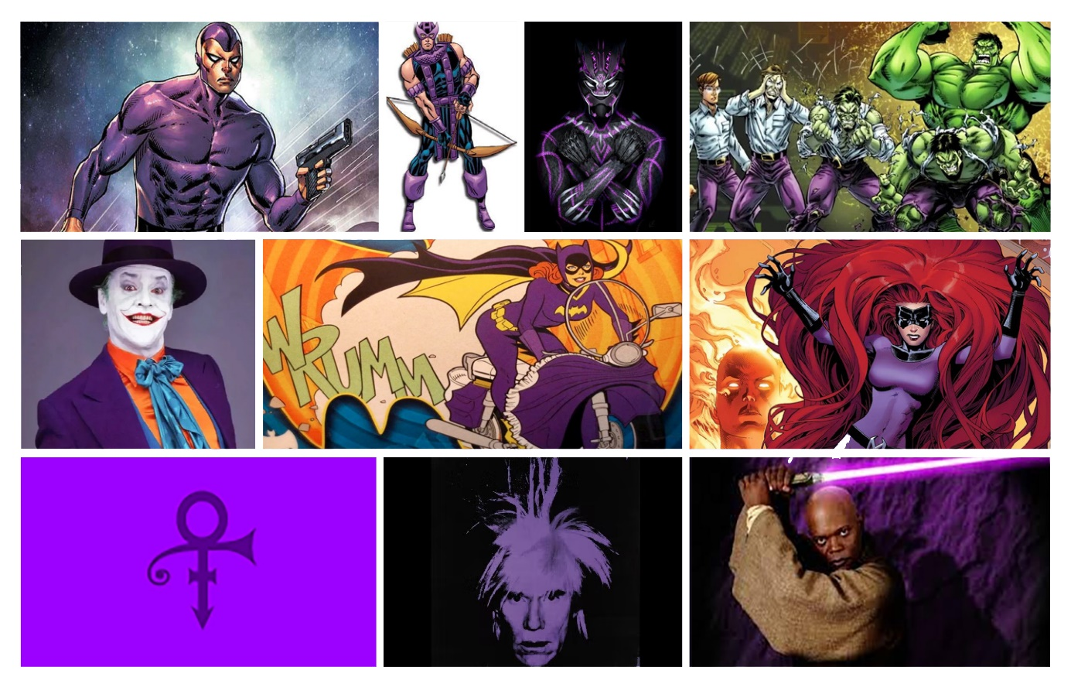

Martin Frei talks about the colour that is so special to him: "I like the fact that a colour is much more than what we can perceive. The colour spectrum visible to our eyes ranges from red to violet. Beyond that shade, colour turns into a waveform that our eyes can no longer detect, ultraviolet. I am fascinated by the idea of creating a watch that celebrates this boundary, this tipping point, this transition from perceptible to imperceptible. The UR-100V UltraViolet is about this exploration of the limits. Our UltraViolet conveys something mystical, it's a hue that sits on the border of a dimension we call colour."

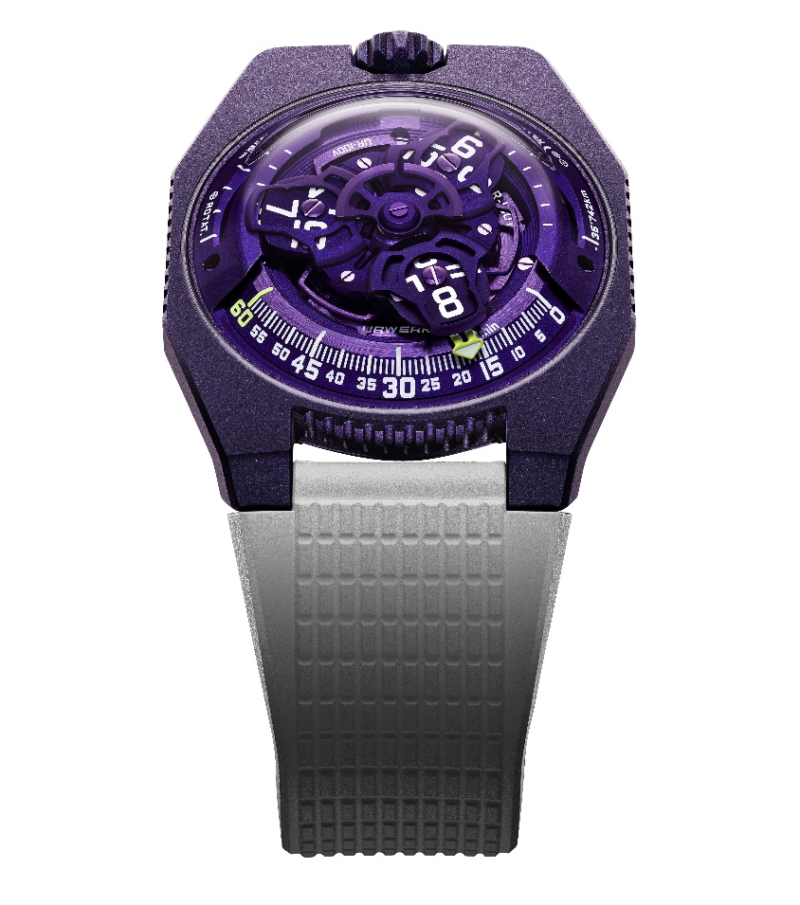

Fitted with a rubber strap, the UR-100V UltraViolet picks up the codes of the 100 family. On the UR-100V, the satellite hours and minutes display is complemented by new information. Once the 60th minute has been reached, the minutes hand vanishes and reappears as a kilometre counter. It illustrates the 555 kilometres travelled every 20 minutes by every inhabitant of Planet Earth. This is in fact the average speed of rotation of the Earth calculated at the Equator (rotational distance). Appearing exactly opposite is the Earth's revolution around the sun (orbital distance), i.e. 35,740 kilometres per 20 minutes. On the face of the UR-100V, hours and kilometres thus share the same status, the same scale of value. These units are lit up at night in incandescent blue for the hours and in flamboyant green for the kilometres. Felix Baumgartner, master watchmaker and co-founder of URWERK says: "This creation was inspired by a gift from my father, Geri Baumgartner, a renowned restorer of antique clocks. It is a clock made by Gustave Sandoz for the 1893 World Exhibition and its particularity lies in the fact that instead of showing the hours, it indicates the rotational distance travelled by the Earth at the Equator.”
Beating beneath the dome of the UR-100V is the new URWERK Calibre 12.02 with its three-satellite time display. "The change of calibre for this version is reflected in the redesign of the central carousel. The hour-markers are placed closer to the minutes scale for an even more intuitive and fluid reading of the time”, explains Felix Baumgartner. This carousel is forged in aluminium and then sanded and shot-blasted after anodising. Each of the satellite screws is satin-finished in a circular pattern. The satellites rest on a sanded and ruthenium-treated brass carousel. The structure covering the hours indication is made of sanded and shot-blasted aluminium. The UR-100V's automatic winding is governed by a bidirectional rotor regulated by a Windfänger airscrew.

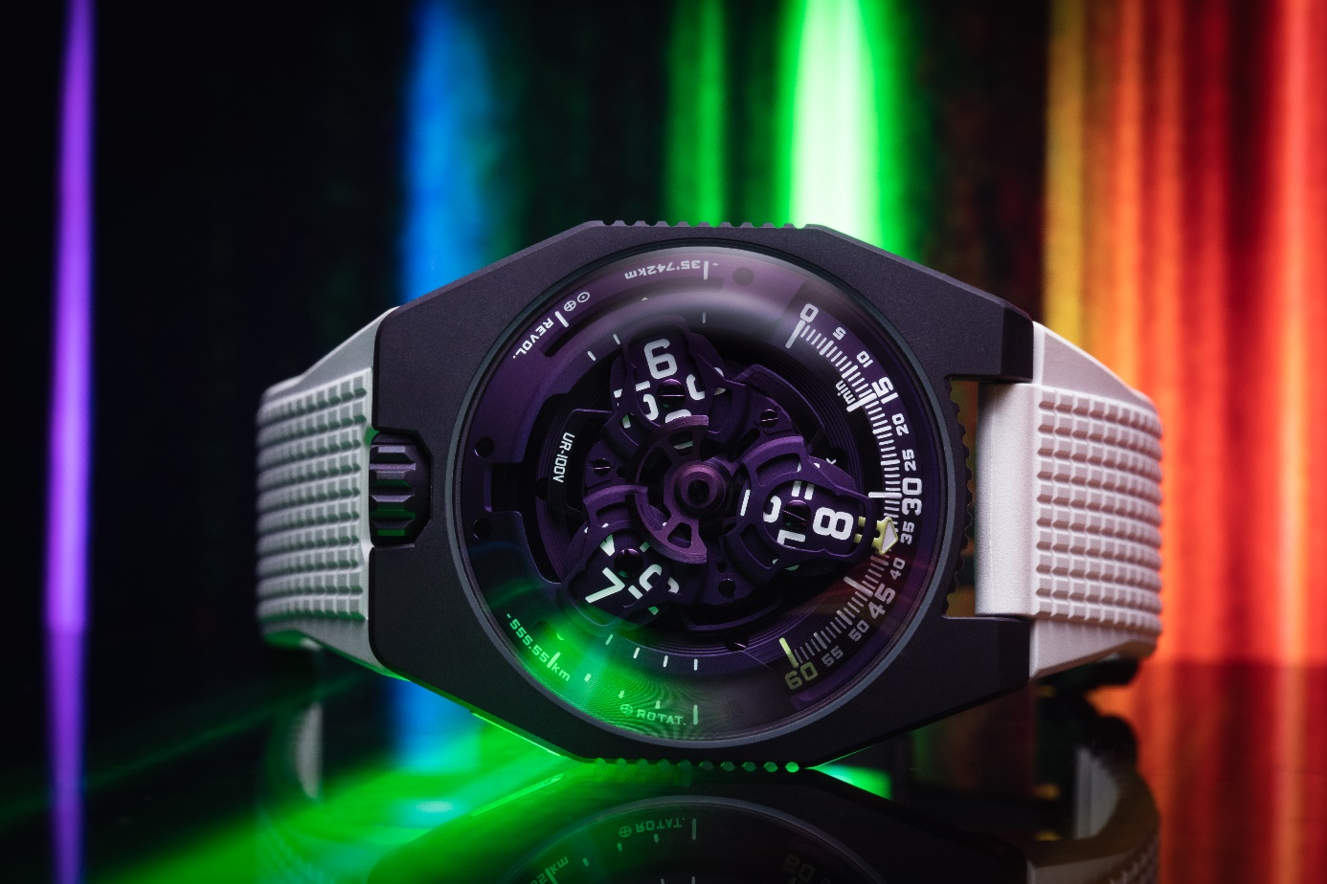

The aesthetics of the UR-100V's case is a regressive pleasure. It will indeed remind the URWERK faithful of the aesthetics characterising the first models from the independent brand: "We have taken certain aesthetic elements from our first constructions and destructured our approach. For example, the steel dome of our historic models is reproduced here through the transparency of sapphire crystal. Its perfection is highlighted by the roughness of the titanium and steel case. As someone who constantly questions the dictates of symmetry, I have played with proportions to challenge the eye”, sums up Martin Frei.

UR-100V UltraViolet

Movement
Calibre | Selfwinding UR 12.02 movement governed by a Windfänger airscrew
Jewels | 40
Frequency | 28,800 v/h - 4Hz
Power reserve | 48 hours
Materials | Satellite hours on beryllium-bronze Geneva crosses; aluminium carousel; carousel and triple baseplates in ARCAP alloy
Finishes | Circular graining, sanding, shot-blasting, circular satin finishing  Chamfered screw heads  Hours and minutes painted in Super-LumiNova®
Indications | Satellite hours; minutes; rotational distance at the Equator in 20 minutes; orbital distance in 20 minutes
Case
Material | Violet DLC on sanded shot-blasted titanium.
Dimensions | Width 41.0 mm, length: 49,7 mm, thickness : 14.0 mm
Glass | Sapphire crystal
Water resistance | Pressure tested at 3ATM (30m)
Strap | Textured rubber with titanium folding clasp
 | Price CHF 55,000.00 (Swiss francs / excluding tax)

______________________

Contact: Ms Yacine Sar
press@urwerk.com
www.urwerk.com
+41 22 900 20 27

