**URWERK PRESENTS THE NEW UR-100V**

**TIME AND CULTURE III**

Geneva, June 2025 – URWERK continues its exploration of time across civilisations and today unveils an extraordinary creation: the UR-100V Time and Culture III. This one-of-a-kind creation stems from an unprecedented artistic collaboration between the Swiss watchmaking house and the David Kakabadze studio based in Tbilisi, Georgia.

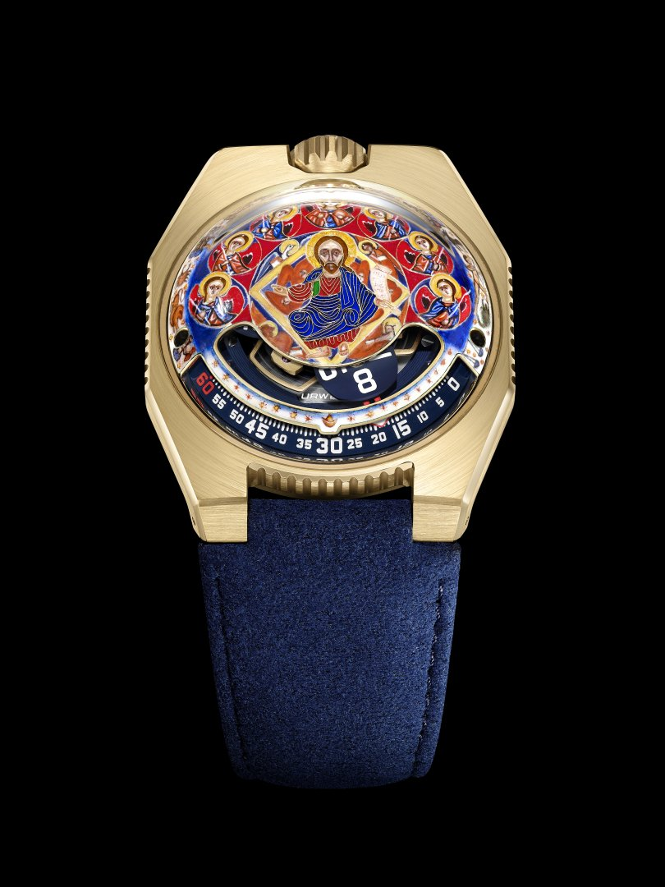

Through its “Time and Culture” collection, URWERK celebrates the foundational concepts of time transcription. A journey of remembrance through civilisations. After exploring Native American and Mesopotamian symbolism, the new UR-100V Time and Culture carries us to the heart of Georgian Orthodox tradition, to lands where spirituality, religion and art have for centuries been closely entwined.

A miniature work of art

The decoration adorning the UR-100V Time and Culture III, crafted from yellow gold, is a true masterpiece of 24K *cloisonné* enamel and miniature painting. It took 1,152 days to complete, using 19 different enamels and requiring 16 firings at 750°C. Each step, each colour and each curve testifies to the age-old expertise passionately passed down by the master artisans of the Kakabadze atelier.

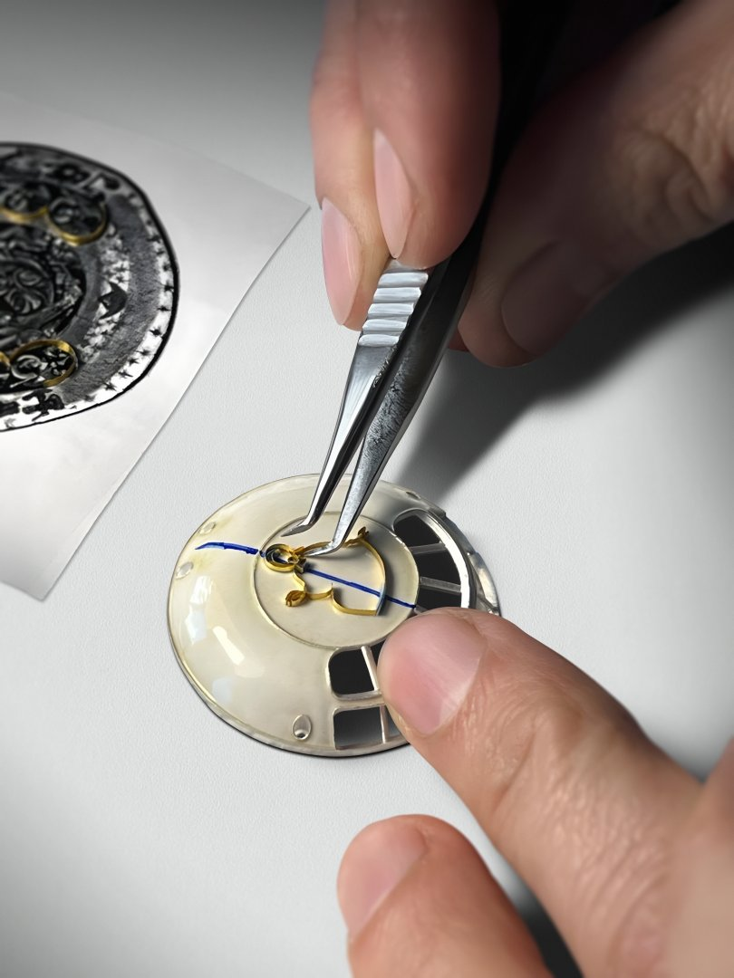 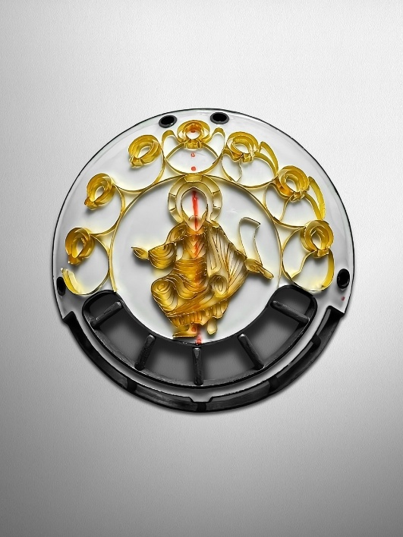

Inspired by a fragment of the zodiac wall frescoes in Svetitskhoveli Cathedral, a true gem of Georgian cultural heritage, the composition pays homage to Christian liturgy: according to an ancient legend, a man named Elias brought Christ’s robe to Georgia after witnessing the Crucifixion. His sister, Sidonia, was so overwhelmed with emotion upon touching the sacred garment that she died clutching it. Unable to remove it from her grasp, she was buried with the robe, and a cedar tree grew from her grave. In the 4th century, following his conversion to Christianity, King Mirian III built Georgia’s first church on the site believed to be Sidonia’s tomb.

The design featured on the UR-100V *Time and Culture III* thus depicts Christ surrounded by 12 celestial symbols, representing 12 cycles of time: 12 months, 12 hours, 12 constellations.

Beneath this work of art beats Caliber UR 12.01. Time is expressed through a wandering hour satellite indication, URWERK's iconic signature.

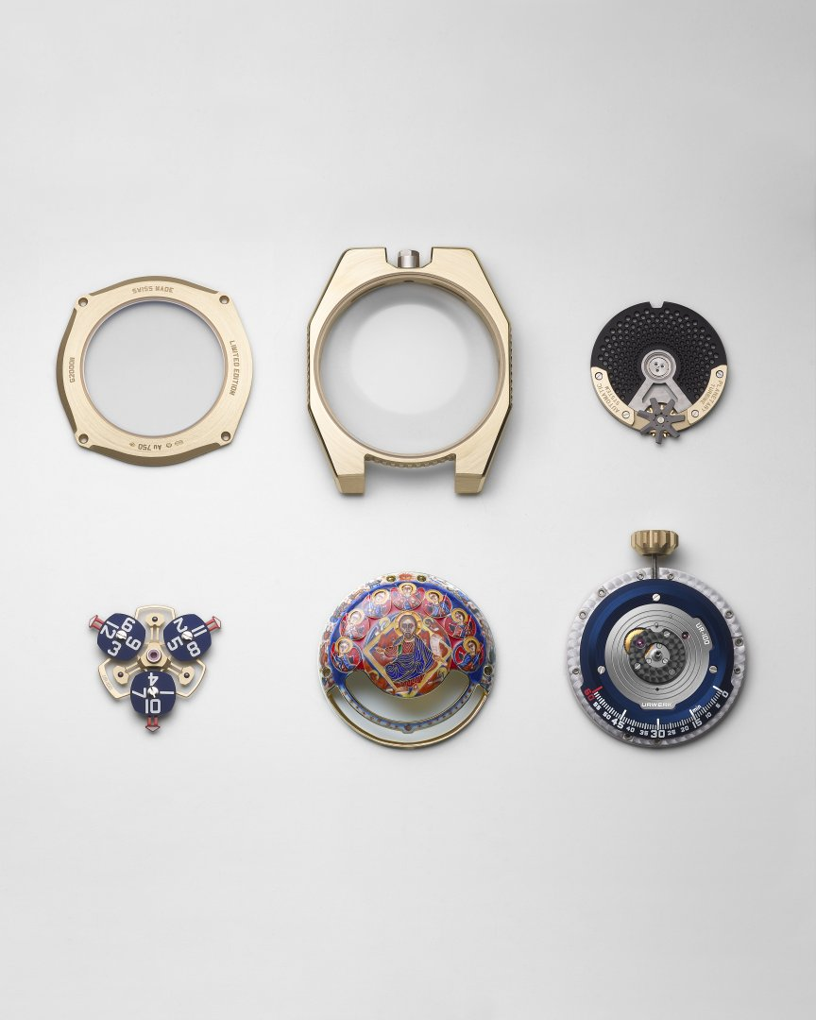

A watch. A memory beyond memory.

This UR-100V Time and Culture III is a manifesto through which contemporary watchmaking engages in a dialog with ancient spirituality and the emotion of traditions. A time capsule where every second becomes a radiant glimpse of eternity.

UR-100V Time and Culture III

pièce unique

|  |  |
| --- | --- |
| **Movement** |  |
|  |  | |
| Calibre  Jewels | Self-winding UR 12.02 movement governed by a Windfänger airscrew  40 |
| Frequency | 28,800 v/h 4Hz |
| Power reserve | 48 hours |
| Materials | Aluminium satellite hours on beryllium-bronze Geneva crosses; aluminium carousel; carousel and triple baseplates in ARCAP alloy. |
| Finishing | Circular satin brushing, sand-blasting, shot-blasting, circular satin finishing, circular graining  Polished screw heads  Hours and minutes painted in Super-LumiNova  Dome beneath the sapphire crafted in *cloisonné* enamelled 24-carat gold. |
| Indications | Satellite hours; minutes. |
|  |  |
| **Case** |  |
| Material | 2N 18K yellow gold. |
| Dimensions | Width: 41 mm, length: 49.70 mm, thickness: 14 mm |
| Glass | Sapphire crystal |
| Water resistance | Pressure-tested at 3ATM (30m) |
| Strap | Alcantara and leather, 2N 18K yellow gold pin buckle |

____________________

Contact: Ms Yacine Sar

[press@urwerk.com](mailto:press@urwerk.com)

[www.urwerk.com/press](http://www.urwerk.com/press)

+41 22 900 20 27

URWERK

“Our goal is not to offer yet another reinterpretation of an all-too-well-familiar mechanical complication,” explains Felix Baumgartner, master watchmaker and co-founder of URWERK. “Our timepieces are unique because each model demands an entirely original design effort. Our ambition is to rethink the traditional boundaries of fine watchmaking—and to challenge them as we forge our own path,” he concludes.

This same conviction is shared by Martin Frei, URWERK’s artistic director and fellow co-founder, who defines the distinctive aesthetic of each model: “I come from a world where creative freedom knows no limits. I’m not from the traditional watchmaking sphere, so my entire cultural background becomes a source of inspiration.”

Though URWERK is a relatively young company—founded in 1997—it stands as a pioneer within the landscape of independent watchmaking. With an annual production limited to just 150 pieces, URWERK operates as a true artisan workshop where traditional craftsmanship and cutting-edge design coexist in perfect harmony. The brand creates highly complex, resolutely contemporary timepieces that are unlike any other, yet fully aligned with the most exacting standards of Haute Horlogerie: independent research and innovation, advanced materials, and meticulous hand-finishing.

The name URWERK itself reaches back to 6000 B.C., to the ancient city of Ur in Mesopotamia. It was there that the Sumerians, observing the movement of the sun’s shadow on their monuments, helped define the concept of time as we still know it today. Whether by coincidence or design, “Ur” also means “origin” or “beginning” in German. The second part of the name, “werk,” comes from the German word meaning to work, to create, to innovate—a fitting tribute to the ceaseless dedication of generations of master watchmakers whose legacy continues to shape what we now call Haute Horlogerie.