**The UR-100V Magic T appears in a “Hunter Green” version**

**enabling URWERK to redefine colour perception.**

Geneva – 29 January 2025

Green? Yes, but not quite. Grey? Not exactly. Under the light, this shade tends towards an ash green – sophisticated and subtly metallic. A redefined hue with a discreet elegance, so British!

This unique aesthetic comes to life in the new UR-100V ‘Hunter Green’, a watch that redefines wristworn allure.

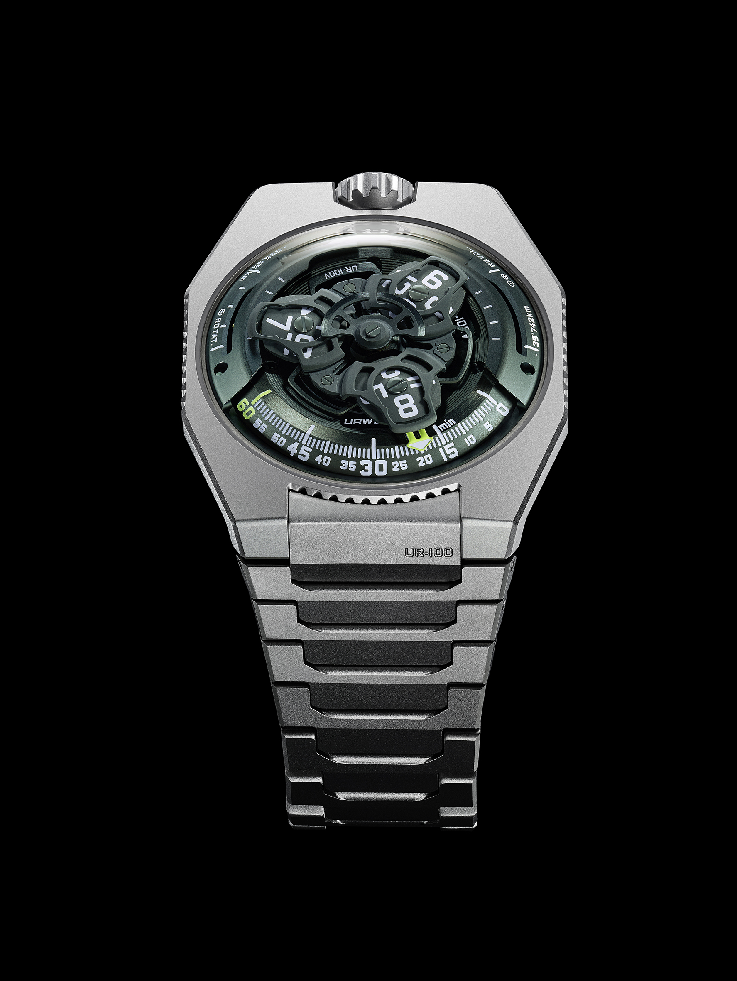

With this state-of-the-art full-titanium variation, URWERK once again magnifies the technical and visual minimalism for which the 100 ‘Magic T’ line is renowned. From case to bracelet, everything has been carefully designed and crafted to capture the very essence of the colour and material.

Signature versatility

“The UR-100V is like a blank canvas providing scope for infinite exploration”, says Martin Frei, URWERK’s artistic director and co-founder. “We're having fun with this collection, constantly rediscovering it through new expressions. Hunter Green was an obvious choice. It's a living, breathing colour that interacts with light and time.”

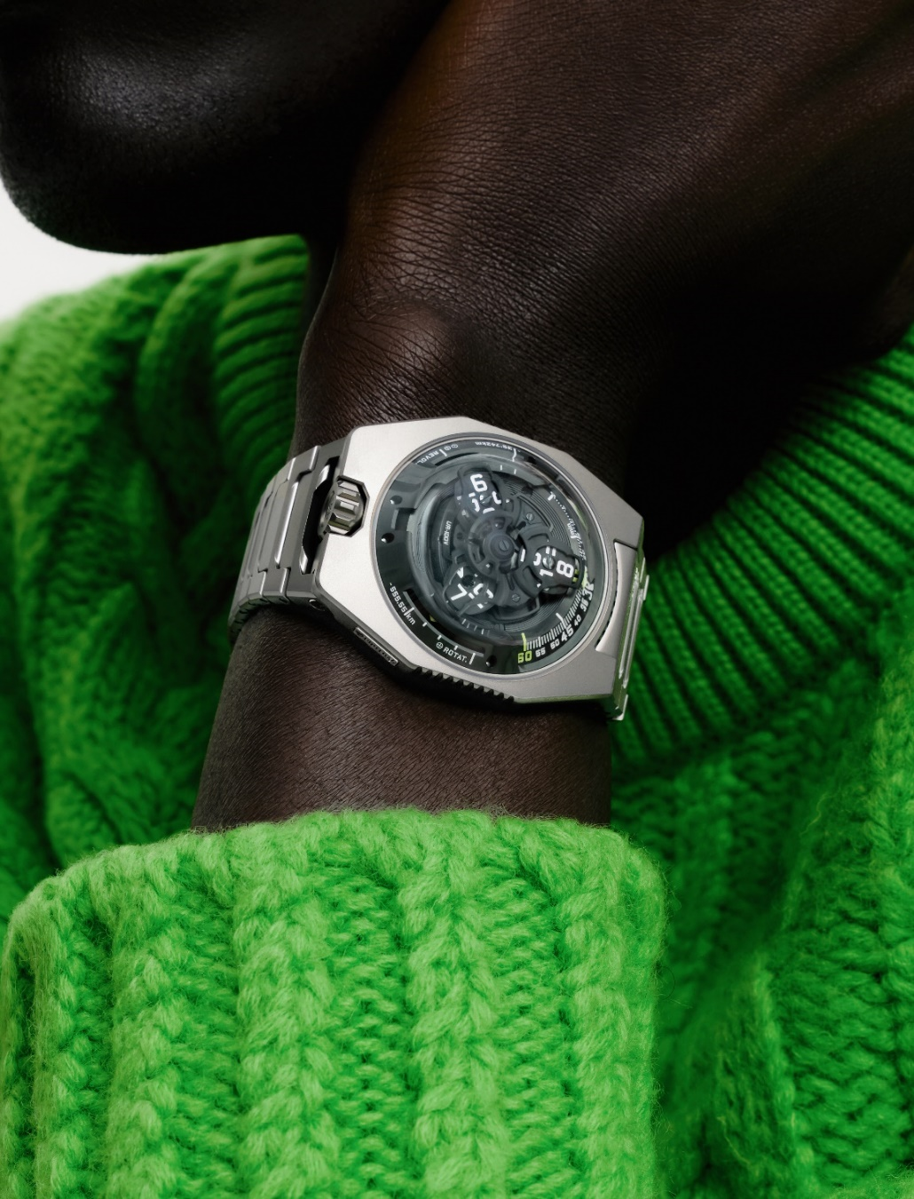

Felix Baumgartner, master watchmaker and co-founder of URWERK, adds: “We worked on this metallic ash green with the same devotion as an antique patina, endowing the timepiece with an aura that is both industrial and organic. We’ve emphasised the depth of the dial and retained the mesmerising magic of the titanium case and bracelet. Exploring this watch becomes almost a game of discovery through time and space.”

Simplicity and technical sophistication

The UR-100V ‘Hunter Green’ retains the essence of the 100 collection: perfect harmony between visual minimalism and cutting-edge watchmaking engineering. Martin Frei plays tirelessly with shapes in creating a unique aesthetic language, while Felix Baumgartner reinvents satellite-type wandering hours. There are no traditional hands here. The hours satellite crosses a graduated arc to indicate the minutes and once its 60 minutes are up, a new satellite bearing the next hour appears, in a poetic and precise mechanical choreography.

Inspired by a 17th-century clock, this watchmaking technology has been propelled into another dimension by URWERK. The UR-100V “Hunter Green” is both a tribute to – and a futuristic exploration – of space, volume and time.

A watch connected to space

The UR-100V doesn't just tell the time, it also features two unique counters:

The first displays the 555 kilometres covered by the Earth over a period of 20 minutes as it rotates on its own axis.

The second shows the 35,740 kilometres travelled by the Earth in 20 minutes as it revolves around the Sun.

The UR-100V ‘Hunter Green’ thus transcends its watchmaking function to become a silent witness to the Earth's trajectory in the sidereal vacuum, offering a colour new exploration in URWERK's epic and ongoing watchmaking saga.

UR-100V *Magic T* – “Hunter Green” edition

|  |  |  |  |  |  |  |  |  |  |  |  |  |  |  |  |  |  |  |  |  |  |  |  |  |  |  |  |  |  |  |  |
| --- | --- | --- | --- | --- | --- | --- | --- | --- | --- | --- | --- | --- | --- | --- | --- | --- | --- | --- | --- | --- | --- | --- | --- | --- | --- | --- | --- | --- | --- | --- | --- |
| |  |  | | --- | --- | | **Movement** |  | | Calibre | Self-winding UR 12.02 movement governed by a Windfänger airscrew | | Jewels | 40 | | Frequency | 28 800 v/h – 4 Hz | | Power reserve | 48 hours | | Materials | Satellite hours on beryllium-bronze Geneva crosses; aluminium carousel; carousel and triple baseplates in ARCAP alloy | | Finishing | Circular graining, sand-blasting, shot-blasting, circular satin finishing  Chamfered screw heads  Hours and minutes painted in Super-LumiNova® | | Indications | Satellite hours; minutes; rotational distance at the Equator in 20 minutes; orbital distance in 20 minutes | | **Case** |  | | Material | Sand-blasted, shot-blasted titanium. | | Dimensions | Width: 41 mm, length: 49.70 mm, thickness: 14 mm | | Glass | Sapphire crystal | | Water resistance | Pressure-tested at 3 ATM (30 m) | | Bracelet | Titanium with 32 sand-blasted and shot-blasted links | |  | **Price CHF 58,000 (Swiss francs, excl. tax)** | |  |

________________________________________

Contact:

Ms Yacine Sar [press@urwerk.com](mailto:press@urwerk.com)

+41 22 900 20 27 [www.urwerk.com/press](http://www.urwerk.com/press)

**URWERK**

Founded by Felix Baumgartner and Martin Frei, URWERK is the result of a strongly held belief that the history of Fine Watchmaking is a constantly changing art: “ Bringing out yet another version of an existing mechanical complications was never our aim ” explains watchmaker Felix Baumgartner, “Our watches are unique because they are all designed as original works, which makes them rare and priceless.” The original styling of each URWERK model is signed by chief designer Martin Frei. “I come from a background where creativeness has no limits. I am in no way prisoner of the traditional constraints of watchmaking, and I can therefore be freely inspired by my cultural heritage.”

Although URWERK is a young company established in 1997, it is recognised as one of the forerunners of the new wave known as nouvelle horlogerie. Producing just 150 watches a year, the company sees itself as a craftsman’s studio where traditional expertise coexists with avant-garde styling. The company manufactures modern and complex watches that are unprecedented and in keeping with the most demanding criteria of fine watchmaking: independent design and research, advanced materials and handcrafted finishes.

The name URWERK comes from the ancient city of Ur of the Chaldees in Mesopotamia, founded nearly 6,000 years ago where the Sumerian inhabitants first established units of time based on the shadows cast by its monuments. Ur in the German language also means primeval or original and Werk means an achievement or a mechanism. Thus URWERK can be translated as an original movement — a tribute to generations of watchmakers whose work has resulted in what we know today as haute horlogerie, or superlative watchmaking.