The UR-100V - "LightSpeed”
An odyssey through our cosmos

Geneva - 07 February 2024.
In an age when science fiction merges with reality, certain numerical values possess reassuring, pervasive and nearly immutable characteristics. These include the number 299,792,458 km/s. It's a mysterious figure relating as much to the physical theory of classical mechanics as it does with Azimov’s worlds of fantasy. It represents the ultimate speed: that of the propagation of energy, mastered only by the initiated. A pervasive constant, the speed of light symbolised by the letter "c".
This almost mystical number calls to mind both the foundations of Einstein's theory of relativity and the futuristic visions of a distant galaxy explored by the Jedi of Star Wars and the intrepid captains of Star Trek. Mastering this speed means plunging into hyperspace, defying the laws of physics and navigating through the universe’s multiple dimensions. An adventure worthy of the greatest explorers, from the Goa'uld tacticians in Stargate to the Spacing Guild navigators in Dune.

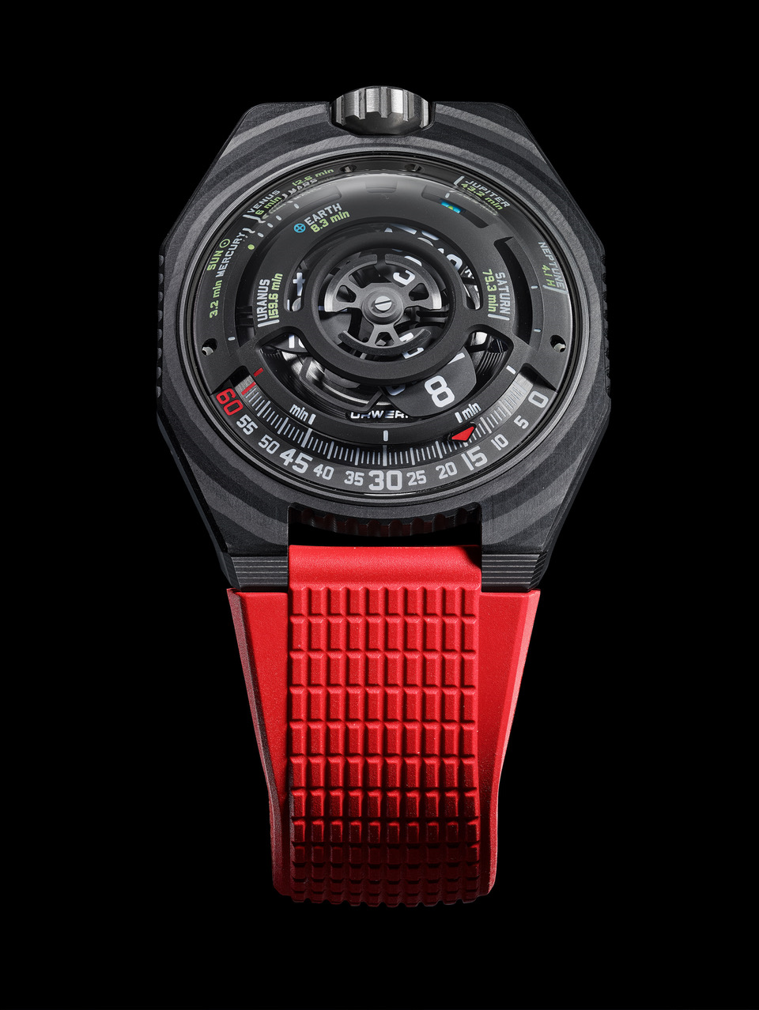
URWERK's UR-100V LightSpeed is the realisation of this dream, bringing Time, Space and Light together in a single place. URWERK’s artistic director and co-founder Martin Frei says: "Wearing this creation is like having a piece of the universe on your wrist, a vision of the cosmos in miniature, on a human scale.” The UR-100V LightSpeed houses a 3D planetarium featuring eight celestial bodies from our solar system, eight points of reference. "Starting from the Sun, we calculated and illustrated the time taken for a ray of light to reach each of the planets. The Sun’s rays take 8.3 minutes to reach the Earth, while the same ray reaches the surface of Jupiter 35 minutes later. A journey through space and time with light as the medium, the most magical of all vessels” he explains. "This is the story we were all told as children”, adds URWERK’s master watchmaker and co-founder Felix Baumgartner. “It is the one that explains our place on Earth, the immensity of the universe and our out-of-step relationship with the present moment: by the time the light of a star reaches us, that star has probably long since ceased to shine. What we see is no longer there; we perceive a time, a past that no longer exists.”

It's a fact. The Sun’s rays reach every planet in a specific measured time, reminding us of the dizzying distance and ephemeral beauty of our solar system. The light we see today is an echo of the past, an instant frozen in cosmic time. Within our space-time system, the Sun's light reaches Mercury in 3.2 minutes, Venus in 6 minutes, Earth in 8.3 minutes, Mars in 12.6 minutes, Jupiter in 43.2 minutes, Saturn in 79.3 minutes, Uranus in 159.6 minutes and Neptune in 4.1 hours. Such is the beauty embodied by the UR-100V LightSpeed, whose ultimate reference is the Sun, which inspires the rotor on the back of the timepiece.

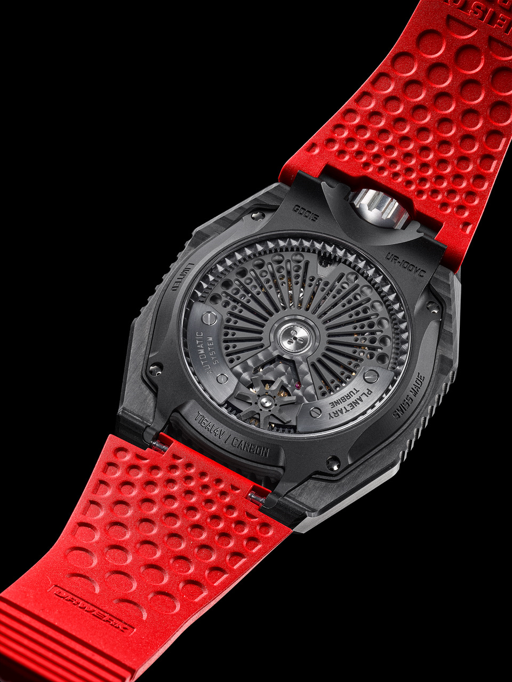
“Light serves as our connection to the Universe, representing the smallest unit of energy capable of being transmitted. Its electromagnetic radiations are precisely in the range that our eyes are attuned to detect. This ability to visualise and interpret this information reconstructs our perception of the world. Whether gazing at distant stars or peering though a microscope, light conveys essential details shaping our understanding of reality, continually expanding our knowledge and comprehension of the vast and intricate universe around us.” concludes Martin Frei.

In addition to its interstellar dimension, the UR-100V LightSpeed pick up the principle of displaying the hours and minutes, which is based on the absence of hands. Instead, a satellite moves along an arc of a graduated circle. The first carries the hours, the second the minutes. And when an hour satellite has covered its 60 minutes, the next one bearing the next hou, appears in front of the minutes index. No one could have imagined that this principle – extrapolated from a 17th century clock – could be so creatively thought out, transformed and transmuted in space, volume and time.

UR-100V “LightSpeed”

Movement
Calibre | Selfwinding UR 12.02 movement governed by a Windfänger airscrew
Jewels | 40
Frequency | 28 800 v/h – 4 Hz
Power reserve | 48 hours
Materials | Satellite hours in aluminium set on beryllium-bronze Geneva crosses; aluminium carousel; triple baseplates in ARCAP alloy, watertight titanium inner container; black PVD-treated aluminium rotor.
Finishing | Circular graining, sand-blasting, shot-blasting, circular satin finishing  Chamfered screw heads  Hours and minutes painted in Super-LumiNova®
Indications | Satellite hours; minutes; time required for a sunbeam to reach eight of the planets in the solar system.
Case

Materials | Black carbon (54-layer ThinPly). Caseback in sand-blasted, shot-blasted DLC-treated Grade 5 titanium.
Dimensions | Width : 43 mm, length : 51.73 mm, thickness : 14.55 mm
Glass | Sapphire crystal
Water resistance | Screw-down crown. Water-tightness chamber. Pressure-tested at 5ATM (50m)
Strap | Textured rubber with folding clasp
Price | CHF 65,000 (Swiss francs, excl. tax)

About URWERK

“Bringing out yet another version of an existing mechanical complication was not our aim”, says Felix Baumgartner, master-watchmaker and co-founder of URWERK. “Our watches are unique because each has been conceived as an original work. That is what makes them valuable and rare. Above all, we want to explore beyond the traditional horizons of watchmaking.” Martin Frei, chief designer and the other co-founder of URWERK, develops the aesthetic signature for each of the models. “I come from a world of total creative freedom. I’m not cast in the watchmaking mold, so i can draw my inspiration from my entire cultural heritage.”

While URWERK is a youthful company established in 1997, it is regarded as a pioneer on the independent watchmaking scene. Producing 150 watches per year, URWERK sees itself as a House of artisans where traditional expertise and avant-garde aesthetics coexist in perfect harmony. URWERK develops complex and modern watches unlike any others and meeting the most demanding Haute Horlogerie criteria: independent research and design, cutting-edge materials and hand-crafted finishing.

The roots of the name URWERK date back to 6000 BC and the Mesopotamian city known as Ur of the Chaldees. Observing the shadow cast by the sun on their monuments, the Sumerians first defined the unit of time as we know it today. The word “Ur” also means “beginnings” or “origins” in German and the last syllable of the URWERK signature also comes the same language, since “werk” means creating, working and innovation. A tribute to the constant work of successive master-watchmakers who have forged what we now refer to as Haute Horlogerie.

