The UR-100V LS Ceramic by URWERK

When time flies at the speed of light

Geneva, 4 February 2026.
There’s watchmaking that tells time – and then there’s watchmaking that chooses to ask questions, push the boundaries of our perceptions and challenge our certainties. The UR-100V ‘LightSpeed’ Ceramic is one such rare creation.
With this model URWERK proposes a reading of time that goes beyond earthly reference points. Here, mechanics do more than measure minutes, instead giving shape to a fundamental, universal phenomenon: the propagation of light through space.

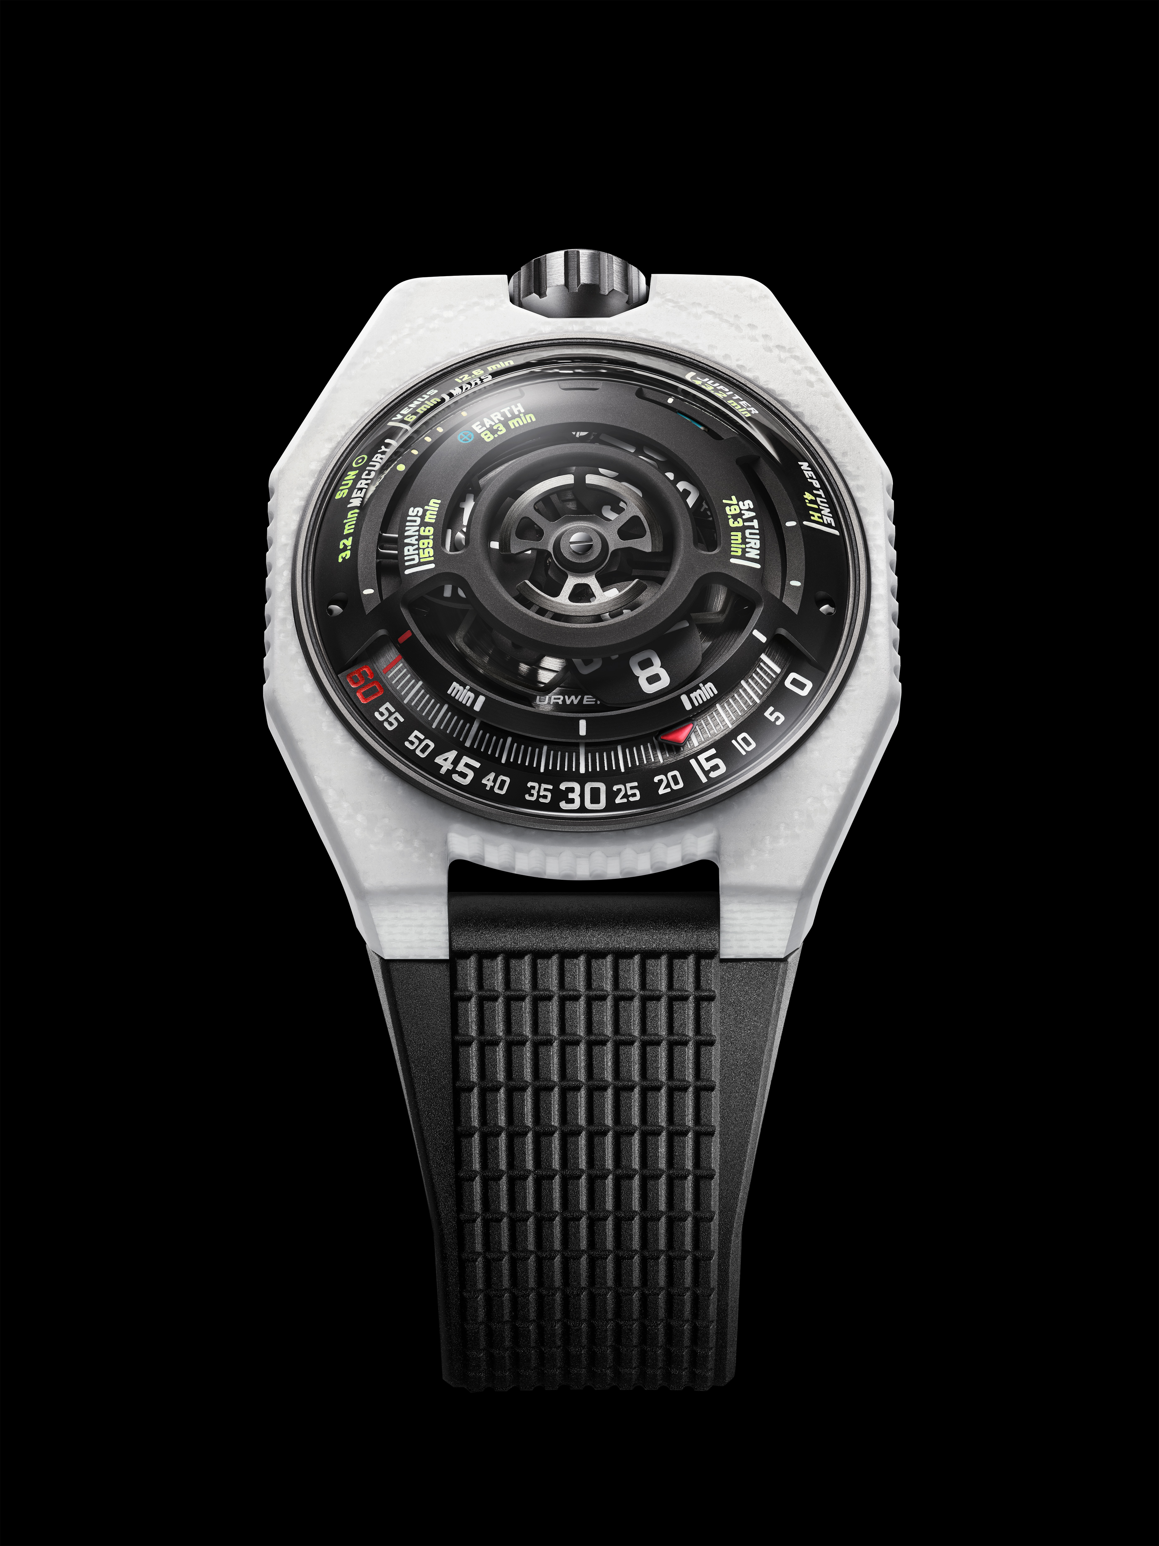

The principle is straightforward in intent, demanding in execution. An emblematic URWERK wandering hour satellite forsakes its conventional role of time teller to become a cosmic marker. The moment it leaves its minutes track, it begins to trace a real journey: that of a photon leaving the Sun and travelling toward the planets of the solar system. Time is no longer counted but traversed.
The UR-100V LS Ceramic expresses physical reality in a deliberately rigorous way. Each indication corresponds to a measurable distance, each movement to a precise scientific data point. The watch becomes an interface between the human scale and the cosmic order: a mechanical translation of astronomy that is readable on the wrist.

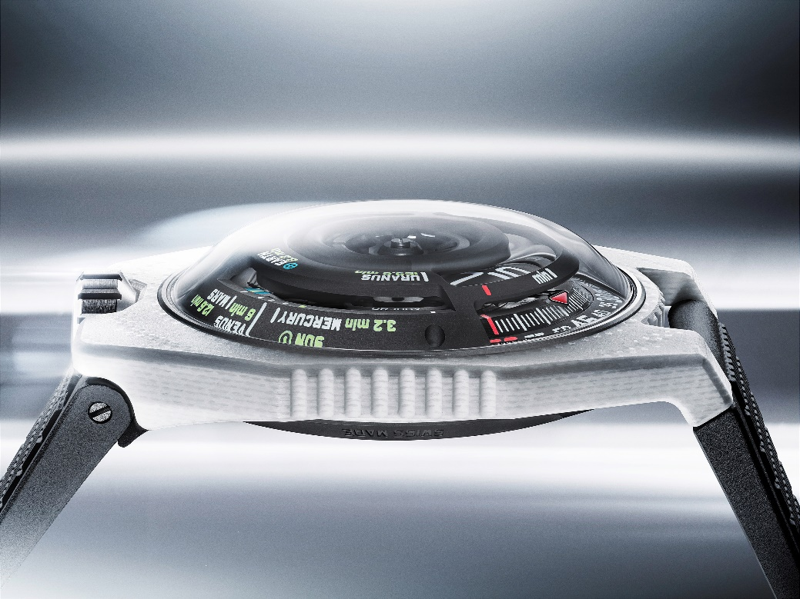

Within this context, light is not a metaphor, but rather a measurable reality. Massless particles of electromagnetic energy known as photons travel at a constant speed of 299,792 km per second. Born in the heart of the Sun, they require thousands of years to escape its dense core before crossing the vacuum of space unhindered, reaching Earth in just 8.3 minutes. What we perceive as immediacy is in fact delayed information. Every ray of light is a memory.

This scientific truth lies at the heart of the UR-100V LS Ceramic. In addition to its satellite hours and minutes, the watch incorporates a three-dimensional planetary display representing the eight planets of the solar system. Each position corresponds to the exact time required for sunlight to travel from the Sun to that planet. When the hours satellite leaves the minutes track, its role shifts. It no longer indicates time in the conventional sense, becoming a marker in motion and tracing the path of a photon across cosmic distances.

“Wearing this creation is like carrying a fragment of the universe on the wrist, a miniature vision of the cosmos scaled to human perception”, explains URWERK’s Artistic Director and co-founder Martin Frei. “By mapping astronomical distances onto the constrained geometry of a wristwatch dial, the transformation of scale reduces the effective velocity of light to a visually quasi-static motion, in which a constant physical speed is perceived as slow due solely to a change of reference and proportion. The sequence unfolds with scientific precision: sunlight reaches Mercury in 3.2 minutes, Venus in 6 minutes, Earth in 8.3 minutes, Mars in 12.6 minutes, Jupiter in 43.2 minutes, Saturn in 79.3 minutes, Uranus in 159.6 minutes and Neptune in 4.1 hours. More than a display of data, this complication offers a tangible sense of cosmic distance, offering an elegant reminder of how vast the universe truly is.”

Felix Baumgartner, Master Watchmaker and co-founder, extends this reflection into philosophical territory: “It is a story we are all told in childhood. It explains our place on Earth, the immensity of the universe and our paradoxical relationship with the present. When the light of a distant star reaches us, that star may have long since ceased to shine. What we see no longer exists and is never the present – only a memory.” The UR-100V LS Ceramic transforms this cosmic reality into a permanent reminder of time’s irreversible nature, expressed in mechanical form.

Material innovation reinforces this narrative. The case represents URWERK’s most advanced exploration of composite engineering to date. As Felix Baumgartner explains: “The extreme hardness of traditional ceramics is also their weakness due to their inherently brittle nature. When sintered at high temperatures, they can shatter under violent impacts. We wanted to move beyond that limitation, so we developed our own material. Thanks to the glass fibres and carbon it contains, our all-new ceramic composite does not break.” This polymer matrix integrating finely woven ceramic fibres alternating with layers of glass fibre and carbon uses technologies derived from aeronautics and medical laser-guided processes. The result combines the visual precision and durability of ceramic with a significantly enhanced resistance to shock: a material that is engineered, rather than decorated.

Aesthetically, the choice of white is deliberate. A specially developed white resin contrasts with the silver tones of the glass-fibre layers. Machining reveals a stratified structure, producing subtle visual depth. Depending on angles and lighting, the case oscillates between deep matt and soft luminescent variations that are not ornamental effects, but rather the natural expression of the material itself: controlled, yet never entirely predictable.

Martin Frei situates this aesthetic within a broader cultural reference: “A case made of white ceramics frames the black watch dial of the UR-100V LS Ceramic. The Dial represents a window into the deep blackness of space, pointing out the planets of our solar system. White is not a single colour, but an optical effect. It occurs when all visible wavelengths of light are present in balance. In materials, white results from surfaces that reflect and scatter most incoming light. There is no absolute white: it changes with illumination and contrast. White is therefore not a substance, but a state of light. In our new watch case, white ceramic and white light meet – both forms of energy revealed through their surface.”

The architecture is completed by a case measuring 43 mm wide, 51.73 mm long and 14.55 mm thick. Crafted from DLC-treated grade 5 titanium and micro-blasted, the caseback offers a full view of the rotor – an abstract evocation of the Sun – driving the mechanism.

At its core, the UR-100V LS Ceramic is powered by the UR 12.02 automatic calibre. Regulated by the Windfänger system, an air-resistance turbine controls winding efficiency, preventing excessive energy input. Beating at 28,800 vibrations per hour and delivering a 48-hour power reserve via twin barrels, the movement balances complexity with control. Forty jewels support a kinematic structure distributed across three ARCAP alloy plates, chosen for their stability. Aluminium hour satellites mounted on beryllium bronze Maltese crosses, an aluminium carousel and a black PVD-treated aluminium rotor complete the construction.

Finishing is purposeful rather than ornamental: circular graining, sandblasting, shot-blasting, and circular satin finishes structure the visible surfaces. Chamfered screw heads remain as a nod to horological tradition. Super-LumiNova® treatment on the hours and minutes indications ensures legibility without compromising the dial’s strict geometry.

The UR-100V LS Ceramic does not attempt to explain the universe. It does something more restrained and more demanding by translating a scientific reality into a mechanical experience: one that unfolds on the wrist, at human scale, while remaining anchored in the vastness of space.

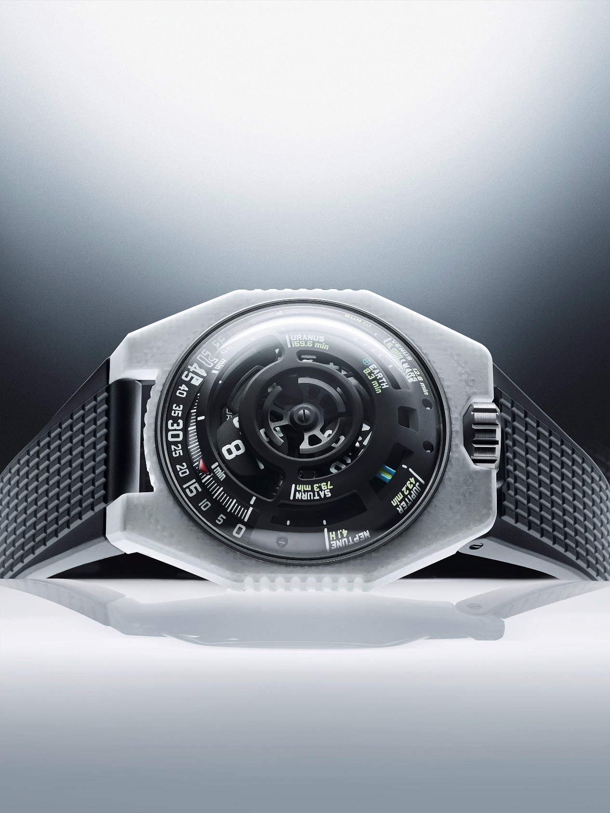

UR-100V “LightSpeed” Ceramic
Limited edition

Technical Specifications

Movement
Calibre | Selfwinding UR 12.02 movement governed by a Windfänger airscrew
Jewels | 40
Frequency | 28 800 v/h – 4 Hz
Power reserve | 48 hours
Materials | Satellite hours in aluminium set on beryllium-bronze Maltese crosses; aluminium carousel; triple baseplates in ARCAP alloy, watertight titanium inner container; black PVD-treated aluminium rotor.
Finishing | Circular graining, sandblasting, shot-blasting, circular satin finishing  Chamfered screw heads  Hours and minutes painted in Super-LumiNova®
Indications | Satellite hours; minutes; time required for a sunbeam to reach eight of the planets in the solar system.
Case
Materials | White ceramic developed for URWERK with silver fibreglass fabric and carbon inserts. Caseback in sand-blasted, shot-blasted DLC-treated Grade 5 titanium.
Dimensions | Width: 43 mm, length: 51.73 mm, thickness: 14.55 mm
Glass | Sapphire crystal
Water resistance | Screw-down crown. Pressure-tested at 5ATM (50m)
Strap | Textured rubber with folding clasp
Price | CHF 67,000 (Swiss francs, excl. tax)

_________________________________

Media contact:

Ms Yacine Sar +41 22 9002027
press@urwerk.com www.urwerk.com/press

About URWERK

“From the very beginning, we refused to confine ourselves to the well-worn path of traditional Grand Complications”, explains master watchmaker Felix Baumgartner, co-founder of URWERK. “Our aim has always been to push the boundaries of horology and to create timepieces that stand as original and singular craftsmanship.”
This spirit is echoed by Martin Frei, URWERK’s chief designer and fellow co-founder: “My artistic background is rooted in boundless creativity. Free from the constraints of classical watchmaking, I draw on my cultural heritage to forge a new design.”

Founded in 1997, URWERK is recognised today as a pioneer among independent watchmakers. With an annual production limited to around 150 timepieces, the Swiss brand operates as a true watchmaking laboratory – where cutting-edge technology meets radical design. Its creations revolve around three distinct lines: the Satellite collection, URWERK’s icon, where wandering hours redefine our perception of time; the Chronometry collection, a testing ground for precision and pioneering mechanics; and Special Projects, a platform for bold experimentation and radical ideas.

URWERK timepieces are modern, complex and unlike anything else, yet remain faithful to the highest standards of fine watchmaking: independent research, advanced materials and meticulous hand-finishing.

The name URWERK pays tribute both to the ancient and the avant-garde. It references the Mesopotamian city of Ur, where Sumerians first measured time by the shadows cast by monuments and draws on the German words Ur (primeval/original) and Werk (work/mechanism). Together, they express the idea of an “original mechanism” – the perfect symbol for a Maison dedicated to reimagining the very concept of time itself.

