URWERK UR-100 Gold Edition

Geneva - May 4, 2020
A long time ago in a galaxy far, far away, a spark shot out of the ether. Radio telescopes reveal that the shining golden object hurtling toward earth appears to be trying to communicate, emitting signals in six million languages. Could it be C-3PO, the protocol droid in the Star Wars saga? No, it is URWERK’s new yellow gold UR-100! This UR-100 also carries a message, but can communicate in the universal languages of the galaxies using light, time, space. But while C-3PO is often irritating and clumsy, albeit extremely polite, the UR-100 awakens six million forms of desire with horological daring and disruptive watchmaking.

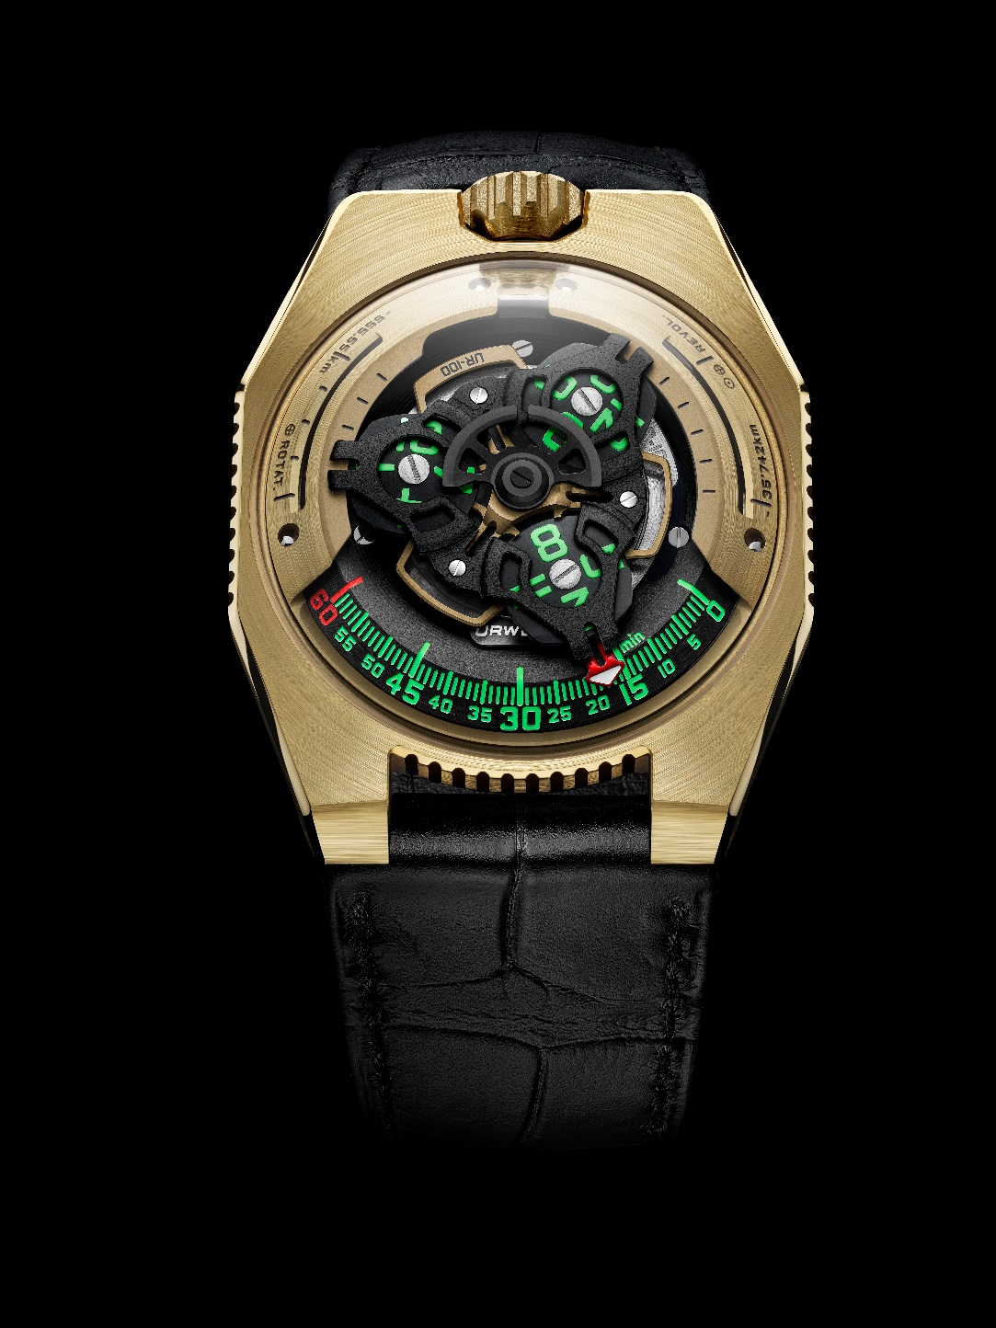
This new creation is the fourth episode in the UR-100 intergalactic saga, recounting the adventures of an atypical time instrument written, produced, and directed by the horological studio URWERK. Approaching light speed, the UR-100 pushes the boundaries of technology, design, indications, and functionality.

"Science fiction has been an inexhaustible source of inspiration since the creation of URWERK," explains co-founder Martin Frei. “I have been a sci-fi geek since childhood. My father was an engineer and worked on incredible projects, including the Apollo Lunar Rover. He was my hero and left me his love of the cosmos and his dreams. "

First and foremost, the UR-100 is slim – extra-flat for a satellite-geared watch – with angular contours; it’s an elongated octagon with three notched sides. The form uses subtle asymmetry, taking clues from Han Solo’s Millennium Falcon. This UR-100 is cut from a solid block of 2N yellow gold, its surface satin-finished to the same pale shine as the Star Wars droid. Topping the case is a sapphire crystal bubble reminiscent of the shape of the first URWERK models, the dome housing the control center of this intergalactic visitor.

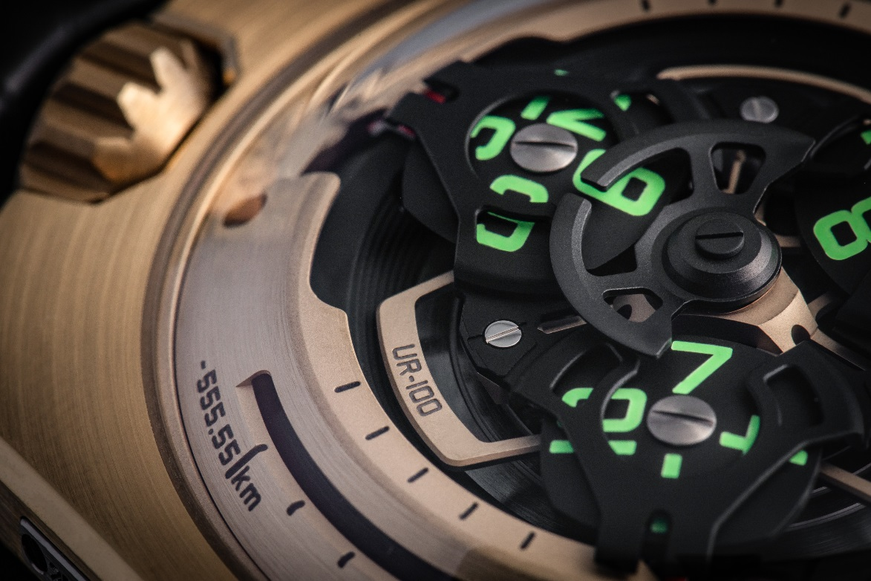

The UR-100’s astrophysics govern the URWERK universe with rotating satellites displaying the hours and minutes. Isochronal revolutions create a miniature cosmic ballet, the hour satellites also displaying minutes as they traverse 120 degrees across the bright green scale. A bold red arrowhead marks the confluence of hours and minutes, offering a unique, highly legible, and intuitive time display. Even while maneuvering at light speed, the automatic winding system is never overloaded thanks to the Windfänger’s regulation of the oscillating mass: this planetary gear limits the speed of rotation of the rotor, minimizing both excessive winding and wear and maximizing reliability and lifespan.
And last, but certainly not least, are the discreet spacetime indications on each side of the top of the dome’s periphery, which are both essential for intergalactic voyages and unique on planet earth. After each of the three red minute arrowheads pass the numeral 60 they disappear and then reappear again on two separate kilometer scales. The first display at 9 o'clock marks the 555 km traveled along the equator during 20 minutes of the earth’s rotation, the second display at 3 o'clock indicates the distance – 35,740 kilometers – traveled by the earth as it orbits the around the sun over 20 minutes. Spacetime never looked so good; Einstein would be proud!

While Star Wars’ famous C-3PO protocol droid is fanatical about respecting rules and conventions, the UR-100 « C-3PO » is fanatical about breaking rules and conventions. As the original C-3PO was reconstructed from heaps of scrap metal on the planet Tatooine, the UR-100 was meticulously assembled from high precision components in Geneva. And just as the lovable golden droid has cemented its place in the collective imagination of science fiction lovers, URWERK’s golden UR-100 carves out its own niche in the hearts of sci-watch aficionados.

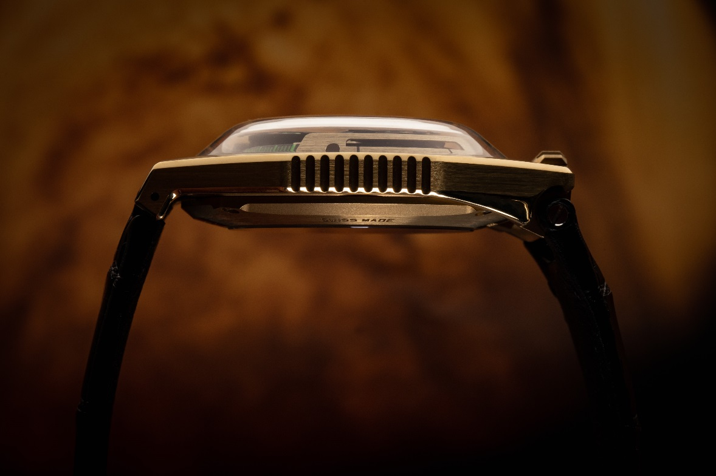

The First Gold UR-100 “Fight C-19” To Be Auctioned: Fighting Covid-19 With Horology

“The URWERK team doesn’t have doctors, nurses, cleaners, or even delivery personal. We are simply artisans realizing our dreams making watches. So to participate in the fight against Covid-19, URWERK will auction “Fight C-19”, the first UR-100 in gold, on the URWERK website, and distribute all money raised to organizations fighting against the COVID-19 pandemic.

The auction will begin at 4 pm GVA time on Friday the 8th of May, 2020, and run over two days.

URWERK will select which organizations fighting against Covid-19 in partnership with the successful bidder of the No. 1 gold UR-100 “Fight C-19”. For more information and/or to participate in the auction, please visit link : https://bit.ly/3bT2uKd

Technical specifications

UR-100 Gold edition – Limited edition of 25 pieces

Indications: Satellite hours; minutes; distance traveled on the Earth's equator in 20 minutes; distance traveled by Earth on its orbit around the sun in 20 minutes

Caliber: UR 12.01 with automatic winding system regulated by URWERK’s proprietary Windfänger system with helical and planetary gearing
Jewels: 39
Frequency: 4 Hz / 28,800 vph
Power reserve: 48 hours
Materials: Aluminum satellite hours on titanium Geneva crosses
Aluminum carousel
Triple bridges in ARCAP

Finishes: Circular grain, sandblasting, micro-blasting, strapping
Chamfered screw heads
Hour and minute index painted with Super-LumiNova

Case: Satin-finished 18k 2N yellow gold
Dimensions: Width 41 mm; length: 49.7 mm; thickness: 14 mm
Strap: leather

Glass: transparent sapphire crystal
Water resistance: 30 meters (3 ATM/3 Bar)

____________________

Media contact:
Ms Yacine Sar
press@urwerk.com
www.urwerk.com/press

