**THE UR-T8 “Raptor” by urwerk**

**a one-of-A-KIND MODEL TO SUPPORT THE MONACO RED CROSS**

Geneva, July 15th 2020.

**THE UR-T8 “Raptor” by urwerk, a one-of-A-MIND MODEL TO SUPPORT THE MONACO RED CROSS**

Geneva, August 25, 2020.

URWERK’s founders, Felix Baumgartner and Martin Frei count themselves lucky. “We’ve built up the company we envisaged, we live from our work and we’re backed by an outstanding team.” But the greatest satisfaction comes from giving something back. That is why the pair often support charity auctions that raise money for health and education. “As fathers, these are the issues that concern us most,” they declare.

For the benefit of the Monaco Red Cross, URWERK is presenting a one-of-a-kind watch for sale. It’s the UR-T8 Raptor, created especially for the Art in Time shop in Monaco, one of the few boutiques for independent watchmakers established at the initiative of Mr Karl Friedrich Scheufele.

With this in mind, URWERK presents the UR-T8 Raptor. The sale of this original one-of-a-kind model created for the retailer Art in Time / Monaco – a unique boutique dedicated to Independents initiated by Mr Karl-Friedrich Scheufele – is intended to benefit the Monaco Red Cross.

The UR-T8 is the ultimate timepiece. Designed to celebrate 20 years of URWERK, this UR-T8 is a distillation of the independent watch brand’s unique blend of expertise and craziness. To make it even more exceptional, talented metal engraver Johnny "King Nerd" Dowell has devoted his talent to creating a truly one-of-a-kind model by adorning the body of the UR-T8 with the reproduction of a scene worthy of the film *Jurassic Park*: two fearsome, larger-than-life Raptor heads.

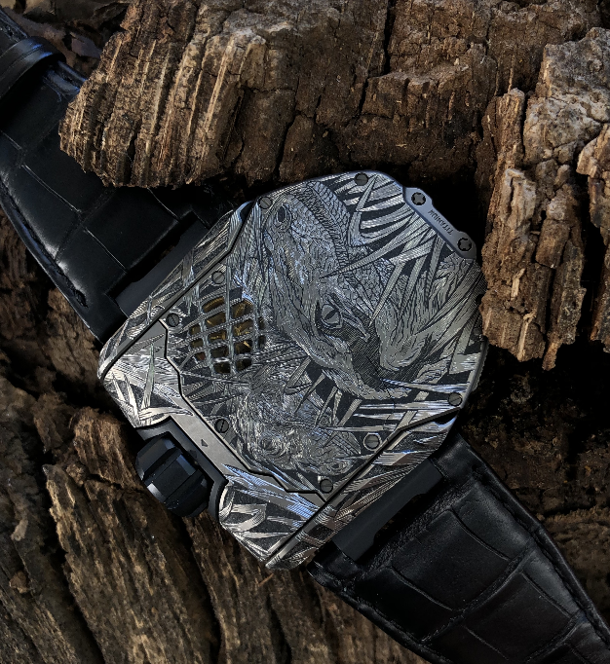

Launched in 2017 to commemorate the brand's 20th anniversary, the UR-T8 is URWERK's first "transformable" watch. A series of precise actions unlocks the case from its cradle, flips it over and returns it with a satisfying click to protect the time beneath a titanium and bronze shield.

Another press on the two buttons on the side of the case releases the mechanism, lifts it vertically, rotates it 180° about its axis and clicks it back into its cradle to return to its basic role as a watch.

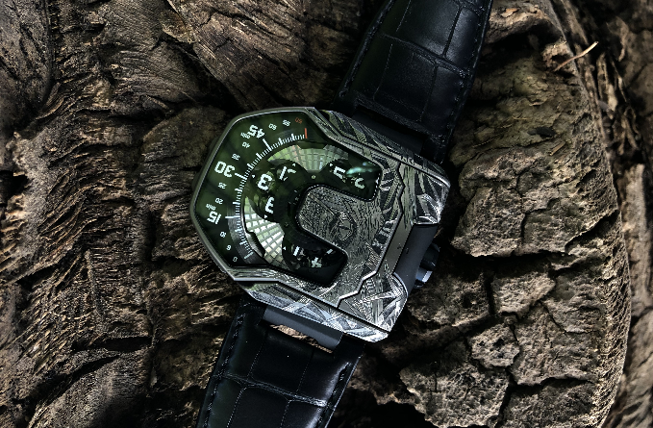

This model features a new version of URWERK’s signature wandering time indication: the most intuitive way to telling the time. The 12 hours in groups of four sweep successively across the 60-minute scale to display the time both digitally and analogically. This is the largest and most elaborate carousel configuration ever designed by URWERK. Each satellite rests on a carousel, which in turn is governed by a mega carousel. Complex planetary gearing transforms these intricately entwined watch jewels, wheels and screws into a meticulously orchestrated ballet.

Another unique URWERK technical feature is the turbine-regulated automatic winding. A turbine connected to the rotor ensures constant and linear winding of the UR-T8.

For URWERK designer and co-founder Martin Frei, a wristwatch is an object that invites interaction, appealing to your visual as well as to your tactile senses. You don't just wear your UR-T8, you engage with it. "Our UR-T8 of course recalls the Reverso watches, we have unstructured the concept to create a genuine URWERK model. The UR-T8 features all the characteristics that we have made our own: the huge crown, the organically shaped sapphire crystal, the textured case that invites your touch, a strong personality and a recognisable visual signature".

Its special aesthetic also owes a lot to the artistic work done by Johnny “King Nerd” Dowell: "When I was given the UR-T8 as a basis for my work, my eyes shone immediately. I was granted carte blanche to adorn the front and back of the watch and I had a lot of fun with it. The dark side of the case inspired me to create this slightly aggressive, dangerous, primitive pattern. I also indulged in one of my favourite exercises, working on shading and subtle colour gradients.”

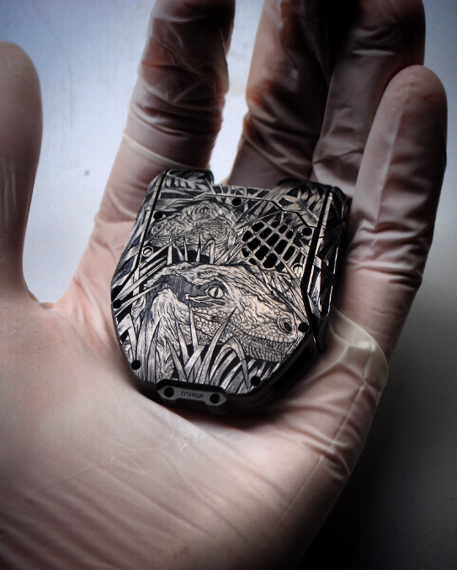

Under the impetus of the Art in Time boutique, this one-of-a-kind model will be auctioned off on behalf of the Monaco Red Cross, whose daily activities are dedicated to helping those in difficulty. As Karl-Friedrich Scheufele explained: "In the current context due to COVID-19, we felt it was important to support this humanitarian aid association, which has been on the front line of the fight against the pandemic in recent months. "

### Technical specifications of the UR-T8 “Raptor” (one-of-a-kind. model)

#### Movement

Calibre: UR 8.01 mechanical self-winding

Balance: Monometallic

Frequency 28 800 v/h, 4Hz

Balance-spring: Flat

Energy: Single barrel

Power reserve: 50 hours

Winding system: Turbine-regulated unidirectional rotor

Finishing: Satin-brushing, circular graining and diamond polishing

#### Spécifications

Satellite complication with hours/minutes rotation modules fitted on planetary gearing

#### Case

Transformer-type case in grade 5 titanium

Dimensions: 60.23mm X 48.35mm X 20.02mm

Water resistance: 3 ATM

_____________________________

CONTACTS :

Ms Yacine Sar

URWERK s.a.

+41 22 900 2027

[yacine@urwerk.com](mailto:yacine@urwerk.com)

[www.urwerk.com/press](http://www.urwerk.com/press)

ART IN TIME

ONE MONTE CARLO, Place du Casino

MC 98000 MONACO

Tél. (+377) 93 15 00 00

E-mail : [contact@art-in-time.com](mailto:contact@art-in-time.com)

CROIX-ROUGE MONÉGASQUE/MONACO REDCROSS

27 boulevard de Suisse

MC 98000 MONACO

Tél. (+377) 97 97 68 00

E-mail : [redcross@croix-rouge.mc](mailto:redcross@croix-rouge.mc)