URWERK’s UR-T8
Because you are only 20 once

URWERK celebrates its 20th birthday in 2017 in style. No fireworks, candles nor even congratulations but instead another opportunity to step out of the ordinary, to swim against the current and to amaze.
URWERK, the independent watchmaking company, today presents the UR-T8. It’s not only a new timepiece but an URWERK that could again transform our concept of the wristwatch.
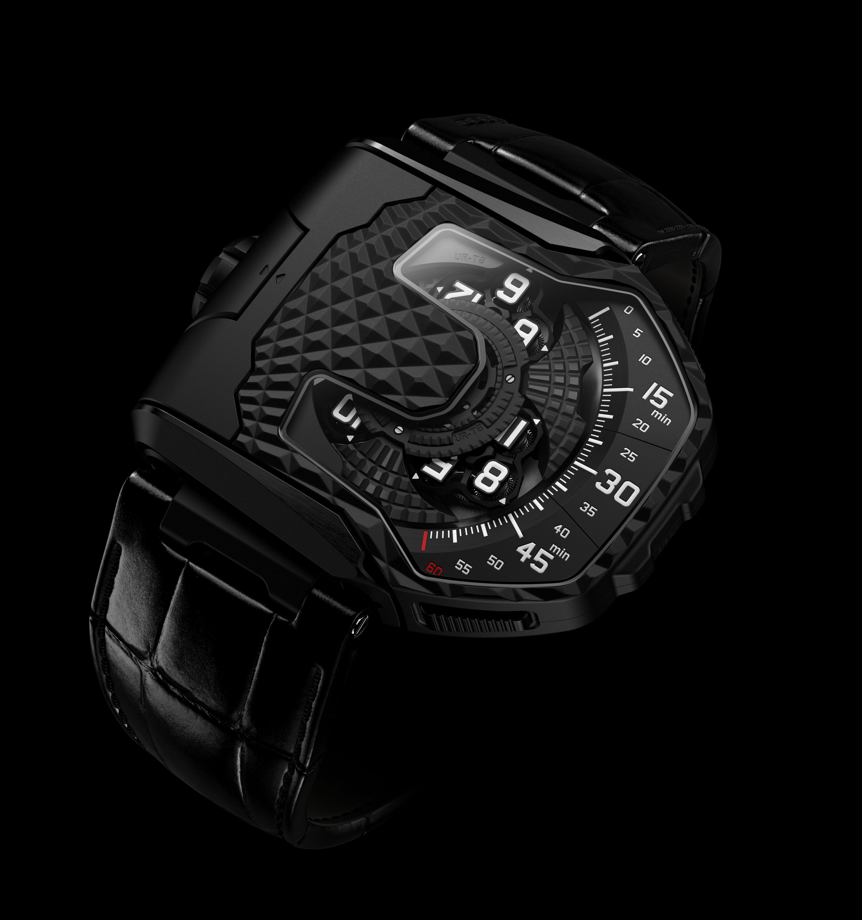

The UR-T8, which marks the 20th anniversary of the brand, is URWERK’s first transformable watch. A series of precise actions unlocks the case from its cradle, flips it over and returns it with a satisfying click to protect the time beneath a titanium shield.
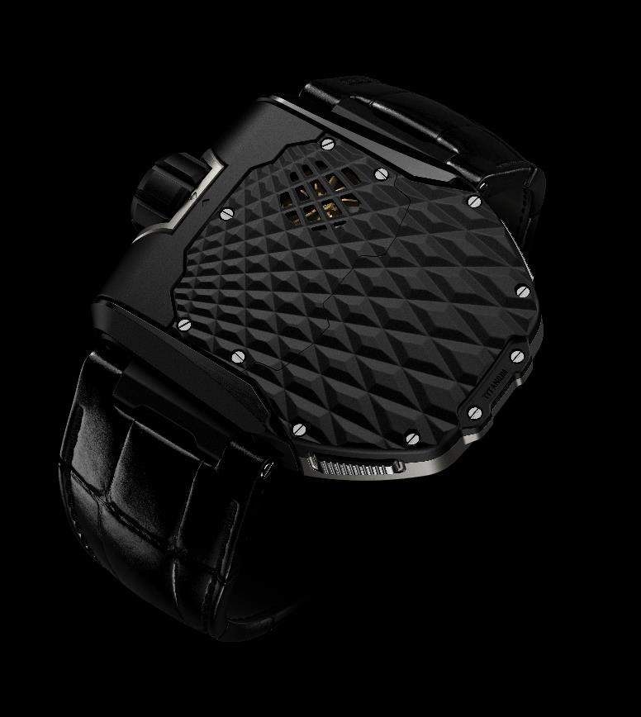

It then becomes a mystery object on your wrist. From its shape and its intriguing, highly textured pattern, it is impossible to guess that it is, or even could be, a wristwatch.
Squeeze again the two buttons on the side of the case to release it, lift it vertically, rotate it 180° about its axis and click it back into its cradle to return to the present time.

There you discover a new version of URWERK’s trademark wandering-hour indication — the most intuitive way of telling the time. The 12 hours in groups of four on a three-armed carousel successively sweep across the scale of 60 minutes to show the time both digitally and analogically. It is the biggest and most elaborate carousel configuration yet applied by URWERK, with each arm supporting a satellite carousel bearing the four hour numerals. A complex planetary gearing transforms a tangle of wheels, screws and jewel bearings into a meticulously orchestrated ballet.
Another technical feature unique to URWERK is the pneumatic control of the selfwinding system. A gilded spinning vane connected to the winding rotor absorbs any sudden and violent movements of the rotor without compromising its winding efficiency.

For URWERK’s designer and co-founder, Martin Frei, a wristwatch is an object that invites interaction, appealing to your visual as well as to your tactile senses. You don’t just wear your UR-T8, you engage with it. “Our UR-T8 of course recalls the Reverso watches, we have deconstructed the concept to create a genuine URWERK model. The UR-T8 features all the characteristics that we have made our own: the huge crown, the organically shaped sapphire-crystal glass, the textured case that invites your touch, a strong personality and a recognisable visual signature.”

URWERK’s convention-defying time indication and mechanical elegance are the result of painstaking efforts by the company’s chief watchmaker, Felix Baumgartner. “Our UR-T8 is a milestone in the story of URWERK. Our first 20 years were dominated by the wandering hour; the rest of the story has yet to be written for there are so many areas we have still to explore. It’s now the time to turn a page and we want to do it with style. “
Felix and Martin founded the company in 1997. Together they have developed an original vision of time, creating wristwatches that are revolutionary in both design and engineering.
The UR-T8, an exemplary expression of that vision, is available in an initial series of 60 watches in natural titanium or with a black PVD coating.

Technical Specifications UR-T8

Movement
Calibre: Selfwinding UR 8.01
Balance: Monometallic

Frequency: 28,800v/h, 4Hz
Balance spring: Flat
Power: Single barrel
Power reserve: 50 hours
Winding system: Uni-directional rotor connected to a spinning vane
Finish: Brushed, circular grained and diamond-cuts

Indications
Satellite complication with rotating hours modules mounted on planetary gears

Case
Flip-over case in Grade 5 titanium
Dimensions: 60.23mm X 48.35mm X 20.02mm
Water resistance: 3 ATM
________________________________
Media contact
Ms Yacine Sar - URWERK S.A.
press@urwerk.com
Direct line +41 22 900 2027 Mobile: +41 79 834 4665

ABOUT URWERK

“We don’t try to bring out new versions of existing complicated mechanisms,” explains watchmaker Felix Baumgartner, co-founder of Urwerk. “Our watches are unique because they are all designed as original works, which makes them rare and priceless. Our main aim is to go beyond the traditional horizons of watchmaking.” The original styling of each Urwerk model is signed by chief designer Martin Frei, the company’s other co-founder. “I come from a background where creativeness has no limits. I am in no way prisoner of the traditional constraints of watchmaking, and I can therefore be freely inspired by my cultural heritage.”

Although Urwerk is a young company established in 1997, it is recognised as one of the forerunners of the new wave known as nouvelle horlogerie. Producing just 150 watches a year, the company sees itself as a craftsman’s studio where traditional expertise coexists with avant-garde styling. The company manufactures modern and complex watches that are unprecedented and in keeping with the most demanding criteria of fine watchmaking: independent design and research, advanced materials and handcrafted finishes.

The name Urwerk comes from the ancient city of Ur of the Chaldees in Mesopotamia, founded nearly 6,000 years ago where the Sumerian inhabitants first established units of time based on the shadows cast by its monuments. Ur in the German language also means primeval or original and Werk means an achievement or a mechanism. Thus Urwerk can be translated as an original movement — a tribute to generations of watchmakers whose work has resulted in what we know today as haute horlogerie, or superlative watchmaking.

www.urwerk.com
-www.facebook.com/urwerk

