Moon Satellite
for Only Watch 2019

Geneva, September 23rd 2019

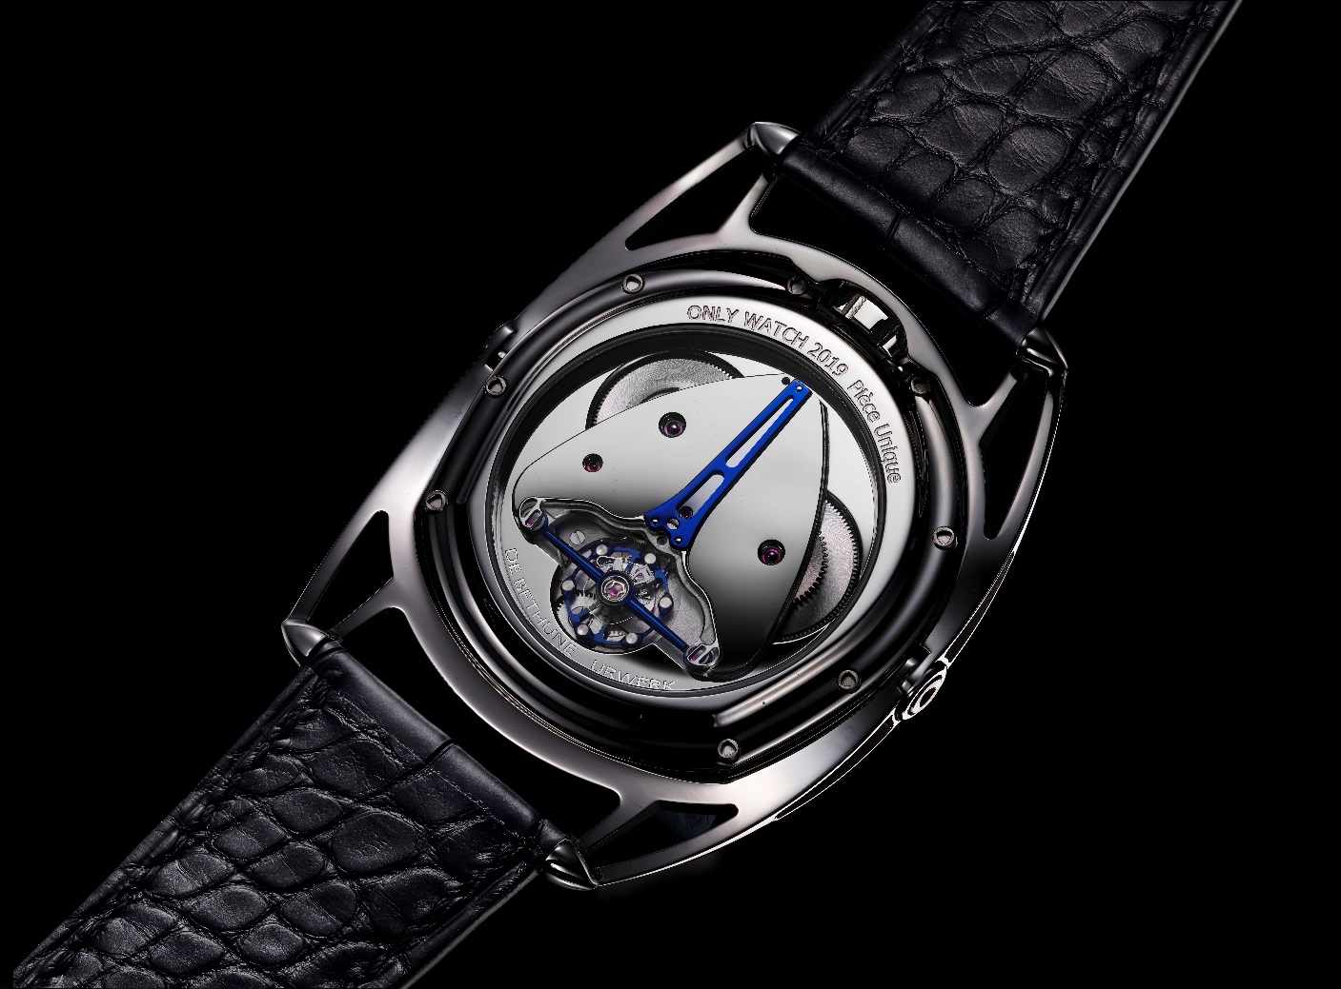
Moon Satellite
For Only Watch 2019

Technical specifications

Name: Moon Satellite for Only Watch 2019
Reference: OW19
Functions: Wandering hour satellite, Minutes, Spherical moon phase indication at 6 o’clock, Power reserve situated on the back
Movement: DB2105
Type: Mechanical hand-wound movement
Adjustment: Winding, setting the time and spherical moon phase adjustment by means of the crown (3 positions)

Technical features of calibre DBUR2105

Number of parts: 336
Jewelling: 37 jewels
Diameter: 30 mm
Power reserve: 4 days, ensured by a self-regulating twin barrel
De Bethune Innovation (2004)

Specificities:
Hour satellite indication designed by URWERK with triple base plate in ARCAAP; satellite in aluminum mounted on Geneva crosses in beryllium bronze. Hand painted SuperLuminova index.

Titanium balance wheel with white gold inserts, optimised for temperature differences and air penetration
De Bethune Patent (2016)

"De Bethune" balance-spring with flat terminal curve
De Bethune Patent (2006)

Silicon escape wheel

Spherical moon phase indication accurate to a degree of one lunar day every 122 years – De Bethune Patent (2004)

Triple pare-chute shock-absorbing system
De Bethune Innovation (2005)

Frequency: 28,800 vibrations per hour

Adornment: Concave plate covers and mirror-polished barrels bridge
Open worked and hand sailed barrels
Steel parts beveled and polished by hand

Case and strap

Case material: Polished grade 5 titanium
Case width: 43 mm
Case thickness: 13.3 mm
Lugs: Short or long floating lugs in polished grade 5 titanium
De Bethune Patent (2006)
Crystal: In sapphire crystal (1800 Vickers hardness) with double anti-reflective coating
Case back: Screwed case back in grade 5 polished titanium
Sapphire crystal (1800 Vickers hardness) with double anti-reflective coating
Water resistance: 3 ATM
Strap: Extra-supple alligator leather, alligator lining
Buckle: Pin buckle in polished grade 5 titanium

