A one-off signed DE BETHUNE x URWERK for Only Watch 2019

Expressing the perfection ofthe celestial order, this unique timepiece is a complex interaction of mechanismsspecific to De Bethune and Urwerk – a true fusion of their watchmaking genes.

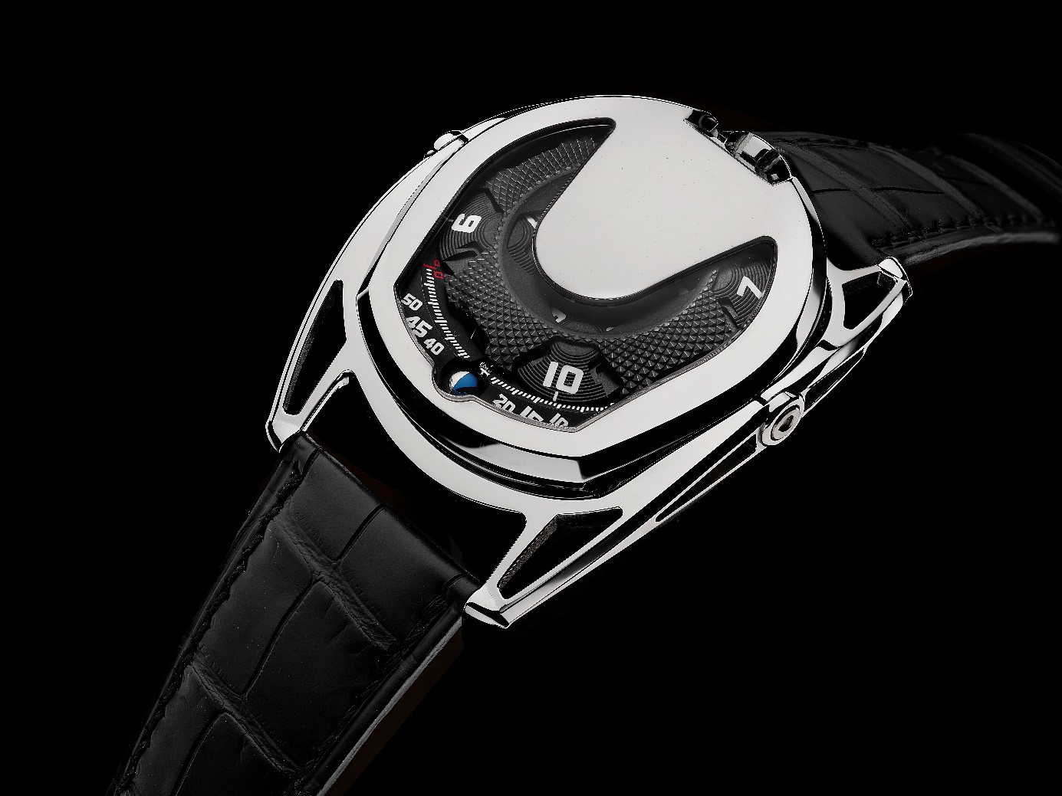

United we are stronger in the fight against disease. In support of the Only Watch biennial charity auction of unique timekeepers, two great independent watchmaking “Maisons” – De Bethune and Urwerk – joined their creative energies in bringing forth a timepiece that arouses curiosity, focuses attention and touches the senses. From the outside, a case that challenges established norms, fusing the design and function genetics of De Bethune and Urwerk with its floating lugs and the singular vibrancy of mirror polished titanium. Under the hood and curved sapphire crystal, a mechanical universe which amazes us with the one-off URDB01 caliber jointly developed for this very special auction – the crown at 12 o'clock, spherical moon phase, and Urwerk’s signature time indication with the now-famous satellite window in an arc that evokes the sun's curvature.
The collaboration
DE BETHUNE x URWERK is the story of four personalities, Denis Flageollet and Pierre Jacques at De Bethune, and Felix Baumgartner and Martin Frei at Urwerk. A story of mutual respect and implicit trust. The meeting of two ultra-creative and independent watchmaking minds, linked by a longstanding friendship, to donate for auction a truly original and highly desirable timepiece in support of the fight against Duchenne muscular dystrophy. 1 + 1 = 3.

