Pictures
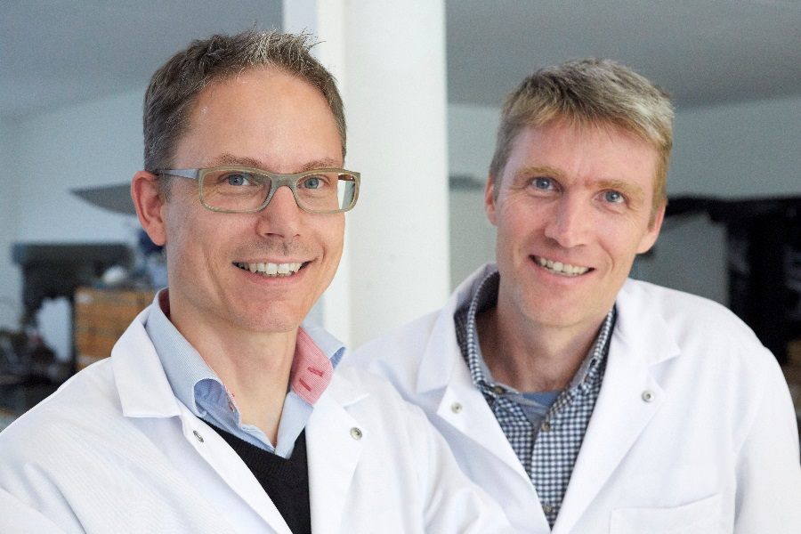

Watchmaking engineers Cyrano Devanthey (left) and Dominique Buser, are in charge of the R&D dept of URWERK. In their spare time they also teach at the watchmaking schools of Grenchen and Biel. They are joined in the Naissance d’une montre project by Dominique’s former star pupil, David Friedli.
Cyrano and Dominique were apprentices together at the Solothurn watchmaking school, graduating in 1994. Dominique went on to gain a masters in physics while Cyrano worked his way up to the head of Omega’s luxury watch division. They came together again in 2009 to set up a watch engineering workshop in Buchs working exclusively for the independent watch brand URWERK.

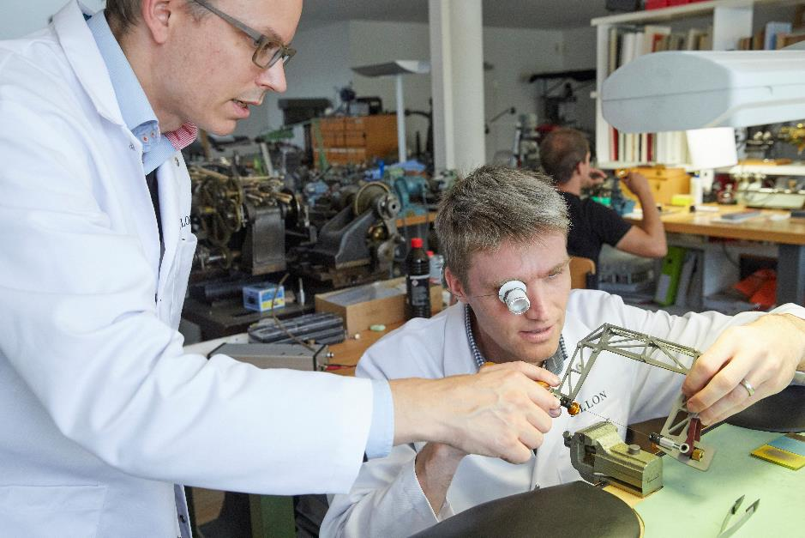
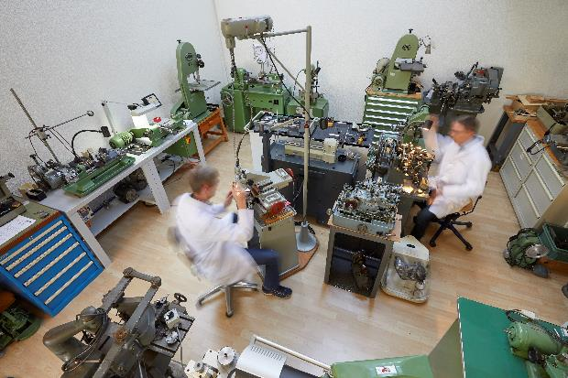

Dominique Buser and Cyrano Devanthey re-enact 1950s watchmaking in their museum workshop of traditional watchmaking tools. Determined to make watches in the old way, they collected and restored pre-electronic tools, the earliest dating from the 19th century and the latest built in the 1960s. The tools they are using were the very best of their era, wonderfully precise in skilled hands. Yet, if one of Abraham-Louis Breguet’s watchmakers or an 18th-century Geneva cabinotier were to walk into Devanthey and Buser’s workshop they would have no trouble operating its pantographs, lathes and Jacot tools.

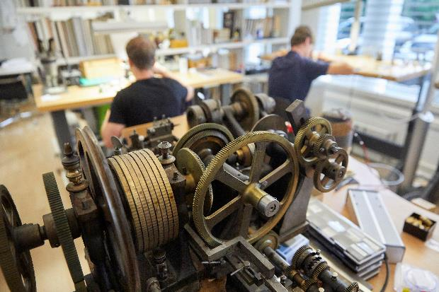

The steam-punk machinery in the foreground is a rare rose engine that engraves straight-line as well as circular patterns. The fashion for engine-turned dials has put these antique machines in demand and they are increasingly hard to come by.

