PICTURES

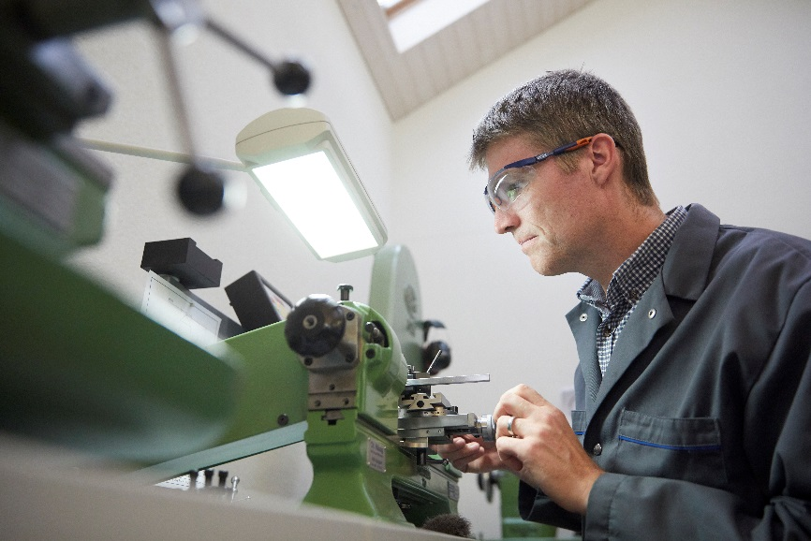

Dominique Buser turns the blanks for the screws on the workshop’s Schäublin 70 lathe, and cuts the threads using a die.

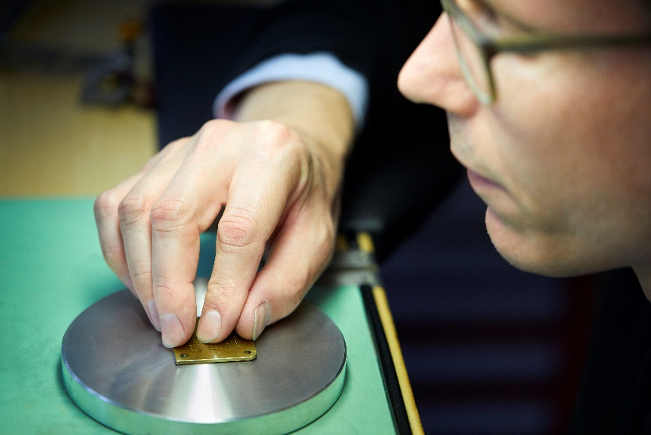

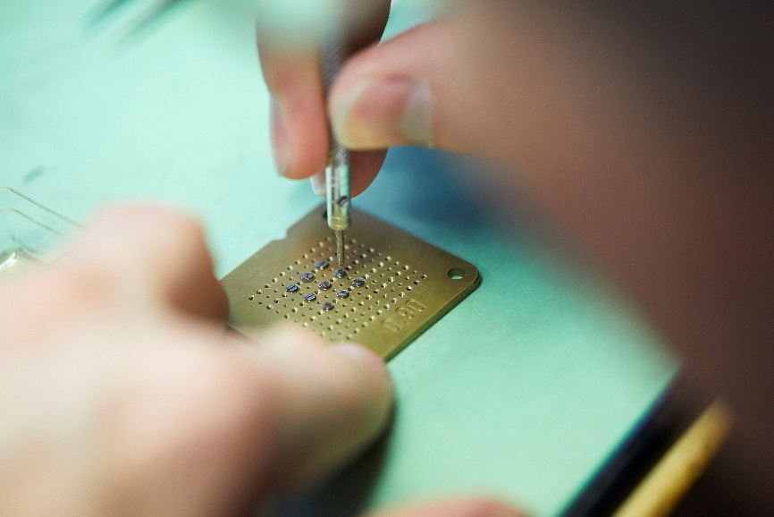

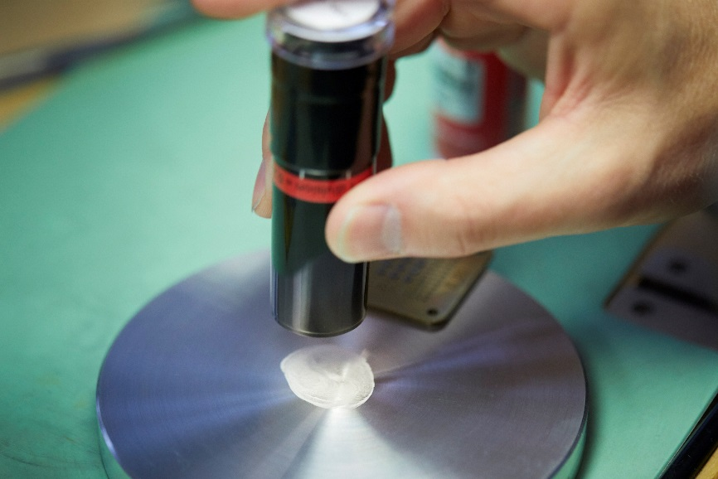

The screws are screwed into a holder while diamond polishing paste is prepared on a tin plate. The heads of the screws are ground flat and polished to a mirror finish.

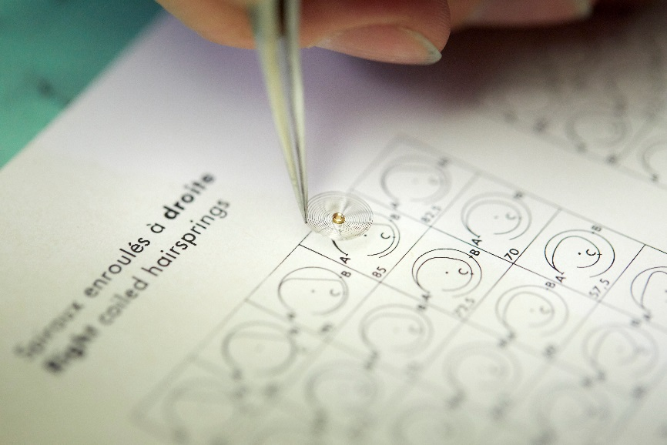

Buser and Devanthey chose a Phillips terminal curve from the different available patterns for the hairspring of Naissance d’une Montre 2.

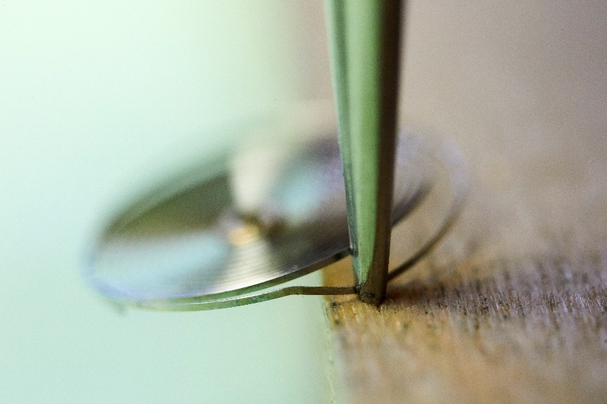

Bending the terminal curve of a hairspring, determining its proper length, and fitting it to the balance are jobs that require such a delicate touch that they have traditionally been done by women.

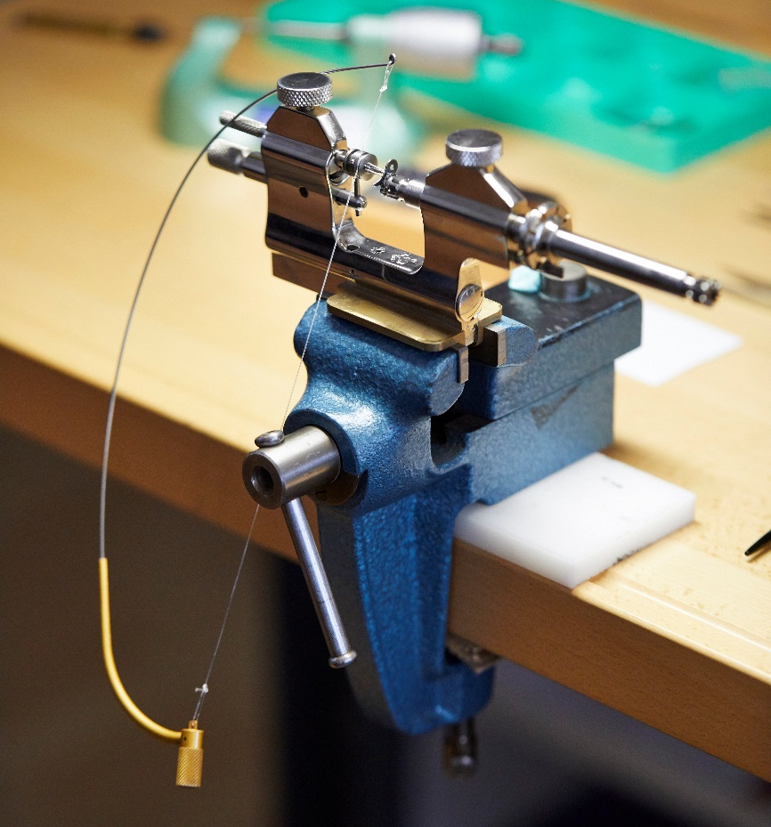

The Jacot tool, complete with bow, would be instantly familiar to a watchmaker of the 18th century.

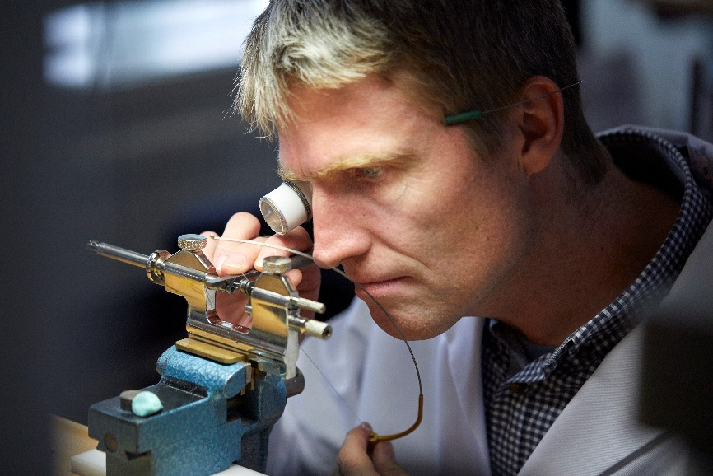

Dominic Buser rotates the spindle of the Jacot tool with a bow while burnishing and rounding a pivot for one of the train wheels.
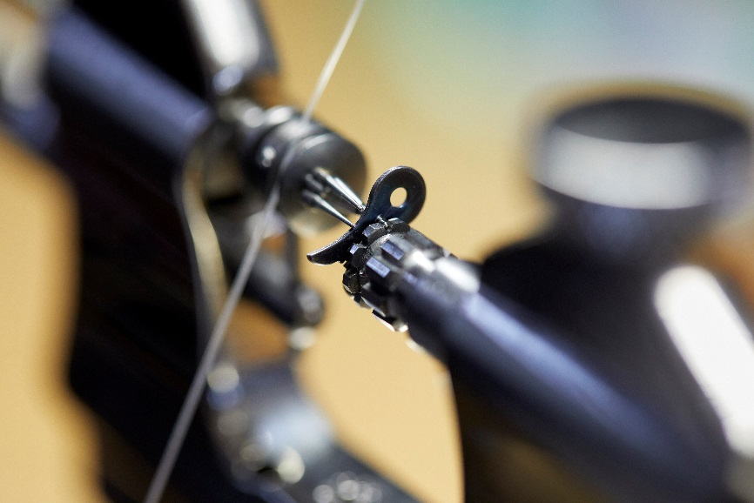

The pivot is held in a clip rotated by a shaft of the spindle. Nylon has replaced horsehair in modern bowstrings.

