Pictures

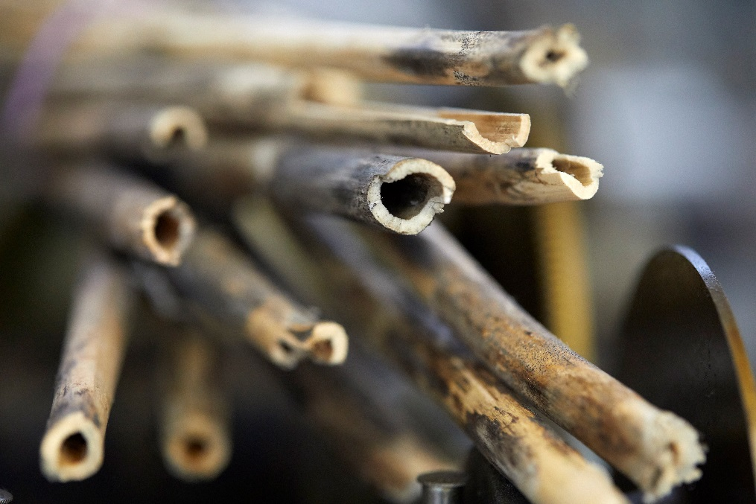
Gentian sticks. The wood used here is a present from Philippe Dufour himself.

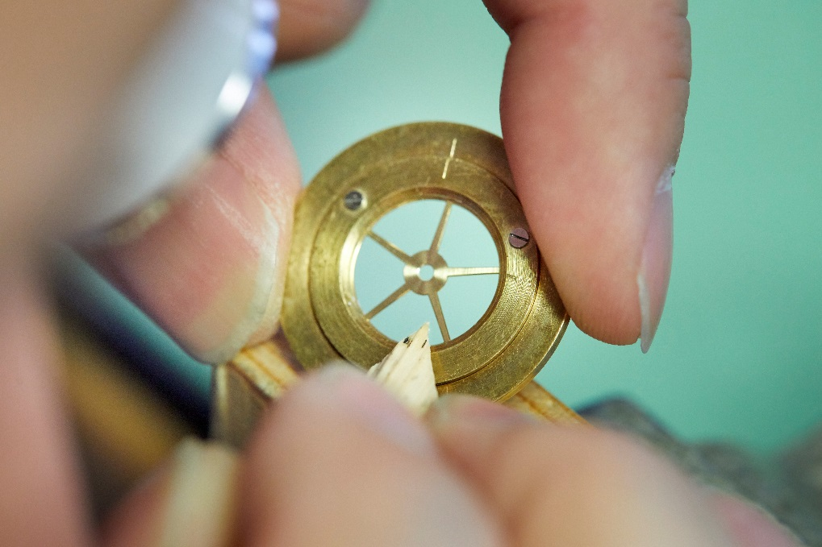
Cleaning chamfer.
The workshop’s collection of carefully selected gentian stalks provides the raw material for a unique hand-crafted tool used to impart the finishing touches to a wheel chamfer.

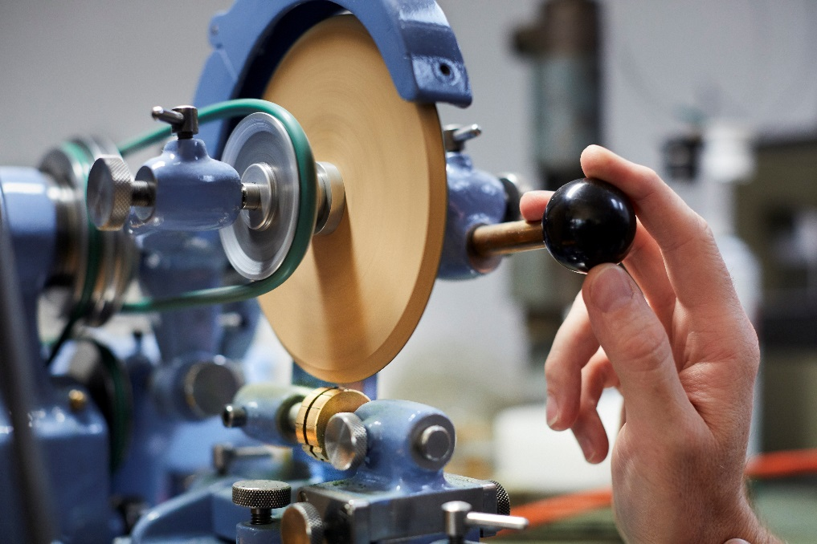
Medium density fibreboard disk.
A fast spinning wood disk polishes the steep valleys between the leaves of a tiny pinion, barely visible on the brass holder. The amount of pressure on the lever needed to polish the floor of the valley without ruining the piece can only be felt.

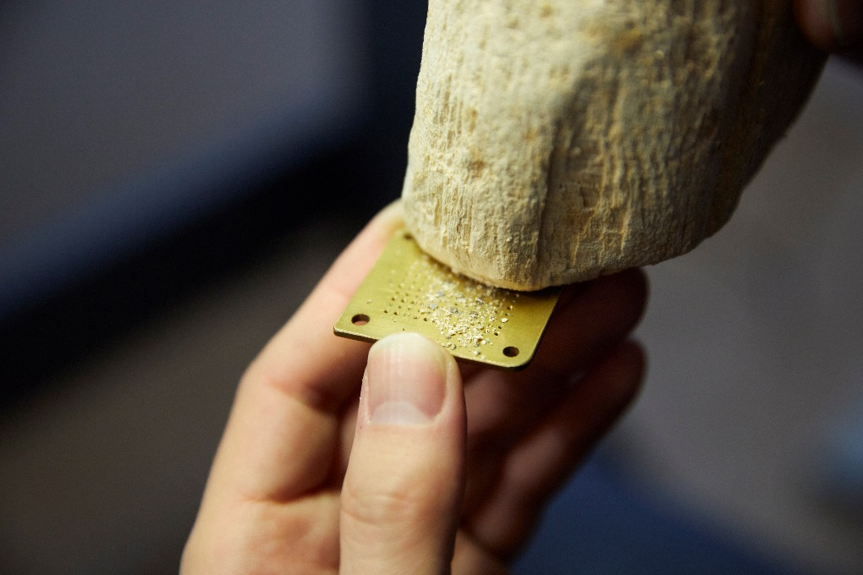
Rotten wood.
Tip from Philippe Dufour: use a piece of wood with dry rot to remove the polishing paste from screw heads without marking their mirror finish.

