«I am the son and the grandson of watchmakers. Horology is in my blood. The first musical concert I remember was played by the more than 50 clocks tick-tocking in my father’s atelier in our home. I was a watchmaker by birth and am now a watchmaker by passion."
Felix Baumgartner, URWERK founding partner and master watchmaker

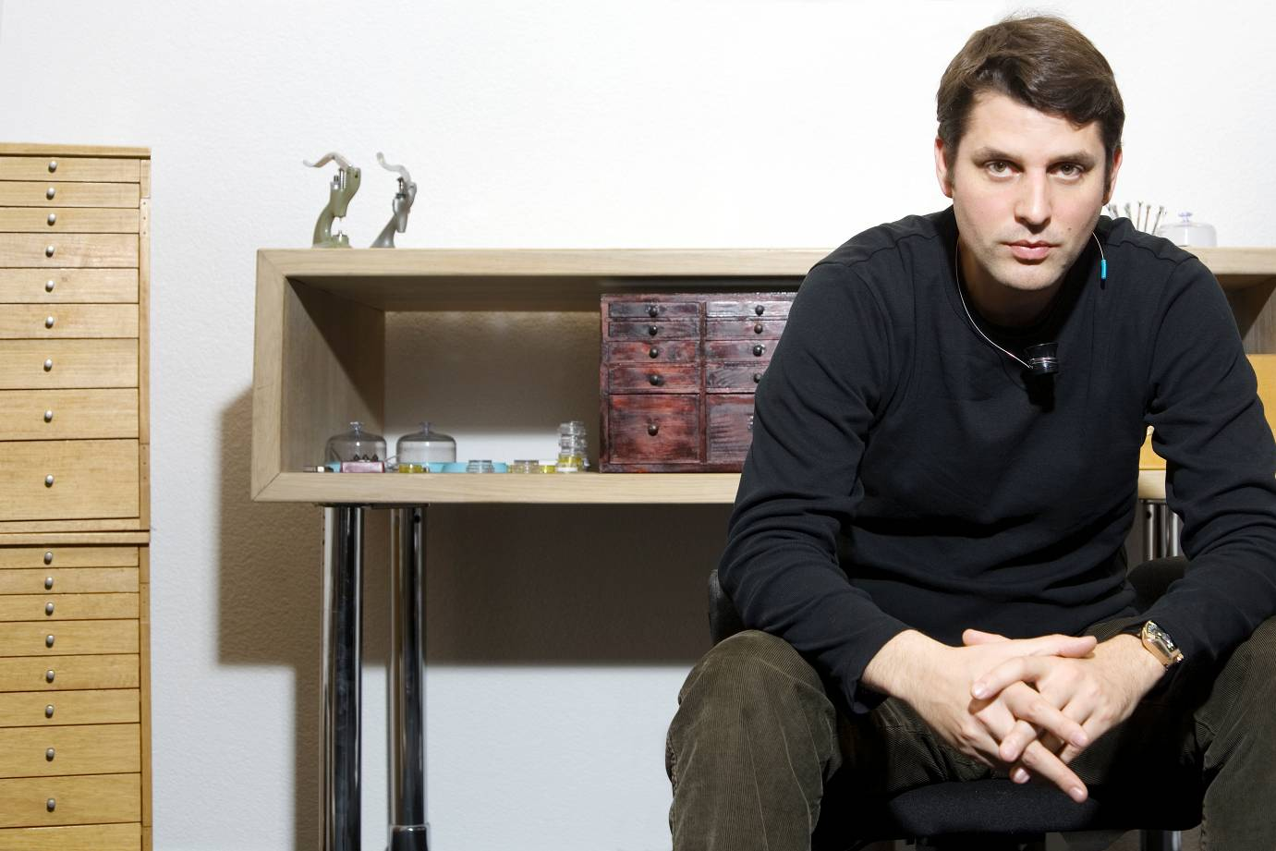

1975 Born in Schaffhausen (Switzerland) into a watchmaking family. Childhood surrounded by exceptional and complicated timepieces in his father's restoration atelier and this forges his horological culture.

1992 Enrols in the prestigious watchmaking school in Solothurn.

1995 Moves to Geneva to work as an independent watchmaker. Develops complicated watches, including perpetual calendars and minute repeaters, as well as restoration commissions for prestigious brands.
Milestone meeting in Zurich with brother Thomas and kindred spirit Martin Frei: start to dream about creating their own timepieces.

1997 Co-founds URWERK s.a. with Thomas Baumgartner and Martin Frei. Their goal: to design and craft watches of a unique style.
Presents first watch at Basel with the AHCI: the UR-101.

1998 Felix Baumgartner is officially inducted into the prestigious AHCI (Horological Academy of Independent Creators).

2003 URWERK unveils the UR-103.01. This model really put the brand on the horological map.

2007 URWERK unveils the UR-201 with its original patented revolting satellite complication.

2013 URWERK unveils the EMC, the first very mechanical timepiece with integrated intelligence. A world first.
The watch is honoured with both the “Mechanical exception” and “Innovation” prizes at the Grand Prix d’Horlogerie de Genève 2014.

2017 URWERK celebrates its 20th anniversary. The independent company employs 17 people, 12 of them watchmakers. It maintains a steady production of no more than 150 watches a year.

2019 In the spirit of Breguet’s inspiration of more than 220 years ago, URWERK designs and is producing the very first Sympathique clock inter connecting a mechanical watch and an atomic clock as time reference.
The watch is honoured with the “Audace” prize at the Grand Prix d’Horlogerie de Genève 2019 rewarding the best watch which features a non-conformist, offbeat approach to watchmaking.

