URWERK presents the EMC: The first high-end mechanical watch with “artificial intelligence”

Singapore, August 28th, 2013
For URWERK, a precision timepiece should have at its base a movement that is accurate, reliable and long lasting. Such a movement should meet specific criteria including accuracy in 5 positions between -4 seconds and +6 seconds over 24 hours. However, while it is one thing to regulate an accurate watch in the controlled world of a workshop, performance in the sometimes-extreme real world, i.e. on the wrist, can be very different. Changes in position and temperature, and shocks, can all adversely affect isochronism (timing regularity) of a wristwatch. The challenge with EMC was in developing a mechanical watch that can be regulated by its owner to obtain the finest chronometric performance. EMC is the first precision mechanical watch that enables timing to be both easily monitored and easily adjusted by its owner.

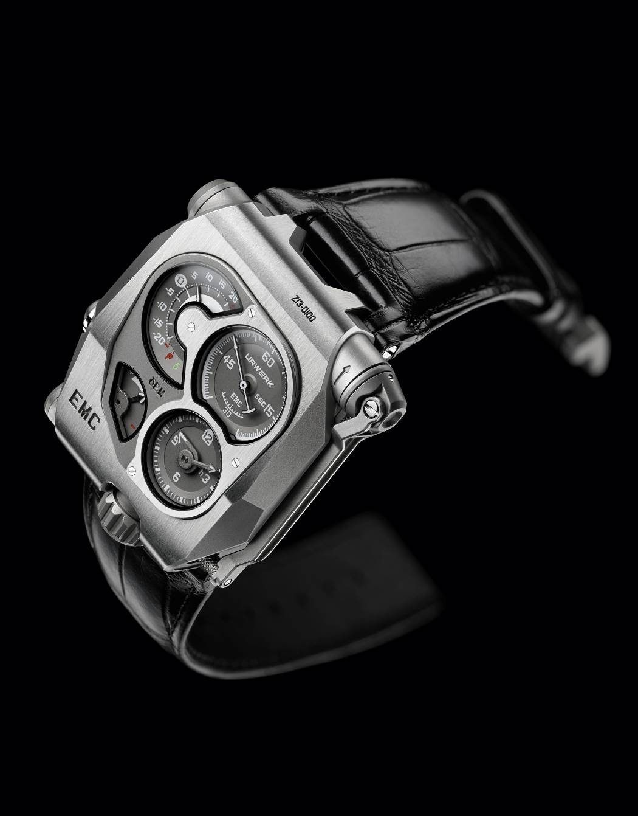

With EMC, not only can the wearer obtain the precise timing rate on demand, they can then use that information to accurately adjust the timing of their watch to suit their own personal rhythm. Electro Mechanical Control (EMC) is the world's first precision mechanical watch in which the timing can be monitored and adjusted by the user to suit their lifestyle – EMC is fully interactive.
Please note that EMC is a fully 100% mechanical watch. The electronics have absolutely no effect on the movement; they only enable monitoring of the movement's precision in a similar way that the electronic speedometer or rev counter of a car has no effect on the mechanical engine and gearbox.

EMC features a deconstructed dial with four separate indications: A clockwise tour of the displays, from top left, presents the: on demand, precision indicator (instantaneous rate delta δ) ranging from -20 to + 20 seconds per day; seconds dial with counter-balanced seconds hand; hours and minutes; and 80-hour power reserve indicator. Turning EMC over reveals the fully in-house movement with the integrated circuit board – the EMC 'brain' –, the top of one of the two mainspring barrels near the crown and the top of the balance wheel and optical sensor on the winding handle side.
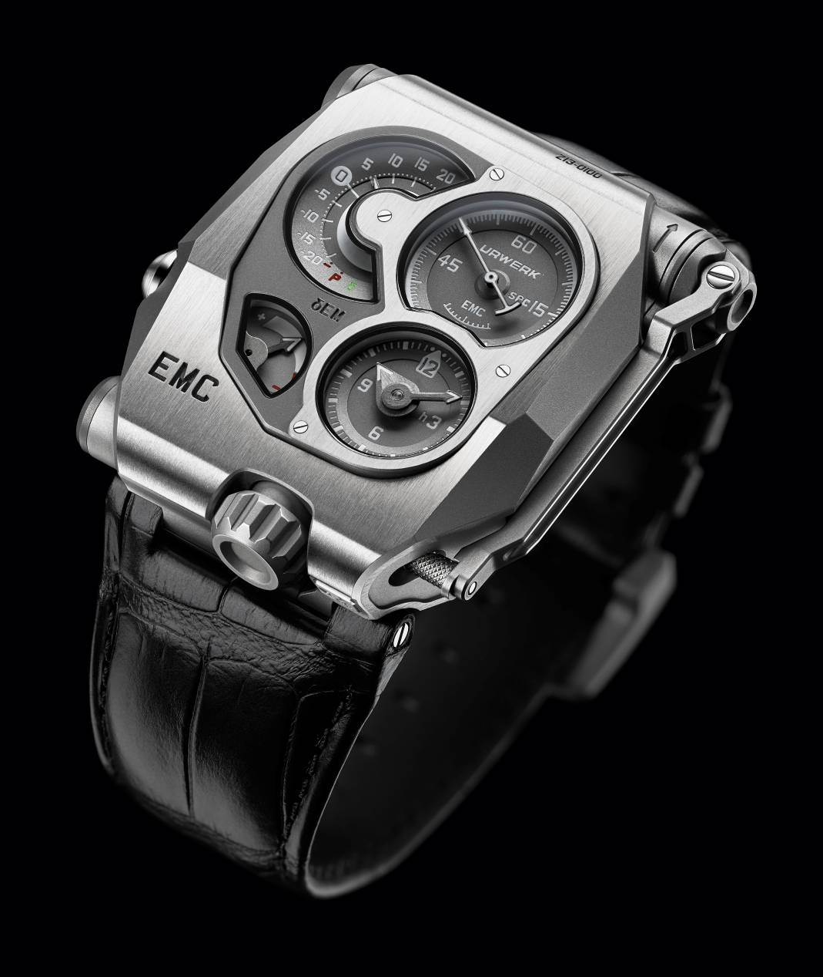

“Our idea for ​​EMC goes back almost six years and is a natural continuation of my work as a watchmaker," says Felix Baumgartner, co-founder of URWERK. “Like all watchmakers, I have on my bench a Witschi – an instrument to test the precision of my work. This impartial and uncompromising judge ‘listens’ to the rhythm of the balance and makes a verdict on the performance of the movement by measuring the timing rate, the number of seconds the movement gains or loses in 24 hours. This device is what I always refer back to; you might say it’s my only boss in the atelier!”
The audacious idea to incorporate a Witschi-like measuring instrument in a mechanical watch became a veritable quest for URWERK. “EMC allows you to obtain a reliable and accurate piece of data on your timepiece at the touch of a button – information that until now has been the preserve of professional watchmakers,” says Baumgartner. “Using this information, you can fine-tune one of the most exciting, most jubilant mechanisms invented – the mechanical watch – all by yourself.”
At its heart, EMC has a triple objective: to show how external parameters (positional changes, temperature and pressure) influence the timing of the movement; to enable the wearer to adjust the timing; and to facilitate interactivity between the timepiece and its owner.
EMC is inherently a precision mechanical watch with an in-house movement conceived, developed and crafted in the URWERK ateliers in Zurich and calibrated by URWERK in Geneva. The movement meets the most stringent quality control, with its chronometric performance tested in five positions during a 30-day cycle to ensure that it meets the highest standards for a precision watch.

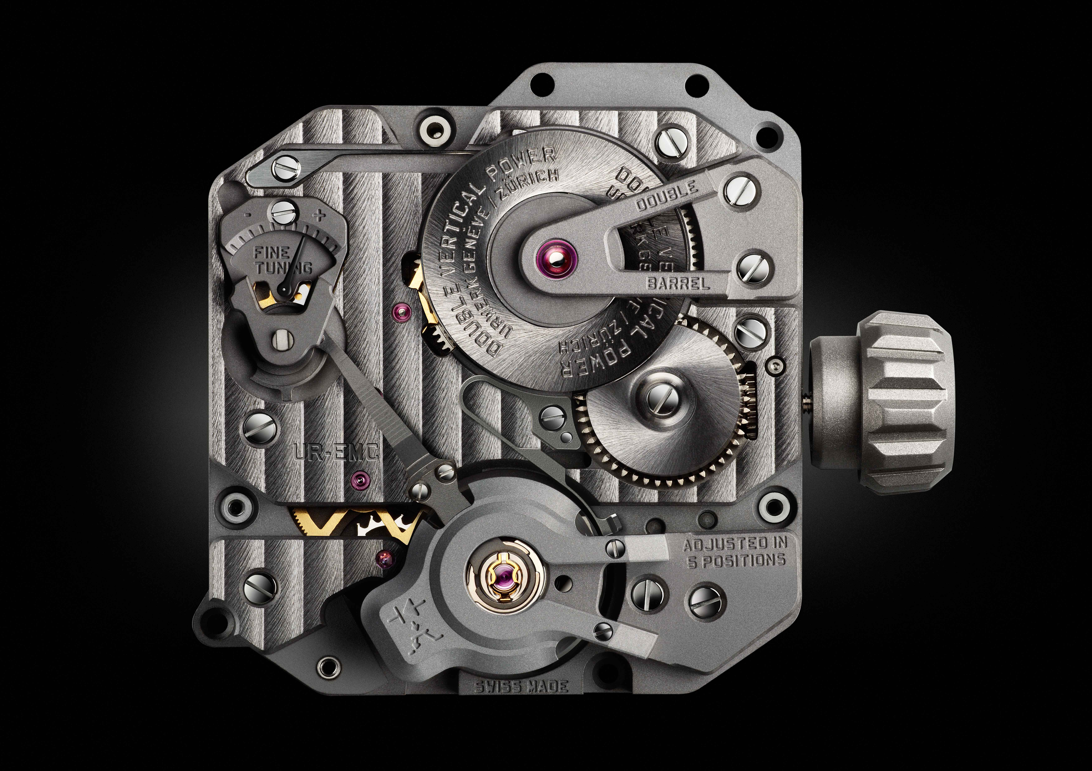
EMC movement is equipped with the following features:
- A bespoke balance wheel made of ARCAP, an alloy long admired by URWERK for its non-magnetic and anti-corrosion properties. From the very first glance, the originality of this specially-developed balance is striking. Its perfectly linear morphology is the result of careful calculations to optimise data from the optical sensor, maximise aerodynamic efficiency and minimise loss of amplitude.
- Power is provided by two large mainspring barrels in series, mounted vertically on a single shaft. These provide a long 80-hour power reserve, which is conducive to stable linear timing performance.
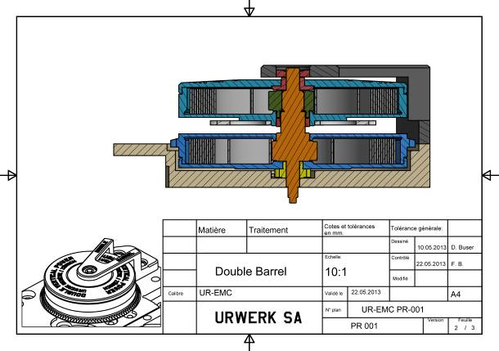
- The timing adjustment screw is accessible on the back of the watch and allows the owner to make very fine adjustments to the balance rate regulator by changing the active length of the balance spring by turning a simple screw.
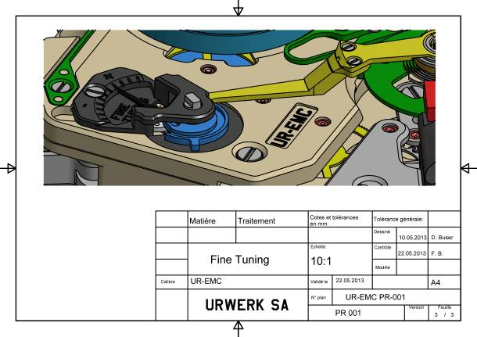

To monitor and evaluate the mechanical movement, an” electronic brain” was then needed. Olivier Evalet, a software developer who is passionate about software and computer engineering, has been instrumental in helping this bold project succeed: "The idea was to use precision optics, i.e. light, to measure the precision of a mechanical movement. The accuracy we managed to achieve is better than 10 microseconds. And we have created a reliable system that is designed to work over the long term. The power for EMC's electronic "brain" derives not from a simple battery but a super capacitor that even after 100,000 to 200,000 charge/discharge cycles loses very little performance. We also chose a high-frequency oscillator with an extremely long life – its instability is only 3 parts per million over a full year."
The innovative EMC timing rate monitoring unit has been developed to include the following:
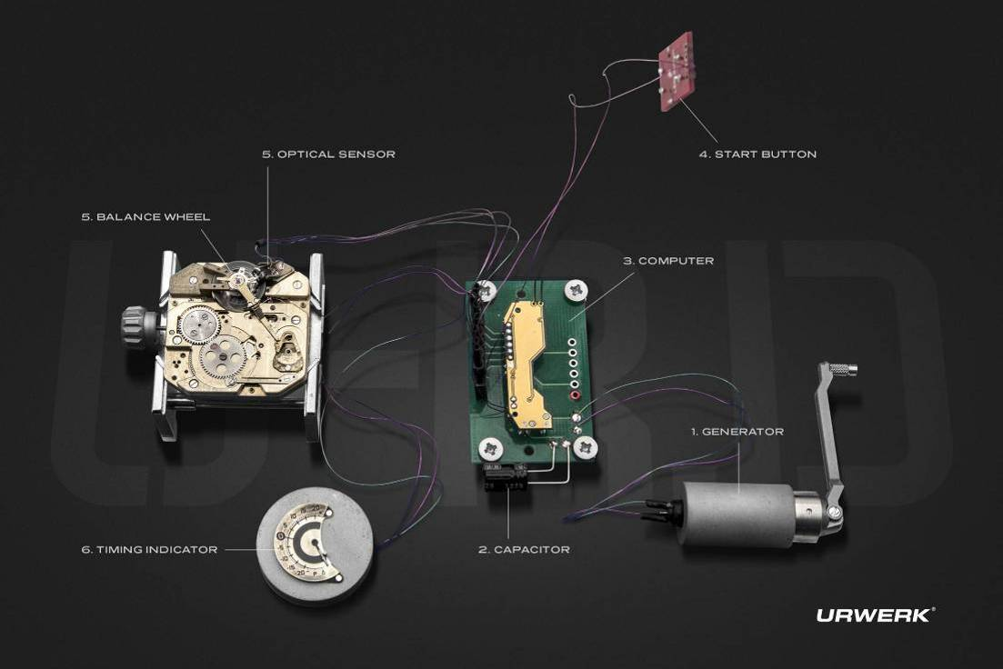
- An optical sensor on the balance wheel capturing the precise rate of oscillation of the 4 hertz / 28,800 vph regulator, over a period of 3 seconds. This sensor consists of a transmitter and a receiver positioned either side of the balance, and is triggered manually by pressing a button on the left side of the case.
- A 16,000,000-hertz electronic oscillator
This provides EMC’s reference timing rate. The performance of the balance of EMC (4hz) is compared against this lightning-fast oscillator to obtain the most accurate measurement possible.
- Artificial intelligence (the computer)
This computer determines the difference between the timing rate of the movement and that of the reference oscillator. Each microsecond difference between the two values is expressed as a gain or loss of a second per day of the timing rate. A variation of just 0.0000014 of a second per half-vibration translates as a variation of a second per day.
- Manual-winding generator (the generator):
EMC’s monitoring unit (the optical sensor and the computer) is powered by a micro-generator made by the Swiss company Maxon, which is well known for developing motors for NASA’s Mars rovers.

Martin Frei – designer and co-founder of URWERK - had the considerable task of bringing all of EMC’s technical elements together in a visually-appealing and comfortably-wearing wristwatch. "At URWERK, the starting point of our creations is usually a sketch of the completed watch that embodies mine and Felix’s ideas before the micro-mechanics are fully developed. But with EMC, the technical features of the timepiece were already established and this made my task that little bit trickier. We miniaturised the EMC components to the extreme and this allowed me some leeway in terms of design. My approach was one of pragmatism – from incorporating the folding crank into the caseband, to making the electrical energy storing capacitor part of the case. In terms of design, you can spot the influence of objects that are dear to me: the crank echoes that of old SLR cameras; and the design of the balance wheel is reminiscent of a vintage 1/4 inch tape reel.
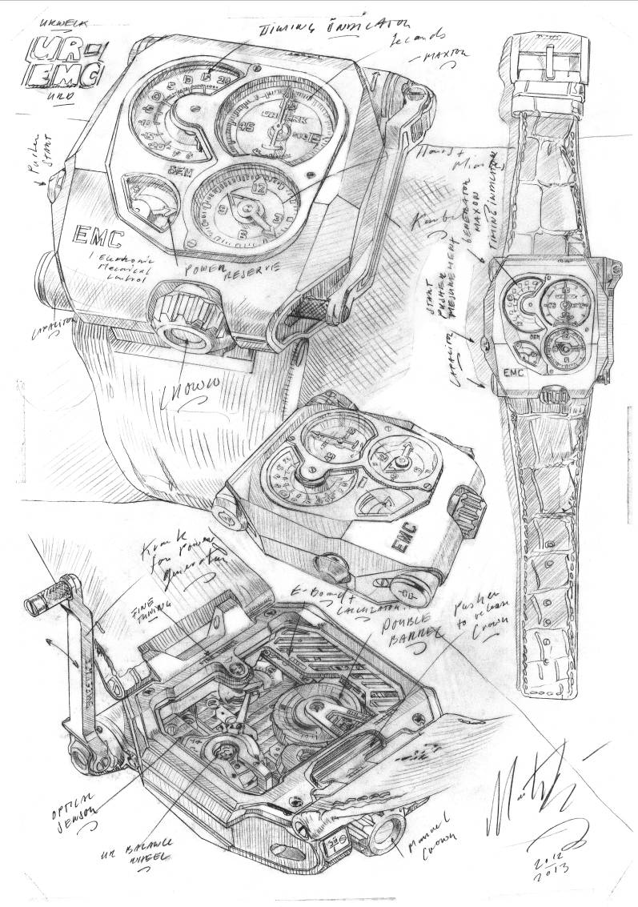
EMC marks the dawn of a new era, that of an interactive smart mechanical watch allowing the owner to gauge the precision of their timepiece’s chronometric performance and fine-tune it to better suit their daily rhythm and pace of life.

Technical specifications
Case
Material: Titanium and steel
Dimensions: 43mm width, 51mm length, 15.8mm height
Crystal: Sapphire crystal
Water resistance: Pressure tested to 30m / 3ATM
Finishing: satin finish; shot-blasting
Movement
Calibre UR-EMC calibre conceived, developed and manufactured by URWERK
Escapement Swiss lever escapement
Balance wheel in ARCAP P40, linear balance coupled to the optical sensor
Frequency 28,800 vph – 4Hz
Balance spring Flat
Energy source Vertically mounted double mainspring barrels, connected in series
Power reserve 80 hours
Winding Manual winding
Finishing: Côtes de Genève, snailing, micro-bead blasting , polished bevels on screw heads
Artificial intelligence
Generator Maxon® generator with manual winding charging super capacitor
EMC system Optical sensor controlled by an integrated circuit board ; 16'000'000hz reference oscillator
Indications Hours, minutes, seconds; precision delta, power reserve. Timing adjusment screw
_______________________________
Media contact :
Mrs Yacine Sar press@urwerk.com
Direct line: +41 22 900 20 27
Mobile: +41 79 834 46 65

