Beware of the bite of the Black Cobra

Geneva – July 2010
The latest generation of the UR-CC1 is the result of successful genetic manipulation. A sudden shedding of the skin has transformed the grey gold "King Cobra" case into black, a colour often signalling lethal danger. In colouring the UR-CC1 anthracite, team URWERK reaffirms the aggressiveness of this piece, pushing the Cobra to the extreme. Black character and black heart. Don't be afraid, but do be very careful of the UR-CC1 in black AlTiN

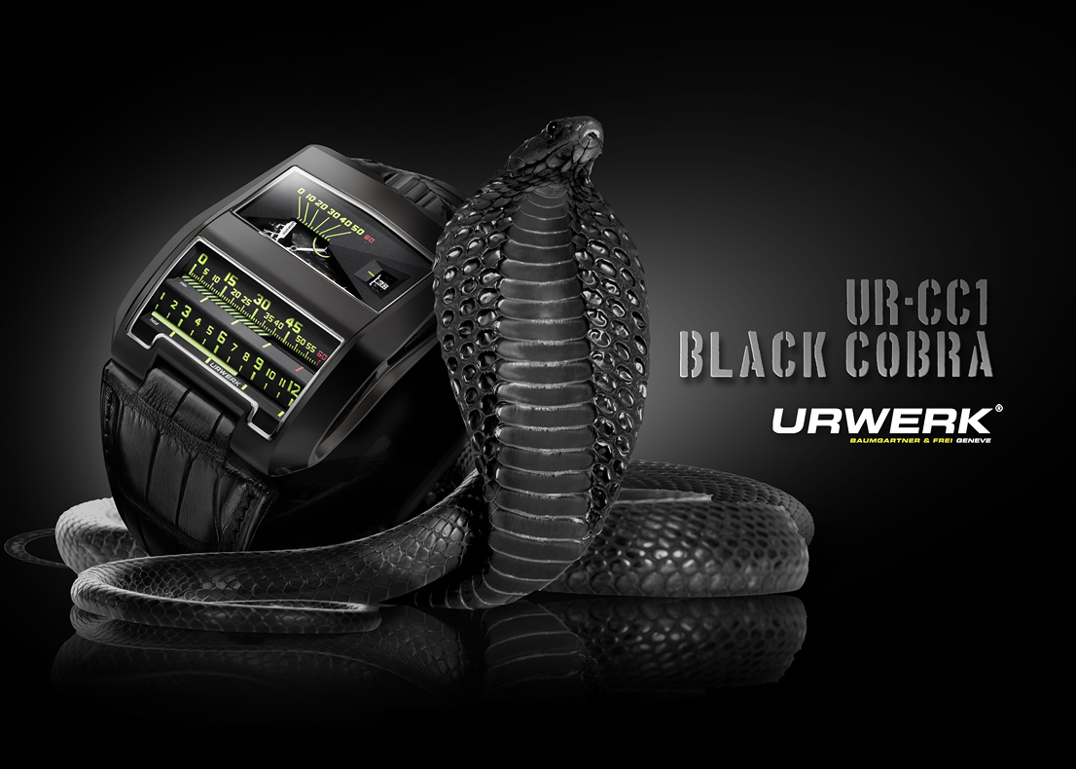

Hold the "Black Cobra" face on (very prudently) and you stare at two unusual indications: jumping hours and retrograde minutes. Bright yellow glowing from black is the only luminous evidence emitting from this reptilian machine. The hours and minutes count down the time by moving linearly. Sounds simple doesn't it?

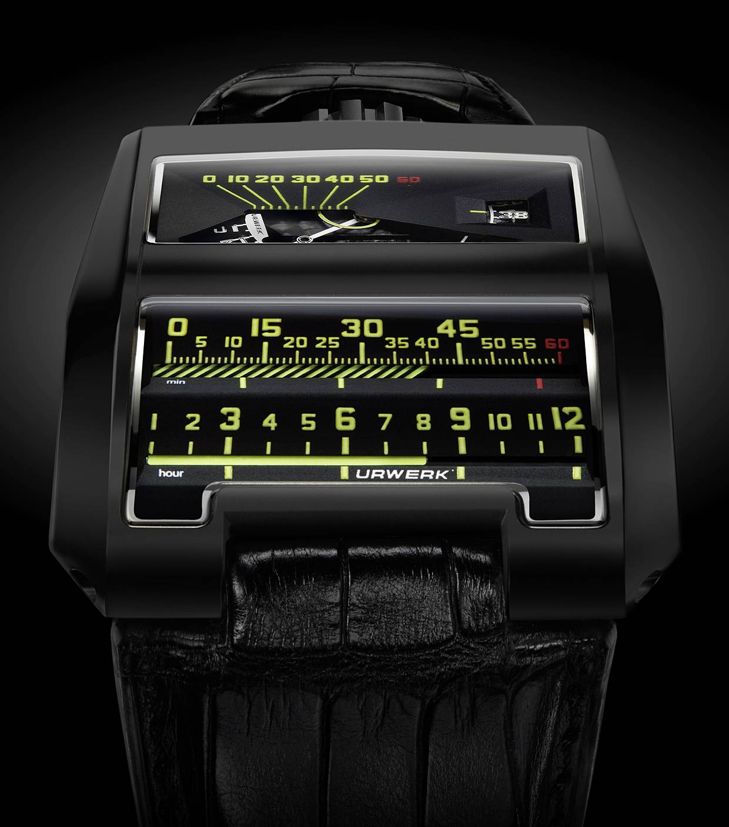

It took more than three years of research and development to overcome the technical challenges involved in linearly indicating the hours and minutes in this fashion.

The resolution of three engineering puzzles allowed the URWERK team to master the reptilian beast:

- The movement develops enough energy to operate the imposing minute cylinder, which is much heavier than a traditional hand, but where to find additional energy to function the jumping hour cylinder?

- A toothed rack moves vertically to rotate the minutes, but how to ensure that it operates smoothly in all positions, despite the varying effects of the immutable laws of gravity?

- Having solved the power issues related to operating the jumping hours, how to ensure that there is enough energy available for the world-premiere digital seconds?
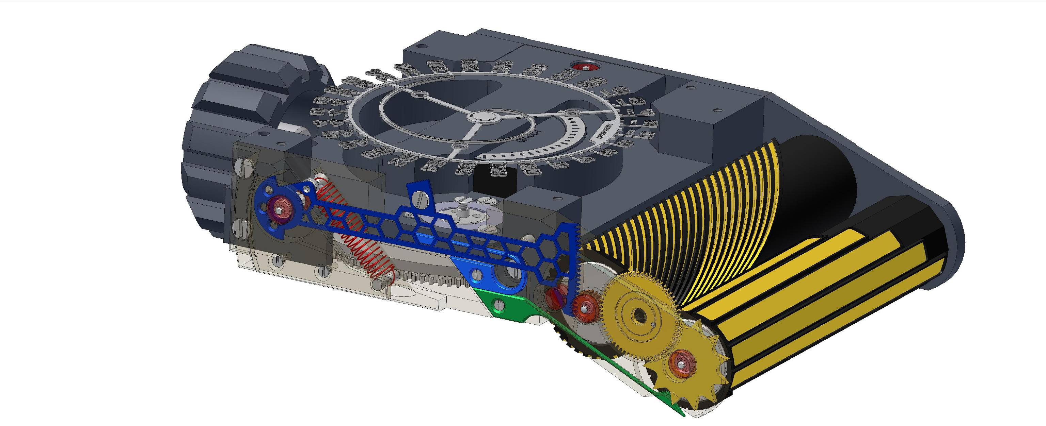A toothed rack/lever, visible through a display panel on the side of the "Black Cobra" transfers energy from the movement to the minute cylinder. The honeycomb structure of the lever offers the two seemingly contradictory properties of lightness and rigidity. Rigidity to accurately convey the profile of the triple cam to the minute cylinder, and extremely light/low mass so as to consume as little energy as possible and so that position, gravity and shocks have minimal effect. The mechanism used is reminiscent of those seen in automata. A toothed segment at the end of a rack exactly moves up and down following the path drawn by the triple cam - a path that has been plotted from 104 reference points. Each of the three cams drives the rack for exactly 60 minutes. At precisely 60 minutes the rack drops on the cam provoking the opposite tooth-end of the rack to fall, which triggers the retrograde mechanism and rotates the minute cylinder. And all of this happens in just 1/10th of a second!
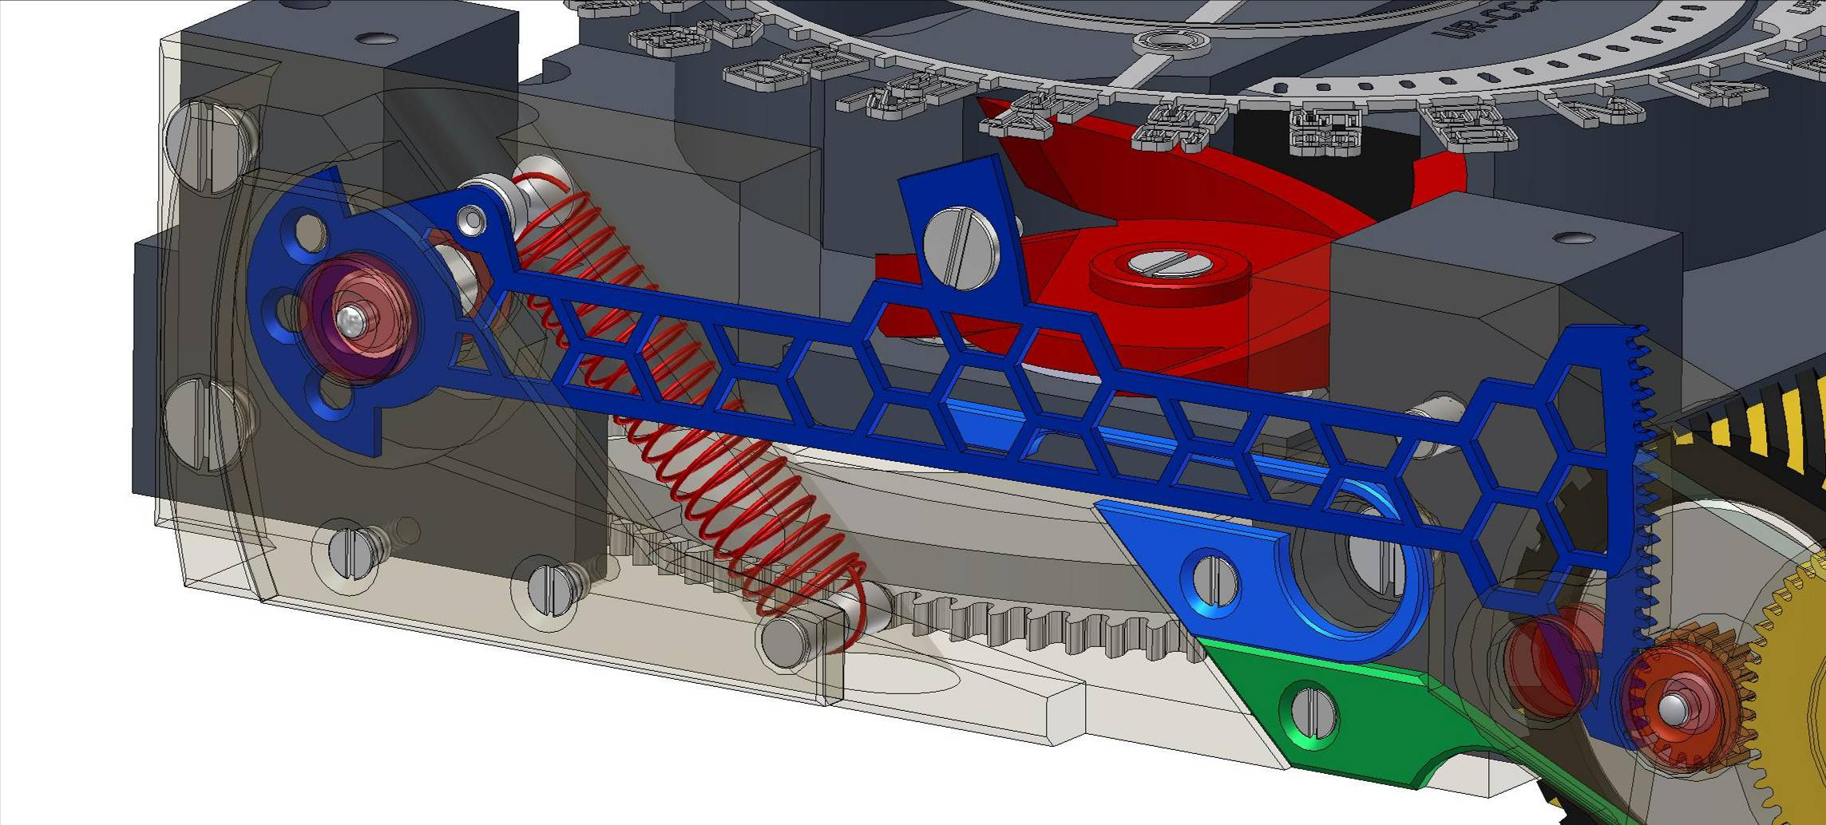
The energy released by the retrograde mechanism is recovered and used to power the rotation of the jumping hour cylinder. Visible through a display panel in the side of the case, a 12 pointed star and positioning spring are the only distinguishable components of this innovative mechanism for
recycling energy
.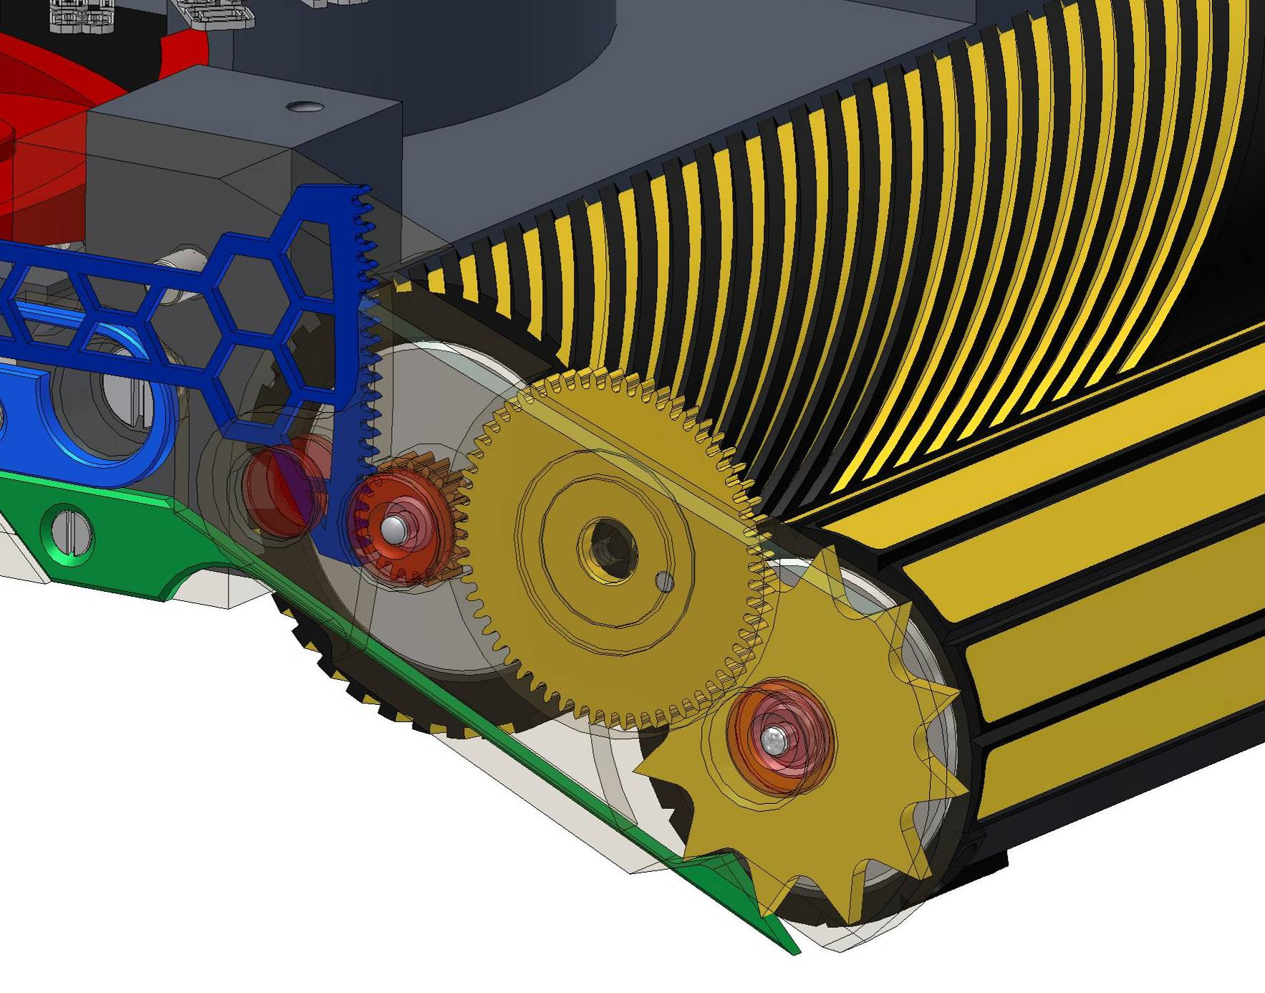

Two essential elements, the disk for the digital seconds and the honeycombed rack, anchor the "Black Cobra" in cutting-edge technology. Photolithography was the only method able to provide the degree of accuracy and low mass required by these two critical components - the seconds' disk weighs just 0.09 of a gram! "We have created a monster that is hungry (for energy) so have ensured that all forces can be recycled and reused. It is a very delicate balance as we work within fixed constraints, i.e. available force, mass, and current production technology, and then we go beyond our capabilities. "explains Felix Baumgartner

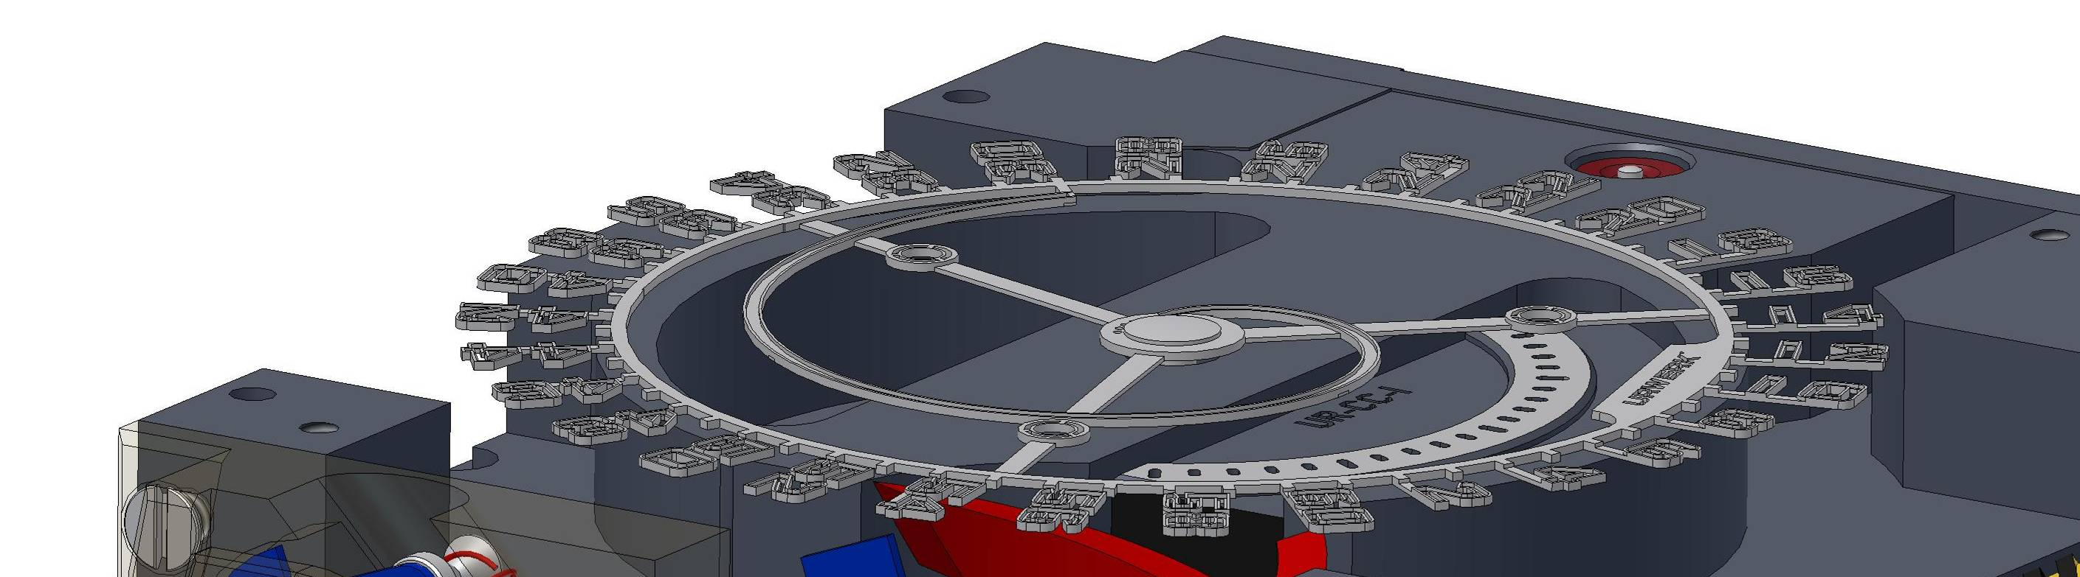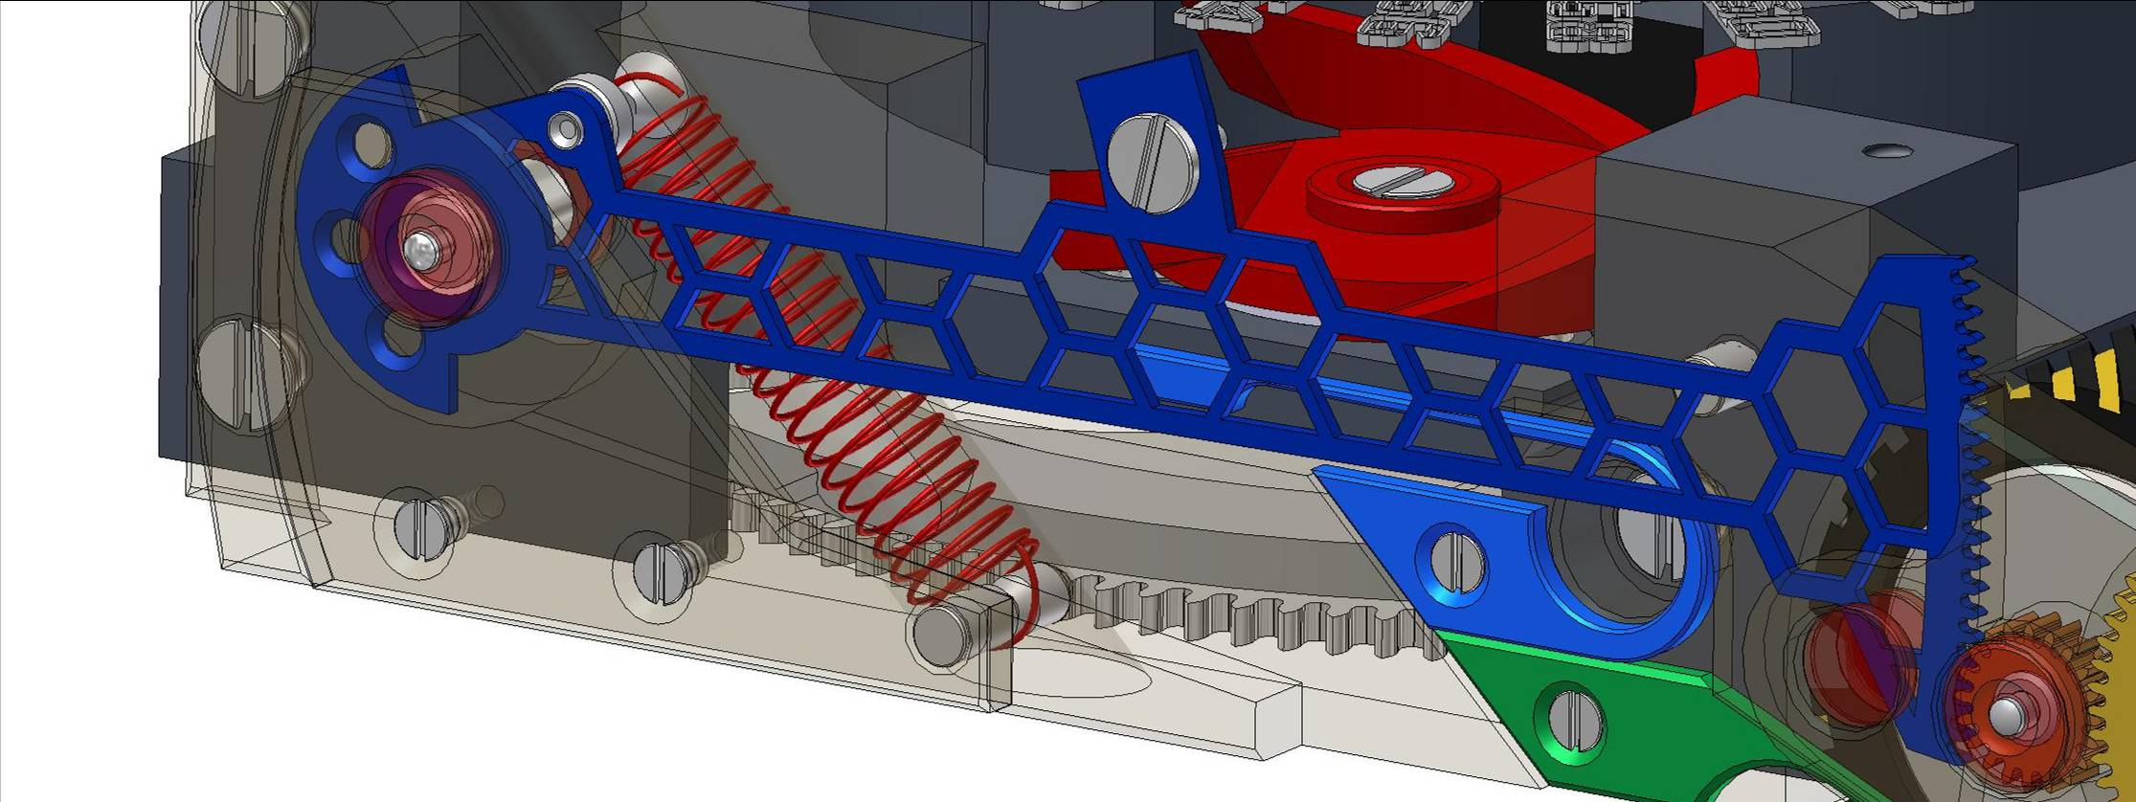

The Black Cobra is a formidable beast and was extremely difficult for the team at URWERK to master. Three years of work and ten prototypes were necessary to tame the beast. Now it's your turn, do you have what it takes?

UR-CC1 « Black cobra | limited edition of 25 pieces
Boîtier | grey gold treated with AlTiN (Aluminium Titane Nitride), base in PE-CVD treated titanium
Particularities | hardness of gold : 380 Vickers  hardness of AlTiN : 3800 Vickers
Indications | linear jumping hours  linear retrograde minutes  seconds displayed both lineally and digitally, a world first
Dimensions | length : 53.9mm  width : 42.6mm  height : 15.4mm
Calibre | UR-8.02
Main characteristics | minute and hour cylinders in aluminium elox (Anodicaly Inactivated Aluminium)  cylinder brackets in titanium  honeycombed rack and seconds disk in nickel manufactured using photolithography  base plate in ARCAP P40 treated with black PVD  triple cam in beryllium bronze  unidirectional winding rotor masse regulated by pneumatic brake « Fly Brake »
Balance frequency | 28'800 bph/4Hz
Power Reserve | 39 hours
Number of jewels | 27 jewels in base movement  10 jewels in complication
Finishing | bridges decorated with perlage then treated with black pvd, movement components decorated with perlage, micro-blasted, complication components diamond-cut and mirror polished, gold case micro-basted then treated with AlTiN, titanium base plate treated with PE-CVD

Press contact:
Ms Yacine Sar press@urwerk.com +4122 900 2027

