The UR-230 from URWERK
The “Eagle” has landed

Geneva – 14 November 2023.
The URWERK UR-200 family is taking off to new heights: with its dual variable-geometry turbine, double shock absorber and hybrid winding system, the UR-7.30 calibre unfurls the wings of URWERK's mechanical possibilities. This UR-230 "Eagle" also features a physical transformation, including the development of a CTP carbon case fitted with a mobile cover, along with aerodynamic lines, a slimmer profile and the measurements of a bird of prey. The UR-230 'Eagle' is a highly sophisticated, highly desirable animal, produced in a limited series of 35.

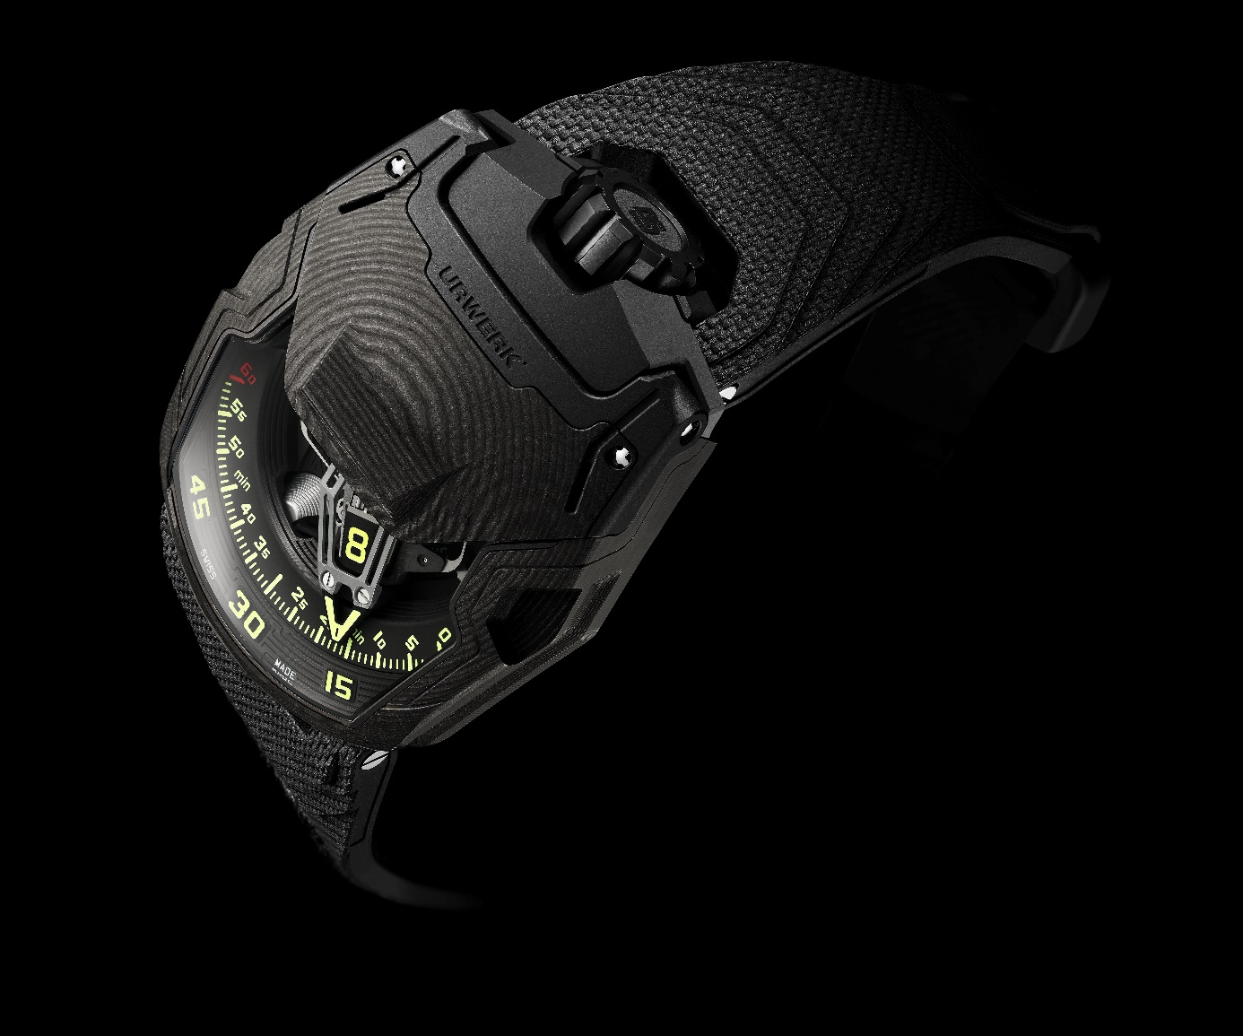

The 200 collection welcomes a new generation: the UR-230. This "Eagle" is distinguished by its exterior, its design and its mechanics. The latest addition to the URWERK family, with its satellite display, wandering hours and retrograde minutes hand, has benefited from an engine upgrade and a high-tech makeover: "It's already been ten years since the success of the UR-220, we wanted to follow up with a creation featuring a strong personality”, explains URWERK co-founder and master watchmaker Felix Baumgartner. “The UR-230 "Eagle" focuses on performance. The turbines, which are one of our URWERK signatures, have been further improved. Today we are unveiling a model whose robustness has been boosted by technology.”

The new UR-230 'Eagle' retains the display concept of the UR-220. It is a sophisticated version of the revolving satellite complication that is URWERK's essential signature. On a three-armed carrousel, rotating blocks each carry four hours’ numerals. They scroll along a 120-degree sector, with the face of the current hour pointing towards the observer. To display the minutes, these display cubes are embedded in an aluminium 3D retrograde hand. At the end of its 60-minute journey, this skeletonised hand returns to index 0, where it takes charge of the cube displaying the next hour. Martin Frei, artistic director and cofounder of URWERK says: "We are proud to present the UR-230, the latest addition to our iconic series 200 launched in 2006 – 2007 with the introduction of the UR-201 'Hammerhead'. Since then, our unceasing quest for innovation has led us to rethink this collection while preserving its energy, its strength. We have evolved the concept, the elegance of the predator, but in a different context. We have created 'the Maltese Falcon' and 'the Pilgrim', watches akin to a bird of prey with their powerful retrograde system. Today, we reveal our UR-230 'Eagle'. This new UR-230 features a complex half-hunter case (with protective cover) crafted from finely layered carbon. The UR-230 is both lightweight and robust. It deserves to bear the name of the king of the skies."

Air flow
In addition to this time display, the UR-230 "Eagle" showcases new functions. URWERK has developed a world-first set of shock absorbers designed to protect the new UR-7.30 calibre via turbines. A first set of turbines is dedicated to attenuating the impact of any external shock, thereby guaranteeing the robustness and durability of the watch. A second set controls the flow of air that feeds the winding system. The strength of this "air brake", designed to modulate the winding power according to the wearer's level of activity, is set by a rotating knob on the back of the watch.

A second switch opposite the first serves to entirely disengage the rotor. The UR-230 'Eagle' then switches to manual winding mode. The level of adjustment of these two functions is indicated by two symmetrical indicators at 11 and 1 o'clock on the CTP carbon cover.

Heart and body
The UR-230 "Eagle" also features the same case design as the UR-200 collection. A trapeze shape with a pronounced elongation towards the 6 o'clock position, a staggered layout around the sapphire apertures, a crown at 12 o'clock and clever management of acute and softened angles: the UR-230 "Eagle" asserts its fundamentally URWERK nature. Its case is once again made from CTP carbon, the material offering the best weight/stiffness/graphic effect ratio.

Black, light and rigid, this carbon is machined in superimposed layers, pressure-bonded at high temperatures. The resulting block is then worked into the mass, following a pattern that reveals the layers in a regular, controlled geometric pattern. The back is made of grooved and perfectly dermo-compatible black DLC titanium. Inside the case, the UR-230 'Eagle' encloses its UR-7.30 calibre in a hermetically sealed container resembling a strongbox.

Beak and talons
UR-230 'Eagle' features a cover that lifts 90 degrees to reveal the entire satellite system. The purpose of this cover is to protect the sapphire crystal. “We created a shock-proof protection for the movement and another for the sapphire crystal”, explains Felix Baumgartner. “This cover created a whole host of technical difficulties for adjusting and connecting the cover and case designs. The brake system was also tested and adjusted until we were completely satisfied." It too is made from CTP carbon mixed with titanium. A beak-shaped edge provides a finger grip, enabling it to be lifted. When closing it, a braking device slows its travel so that it rests gently on the sapphire crystal and then clips into place. Like an eagle whose talons seize its prey in mid-flight, it is silent and impressively accurate.

URWERK / UR-230 “Eagle”
35-piece limited edition

Movement
Calibre | Calibre UR-7.30 developed by URWERK
Winding | Automatic winding with manually wound option
Escapement | Swiss lever
Frequency | 28,800 vph- 4 Hz
Hairspring | Flat
Energy source | Single barrel
Jewels | 50
Power reserve | 48 hours
Materials | Baseplate in ARCAP P40, 3D minutes pointer in aluminium with bronze counterweight; central spring in steel. Hour transporter in aluminium; central carrousel and screws in grade 5 titanium
Decorative finishes | Hours studs  Black-lacquered hour-markers  Black shotpeened power-reserve bridge and circular-grained module  Black shotpeened power-reserve subdial  Finely sandblasted carrousel with its cage featuring a circular satin finish and black rhodium-plating.  Finely sandblasted satellite cam with a circular satin finish.  Finely sandblasted PVD-blackened 3D hand  SuperLuminova components: yellow glowing yellow for the hour transporters and hour-markers; white glowing blue for power reserves; green glowing green, red glowing green for the 60-minute marker and the end of the power-reserve scale.  Polished screws
Indications | Wandering hours on a satellite complication (URWERK patent)  3D retrograde minutes hand  Aerodynamic winding regulation indication (Air Brake)  Automatic winding status indication (On-Off)
Case
Material | Black DLC-treated titanium and Carbon CTP (Carbon Thin Ply) – 318 layers
Dimensions | Width: 44.81 mm; length: 53.55 mm; thickness: 18.38 mm
Glass | Transparent sapphire crystal
Caseback | Black DLC-treated titanium and sapphire crystal glasses
Water resistance | Pressure-tested to 30 m/3 ATM
Strap | Vulcarbonised© rubber, “Kiska” reference with black DLC-treated buckle; Velcro© fastening
Price | CHF 180,000 (Swiss francs / excl. tax)

Media contact:
Ms. Yacine Sar
+41 22 900 2027
press@urwerk.com
https://www.urwerk.com/press

URWERK

“Bringing out yet another version of an existing mechanical complication was not our aim”, says Felix Baumgartner, master-watchmaker and co-founder of URWERK. “Our watches are unique because each has been conceived as an original work. That is what makes them valuable and rare. Above all, we want to explore beyond the traditional horizons of watchmaking.” Martin Frei, chief designer and the other co-founder of URWERK, develops the aesthetic signature for each of the models. “I come from a world of total creative freedom. I’m not cast in the watchmaking mold, so i can draw my inspiration from my entire cultural heritage.”

While URWERK is a youthful company established in 1997, it is regarded as a pioneer on the independent watchmaking scene. Producing 150 watches per year, URWERK sees itself as a House of artisans where traditional expertise and avant-garde aesthetics coexist in perfect harmony. URWERK develops complex and modern watches unlike any others and meeting the most demanding Haute Horlogerie criteria: independent research and design, cutting-edge materials and hand-crafted finishing.

The roots of the name URWERK date back to 6000 BC and the Mesopotamian city known as Ur of the Chaldees. Observing the shadow cast by the sun on their monuments, the Sumerians first defined the unit of time as we know it today. The word “Ur” also means “beginnings” or “origins” in German and the last syllable of the URWERK signature also comes the same language, since “werk” means creating, working and innovation. A tribute to the constant work of successive master-watchmakers who have forged what we now refer to as Haute Horlogerie.

