The UR-120 aka Spock
« Live long and prosper! »

Singapore – October 4th, 2022
Hand up, palm forward, fingers parted in the middle, and then the greeting: « Live long and prosper! » This is a meme known to all Trekkies, almost a world heritage, a salutation that rings like a blessing. This sign is also an integral part of URWERK's brand DNA. It's had pride of place on a wall of the Geneva workshop for ages. And now, so does it above the mainplate of the new UR-120, whose time display reproduces the Vulcan salute. Such is the latest challenge Felix Baumgartner and Martin Frei have taken on, with the hope that it too shall live long and prosper.

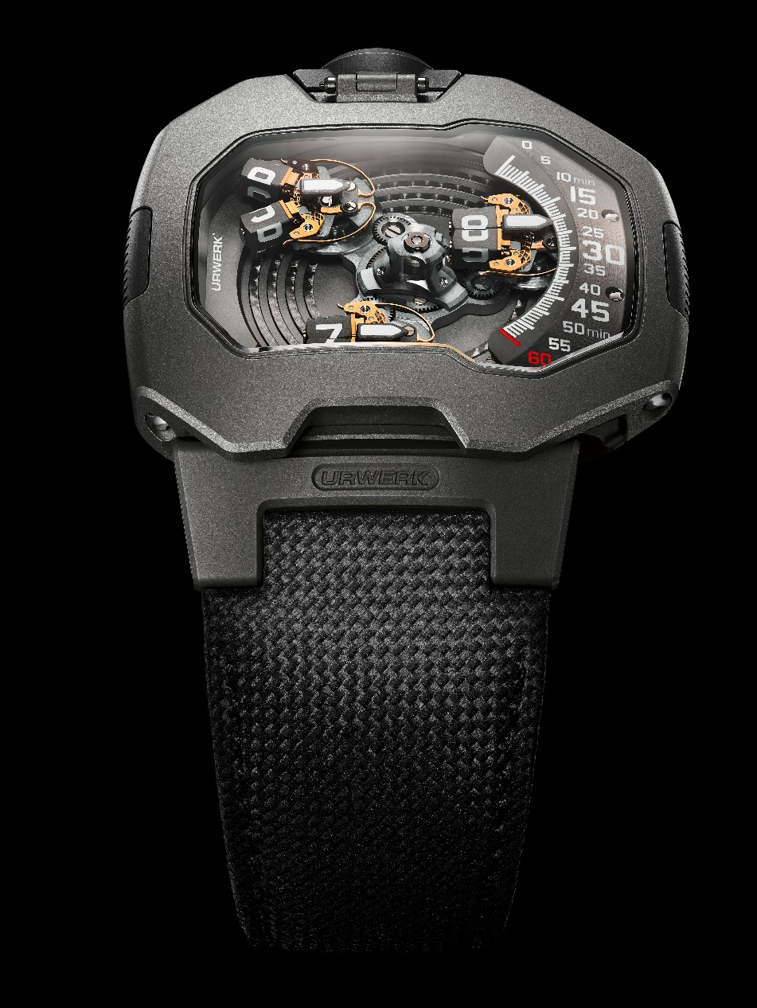

At the crossroad of technical advancement, watchmaking development and space-time inspiration, the UR-120 is a new stage in the constant mutation of the URWERK species. This UR-120 furthers the codes of the UR-110 collection and reshapes its concept. Martin Frei, co-founder and Artistic Director of the brand, goes back up on the ring for a new challenge, 11 years after the UR-110 won the Design Watch Prize at the 2011 GPHG. « I just loved the UR-110, but there were so many other ways to go about it, to keep it evolving...That's what a designer's mind is like. The process is never-ending. » And so Martin Frei went back to the drawing board. « The idea was to go in a thinner, smoother, more elegant direction. To do that, we redesigned the entire satellite system. Each satellite is now made of two sub-elements to make it thinner, easier to read and to give it unprecedented fluidity. »

This new satellite display of the UR-120 was born 16.5 million light-years from Earth, in the Beta Quadrant. That's where the original inspiration for its display, a V-shaped open hand, is customary: in Mr. Spock's civilization, on Vulcan. It relies on rotating satellites which split open so they can spin, each on their own axis. This unprecedented innovation allows for a substantial gain in thickness.

It translates into a unique volume. At 44 mm long, 47 mm wide and 15.8 mm thick, the UR-120 case stands out with its perfect sense of ergonomics. Maximum height is reached in the middle of the sapphire glass, at the apex of a gentle curve. The upper part of the case is totally smooth, without a single screw or notch, offering perfectly fluid lines.

Driving force
The latest celestial object in URWERK's constellation relies on splitting satellites. Inside calibre
UR-20.01, the central carousel is fitted with three arms, each one bearing a satellite. All four sides of said satellite bears an hour marker. When it exits the minute track and reaches the left part of the case, it actuates a trigger that commands the changing of the satellite face. The latter then shows its true nature with an unprecedented kinematic sequence.

The satellite splits open, revealing two rectangular studs. They take on a V shape, thus recreating the Vulcan salute that ultimately gave the UR-120 its nickname. Once separated, both studs spin on their own axis and shut, all in order to display the new hour unit.

There is a triple revolution taking place under the hood of this spacecraft: the satellite-bearing carousel spins on a central axis, each satellite counter-spins in order to remain upright and therefore readable and each stud spins on its own axis.

The other aspects of the display remain typical of the original URWERK species: the satellite carousel moves along the minute track sector, located at the right-hand side of the case. The side shown by the satellite and its position on that scale tell the hour and the minute.

Creative energy
« In truth, when we realized we were going to have to open the satellite, I was over the moon, says Felix Baumgartner, URWERK's co-founder and master watchmaker. Our biggest challenge has always been to manage forces. At the exact moment of the salute, a lyre-shaped spring opens and then closes the satellite. Managing energy then and there is complex and very subtle. We need to manage the opening AND the stud rotation. We ended up manufacturing the spring ourselves, in-house, because we had to go through so many trials while defining its geometry and thickness. With the UR-120, we also experienced a considerable gain in readability: the hour markers these opening studs allowed have grown bigger by 35% compared to the UR-110. »

As a rule, the way URWERK's creations are built and their dimensions result from technical constraints, and chief among them, the volume requirement of the display. A major part of URWERK's very nature is the ability to turn this spatial constraint into a design and watchmaking showmanship opportunity. It then becomes part of the global conversation on imagination, dreaming and the creative drive that keeps watches moving forward.

Principles of ergonomics
On top of this new watchmaking system and the volume it allows, UR-120 heralds several new design elements. Martin Frei acknowledges a personal interpretation of Gerald Genta's own design approach. « I've always loved the way his cases are constructed, with an intertwined lower case and upper case. Technically speaking, that's very smart. » And so, the UR-120 case is made up of two interlocking parts, equivalent to a caseback and a bezel. They connect seamlessly with the help of lateral screws.

A further element of fluidity is provided by the presence of lugs on the UR-120, which are a rare occurrence in the line of URWERK creations. What's more, they're articulated. Inside the one located at 6 o'clock, URWERK has fitted a spring, which is part of the way the strap rests on and sticks to the wrist. The material this strap is made of is another novelty. Rather than its traditional technical fabric, URWERK went for calf leather, embossed with a ballistic-type pattern. It's reminiscent of a woven nylon while offering superior comfort and flexibility.

First edition
UR-120's first series takes on an almost entirely gray form. The upper-case part, the bezel, is made of finely sandblasted steel. The lower part is made of sandblasted titanium and opens up a new design era. A small window offers a direct view on the Windfänger, the star-shaped component which regulates the automatic winding intensity. In the center, a large medallion harbors two types of finishing: deep grooves all over and at 9 o'clock, a plaque bearing the URWERK monogram. The crown is crafted out of steel and the strap is also gray.

That monochromatic continuum is interspersed with golden shards. All Maltese crosses and lyre-shaped springs are 24ct-gold PVD treated, which underlines the technical aspects of this timepiece. Not unlike the Bussard ramjets at the front of the Enterprise's warp engines.

« Live long and prosper! »

UR-120 aka “Spock”
Price: CHF 100,000.00 (CHF / wo. tax)

MOVEMENT

Caliber: | UR-20.01, self-winding
Jewels: | 32
Escapement: | Swiss lever
Frequency: | 4 Hz; 28,800 vph
Power reserve: | 48 hours
Materials: | Beryllium-copper, grey PVD brass, gold-PVD and black-rhodium, anodized aluminum, ARCAP, titanium, LIGA-processed nickel
Hand finishing: | Circular- and straight-graining, sandblasting, côtes de Genève, polished screw heads
DISPLAY | Analog minutes and digital hours satellites mounted on triple planetary gears
CASE

Dimensions: | Width 47 mm; length 44 mm; thickness 15,8mm
Materials: | Sandblasted titanium, sandblasted steel bezel
Crystal: | Curved sapphire crystal with anti-reflective treatment
Water resistance: | Pressure-tested to 3ATM / 30m / 100ft
STRAP | Black calf leather with embossed Cordura pattern

