THE PIONEERING URWERK UR-111C Two-Tone

Geneva – February 26, 2020

Independent Swiss watchmaker URWERK has always championed innovation. And its latest model, the UR-111C - now in a striking Two-Tone (TT) black PVD and brushed steel, teardrop profile case - is no exception. Certainly, as part of the “Special Projects” line - a deviation from the wandering hour indications for which URWERK has become well-known - it’s one of the most conceptually adventurous watches on the market.

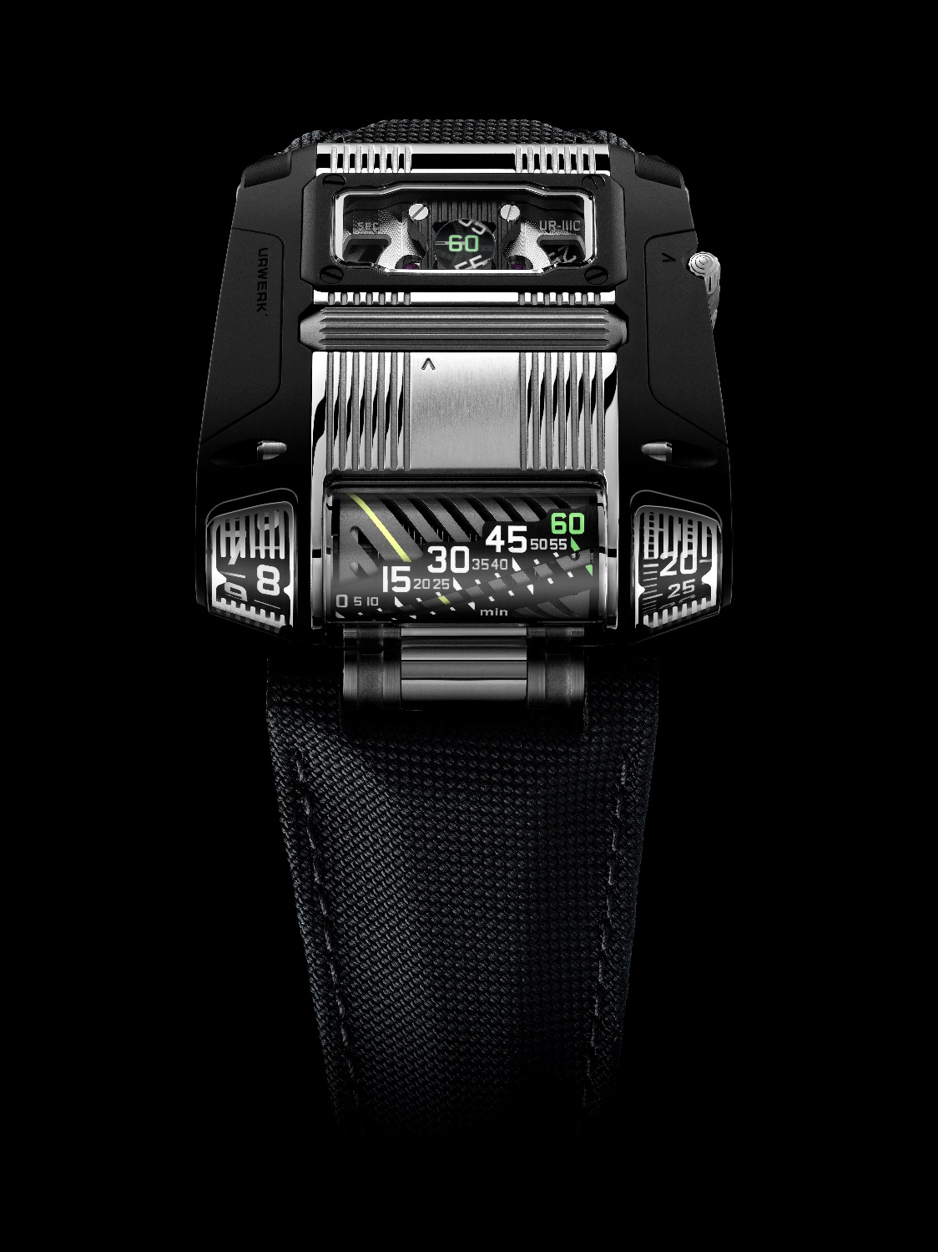

The UR-111C TT comes with three key advances for watchmaking. The first is a retrograde linear minute display in an end-mounted driver’s watch style. This is a spinoff of the mechanism invented for the UR-CC1. With a twist. Here the numerals are set in a 30° diagonal slant for a better readability. This means that the rotating cylinder onto which the minute indicator is painted must rotate 300 degrees about its axis, during which a coiled spring is wound. At the 60th minute, the spring is released, making the indicator jump a further 60 degrees and back to the start position. But it also makes the hour indicator to its left jump too. The result is a pleasing optical illusion of the cylinder rotating endlessly and seamlessly.

The second innovation is the seconds display. Openwork Arabic numerals are set onto two wheels, each graduated in ten second increments. Each wheel is made using a cutting edge process of lithography, electroplating and moulding devised precisely for the creation of very light and specific structures. Indeed, each wheel, complete with its six numerals, weighs just 0.025g - and that’s just as well, given the delicate dance that the two will now take part in. Interlocking like the teeth on cogs, they show a smooth progression of passing seconds. But how is the wearer to see such small-scale elements? They move - at a distance of just one tenth of a millimetre - under what looks to be a kind of circular lens, but which is a cluster of optical fibres.

The third and, in many ways, most stimulating new concept that the UR-111C introduces is its fresh take on the crown, for winding and setting. Doing away with the conventional, side-mounted winder, URWERK’s new piece introduces a roller system, positioned right across the middle of the case top. Rolling will further charge the watch’s self-winding movement. When small lever to the right side of the case is released, the same roller can be used to set the time, with stop-seconds functionality.
Of course, arranging all these micro-mechanics to create the end form of the UR-111C watch has been no easy task. The transmission had to be reimagined to allow a horizontal movement to provide a vertical time read-out within the crystal glass-covered truncated cones to both sides of the linear display. Connecting a roller crown to the winding stem likewise took feats of engineering, minuscule in scale but no less striking in effect.

But that precisely follows the design ethos of URWERK’s co-founders Felix Baumgartner and Martin Frei. More than just telling the time in sophisticated fashion, the UR-111C TT embodies both a visual and, especially unusually in watchmaking, a tactile treat for its owner. They’re ones which will sustain interest and intrigue alike through lifelong wear.

UR-111C TT
Limited edition of 25 pieces
Price: CHF 130’000.00 (Swiss francs / tax not included)

MOVEMENT
Calibre: Self-winding calibre with stop seconds
Jewels: 37
Escapement: Swiss lever
Frequency: 4 Hz
Power reserve: 48 hours
Materials: Anodized aluminium cylinder; LIGA-processed nickel second wheels.
Surface finishes: Circular graining, sanding, Côtes de Genève, polished screw heads.

INDICATIONS
Jumping hours, retrograde linear minutes, digital minutes, digital seconds.

CASE
Dimensions: Width 42mm x length 46mm x thickness 15mm
Glass: Sapphire crystal with anti-reflective coating
Water resistance: Pressure tested to 3ATM / 100ft / 30m

__________________________________

For more information contact:
Ms. Yacine Sar
press@URWERK.com
+41 22 900 2027

Quotes from the co-creators Felix Baumgartner and Martin Frei:

Felix Baumgartner, master watchmaker, co-founder of URWERK
“When we established Urwerk we wanted to capture the excitement that comes from creating something new. It meant taking a fresh look at the wristwatch, not only a complex mechanism but also a source of pleasure. With the UR-111C we focused on one element of the watch that hasn’t changed since it was introduced in the 1840s — the winding crown. We completely redesigned it, changing the way a watch is wound. For this, we had to rework the entire winding train. It was a long and sometimes arduous process, but we succeeded. We devised a new way of interacting with a watch and a new bond between the watch and its owner.”

“I read somewhere that every human needs physical contact with another person at least eight times a day for their wellbeing. It’s the same with a mechanical watch. If it’s neglected, it remains a soulless, inert object. But if you handle it and put it into motion, it suddenly comes to life. This revival is immediately noticeable in our UR-111C; the seconds wheel starts to move, the linear minutes begin their ascension and the hours march inexorably by.”

_______________

Martin Frei, artist, chief designer and co-founder of URWERK
Martin Frei sometimes digs back into his memory for some unexpected inspiration. “I remembered as a kid going to a jewellery store with my dad - he was really into gems - and seeing this natural mineral used as a magnifier. You could put it over a newspaper, say, and the image on the paper would be conveyed to the top of the stone perfectly. Light is even carried through the stone in the way that illuminates whatever is below it. It’s incredible really. I had such a vivid souvenir that decades later I wondered if we could use it in a watch design. Finally, we opted for a more technological alternative. I still wonder why fibre optics haven’t been used more in watchmaking. “

“But having a watch with a second display was, for me, always important because that’s the way we see time passing, as we do with an hourglass. And I think the way the two wheels of the UR-111C’s seconds display fall into each other is like sand passing down through an hourglass. The display is a celebration of the second. Because at the end, it’s all about giving pleasure - haptic pleasure.”

URWERK - Founded in 1997 by Felix Baumgartner and Martin Frei, URWERK is the result of a strongly held belief that the history of Fine Watchmaking is a constantly changing art.

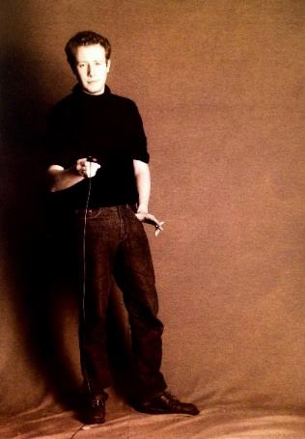
Felix Baumgartner, a watchmaker like his father and grandfather, has time running through his veins. A graduate from the Schaffhausen watchmaking school, Felix learned the secret language of minute-repeaters, tourbillons and perpetual calendars at his father’s bench.
Martin Frei is the artistic counterweight to his partner’s technical expertise. Accepted into the Lucerne’s college of art and design in 1987, Martin delved into every form of visual artistic expression from painting and sculpture to video, emerging as a mature artist.
The two men met by chance and discovered a common fascination with the measurement of time, spending hours analysing the gap between the watches they saw in the shops and the vision of their future creation.

Their first watch, developed in the early nineties, was inspired by the 17th-century night clock built by the Campanus brothers. In it, each hour on a rotating disc rises and sets in an arc like the sun. The wandering hour has since formed the basis for URWERK’s astonishing Satellite collection. URWERK has also been engaged in the uphill task of pushing the limits of mechanical possibilities to make progress in precision timekeeping. A long-term project conducted away from the limelight of the wandering-hour watches. The URWERK team has enlisted the aid of experts in quantum physics and applied the latest techniques in experimental research, resulting in the development of the Chronometry collection - extremely sophisticated time-measuring instruments.
“Bringing out yet another version of an existing mechanical complication was not our aim,” Felix Baumgartner explains. “Our watches are unique because each has been conceived as an original work. This is what makes them valuable and rare. Above all, we want to explore beyond the traditional horizons of watchmaking.” Martin Frei, responsible for the shape of future time, helps make this possible. “I come from a world of total creative freedom. I’m not cast in the watchmaking mould, so I can draw my inspiration from my entire cultural heritage.”

That heritage goes back to the roots of time, reflected in the name of their company. URWERK means “original accomplishment,” and Ur of the Chaldees, in Mesopotamia, is where the Sumerians first observed the concurrence of the heavenly bodies with the seasons, and so developed the first measurements of time.

