The UR-100V Stardust
Twinkle, Twinkle Little star

Geneva, 29 August 2023 – It sparkles brightly in the spotlight. With utmost delight, we extend a warm invitation to hold the UR-100V Stardust in your palm, gently pivoting it to reveal its finest profile, and savoring its true essence. This timepiece is bound to ignite a radiant twinkle in your eyes – a true watchmaker’s promise.

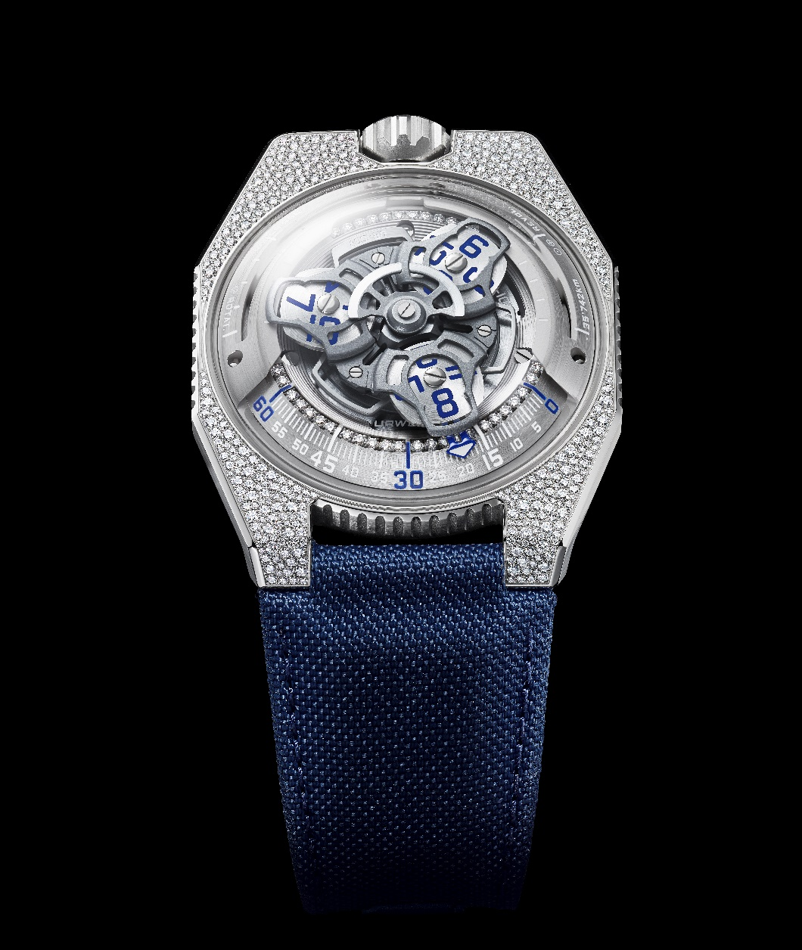

This UR-100V will tell you tales of stars and distant constellations, nascent beauty and flamboyance, flashes of lightning and transparent reflections. "The entire universe is composed of stellar particles, making their presence inevitable in all the forms of matter that surround us. Whether in their raw or transformed state, from carbon to cut diamonds, from iron mineral to steel alloy, this stardust is omnipresent. It's crazy to think that we, as human beings, are also made of this celestial substance. So, the nickname Stardust, logically associated with the setting of this UR-100V, also extends to the watch itself and to its future owner”, says URWERK’s Artistic Director and co-founder, Martin Frei.
This UR-100V is set with 400 diamonds (VVS1, Color D) totalling almost 1.90 carats of pure carbon. The technique chosen here is that of snow-setting: "We wanted a setting reminiscent of the starry heavens, with nothing at all uniform, more like ordered chaos. It wasn't so much the size of the stones that was important to us as their arrangement, this almost random design”, says Felix Baumgartner, master watchmaker and co-founder of URWERK.
Four hundred diamonds meticulously selected from eight different formats adorn the case of the UR-100V Stardust. Only the edges of the watch have been left bare. Run your finger over this mosaic of diamonds and you’ll find the structure is soft to the touch, smooth and fluid. Making this setting was however quite a challenge, because of the nature of the steel used here. Harder and less malleable than gold, steel required more complex and meticulous jewellery craftsmanship. Beneath the UR-100V Stardust's crystal globe, the minutes scale – located on the upper part of the railway-type track – is studded with 36 diamonds, while another 24 adorn the watch crown. The steel pin buckle is enhanced by two rows comprising 11 diamonds each.
In addition to its aesthetics and its wandering hour movement, the UR-100V Stardust is spatial by nature. Like all watches in the 100 collection, it features two recesses on the flanks of its satellite carrier. The first is a kilometre counter representing the distance travelled by the Earth on its own axis in 20 minutes, i.e. 555 km. The second is another kilometre counter showing the distance travelled by the Earth around the Sun during the same period, i.e. 35,740 km. In this way, the UR-100V Stardust bears witness to the Earth's journey across the void of space, passing millions of suns and reflecting their light.
UR-100V Stardust
Movement
Calibre | Selfwinding UR 12.02 movement governed by a Windfänger airscrew
Jewels | 40
Frequency | 28 800 v/h – 4 Hz
Power reserve | 48 hours
Materials | Satellite hours on beryllium-bronze Geneva crosses; aluminium carousel; carousel and triple baseplates in ARCAP alloy
Finishing | Circular graining, sanding, shot-blasting, circular satin finishing  Chamfered screw heads  Hours and minutes painted in Super-LumiNova® and accentuated by 36 brilliant-cut diamonds
Indications | Satellite hours; minutes; rotational distance at the Equator in 20 minutes; orbital distance in 20 minutes
Case
Materials | Case middle in steel, snow-set with 400 brilliant-cut diamonds (VVS1, Color D diamond), steel crown set with 24 brilliant-cut diamonds, case-back in shot-blasted titanium and sapphire
Dimensions | Width: 41.0 mm, length: 49.7 mm, thickness: 14.0 mm
Glass | Sapphire crystal
Water resistance | Pressure-tested at 3ATM (30m)
Strap | Baltimore blue fabric strap; pin buckle in shotblasted steel, set with 22 brilliant-cut diamonds
Price | CHF 88,000
 | (limited production of 10 per year)

___________________________________
Media contact:
Ms Yacine Sar
+41 22 90020 27
https://www.urwerk.com/press/ur-100v-stardust

URWERK

“Here at URWERK, we don’t try to bring out new versions of existing horological complications”, explains watchmaker Felix Baumgartner, co-founder of URWERK.” The approach is straightforward, clear-cut and steadfast.
Since its appearance on the watch industry scene in 1997, URWERK has been shaking up the world of Haute Horlogerie by imposing its revolutionary vision of time. Rebellious and unconventional to the core, URWERK is a youthful company, yet one that plays a pioneering role in the world of independent horology. Producing just 150 watches a year, the company sees itself as an artisans’ studio where traditional expertise coexists with avant-garde styling. URWERK produces complex contemporary watches that are unprecedented and in keeping with the most demanding fine watchmaking criteria: independent design and research, advanced materials and handcrafted finishes.
URWERK is first and foremost about two strong minds and two powerful personalities. Master watchmaker Felix Baumgartner is the son and grandson of watchmakers, all of which makes him a craftsman at heart. While others talk about timepieces as if they were hobbies, for him, they are at the centre of his life.
Designer-artist and URWERK co-founder Martin Frei is Felix Baumgartner’s alter ego. While studying at Lucerne’s college of art and design from 1987 onwards, Martin delved into every form of visual artistic expression – from painting and sculpture to video. He is particularly fascinated by the definition of time and its expression across successive eras.
The two men quickly became friends, spending hours analysing the gap between the watches they saw in shop windows and the vision of their future creation. Their first watch, developed in the early 1990s, was freely inspired by the 17th century night clock built by the Campanus brothers. In it, time is read off across an arc reproducing the path of the sun from east to west. And the rest, as they say, is history…
“Our watches are unique because each has been conceived as an original work. This is what makes them valuable and rare”, says Felix Baumgartner. The same firm convictions are expressed by Martin Frei, who designs the aesthetic signature of each model. “I come from a world of total creative freedom. I’m not cast in the watchmaking mould, so I can draw inspiration from my entire cultural heritage.”

