The UR-110 RG, protected by a golden shield

Geneva – January 2012

The UR-110 Torpedo has now been embellished with a solid gold armor. The UR-110 RG with its red gold bezel – 5N for the purists – consummately blends a golden touch of class with a high-tech Grade 5 titanium body.

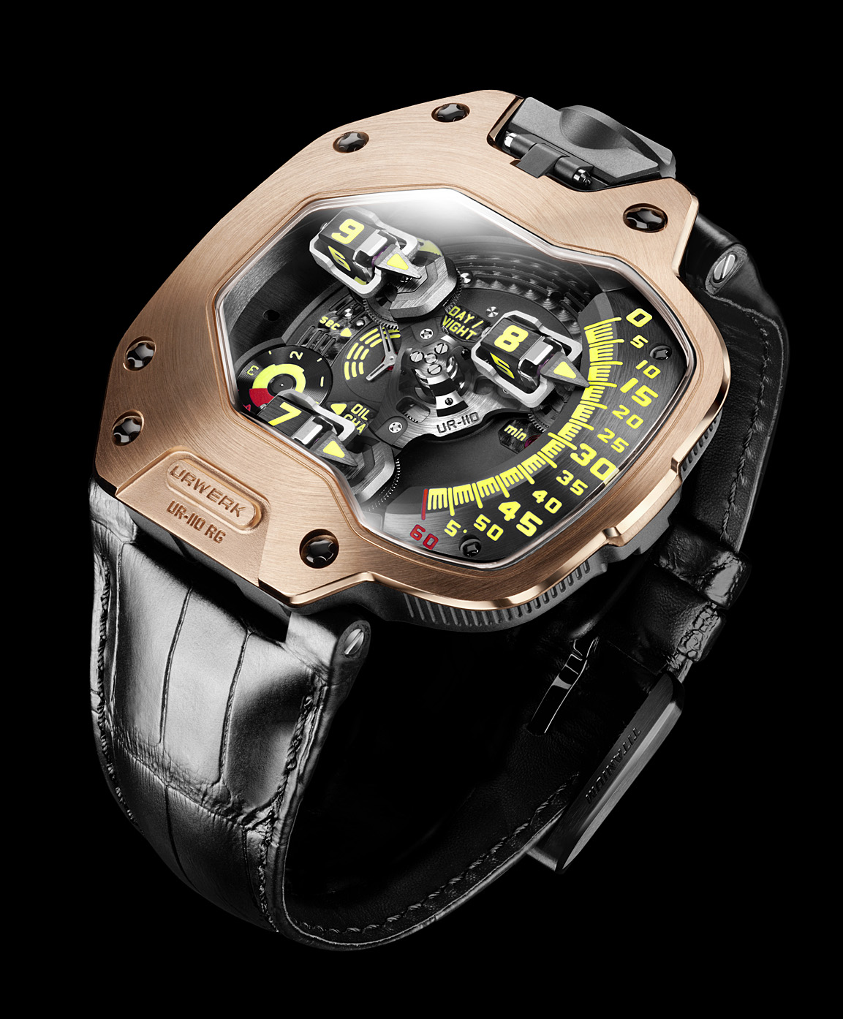

“We are known for complications that require cutting-edge high-performance materials, yet gold has always been one of our favorite materials,” says Felix Baumgartner, URWERK co-founder and chief watchmaker. “All of our collections feature a version crafted in this noble metal, from the very first UR-101 to the UR-110. More than a tradition, it is a milestone for us and we feel that a collection is only complete once a gold version has been created. Gold and titanium are the main components of this new UR-110, a watch of contrasts.”
Martin Frei, URWERK co-founder, adds: "Gold provides a unique feeling and emotion thanks to its density and its special appearance. In all the ancient and modern civilizations, gold was regarded as the material of the Gods. For me, as a trained sculptor and painter, touch is the first sense. This certainly explains my visceral attraction to gold. I like its solid, heavy, reassuring and eternal character. Our UR-110 collection could not be complete without a counterpart in gold. We have now achieved this."

Having won the 2011 Grand Prix d’Horlogerie de Genève prize for Best Design Watch, the UR-110 is at the forefront of watchmaking excellence, continuing URWERK’s radical tradition of telling the time using orbiting satellite complications.

In the UR-110 RG, the time is always shown on the right side of the watch. The satellites follow a vertically arced line, graded from 0 to 60 minutes, in a downward motion. Planetary gearing keeps the three hour-satellites and their arrow-shaped “torpedoes” in parallel formation as they take turns to indicate the time as they pass the 60-minute track. This performance is made possible by means of an architecture featuring three levels of complexity:

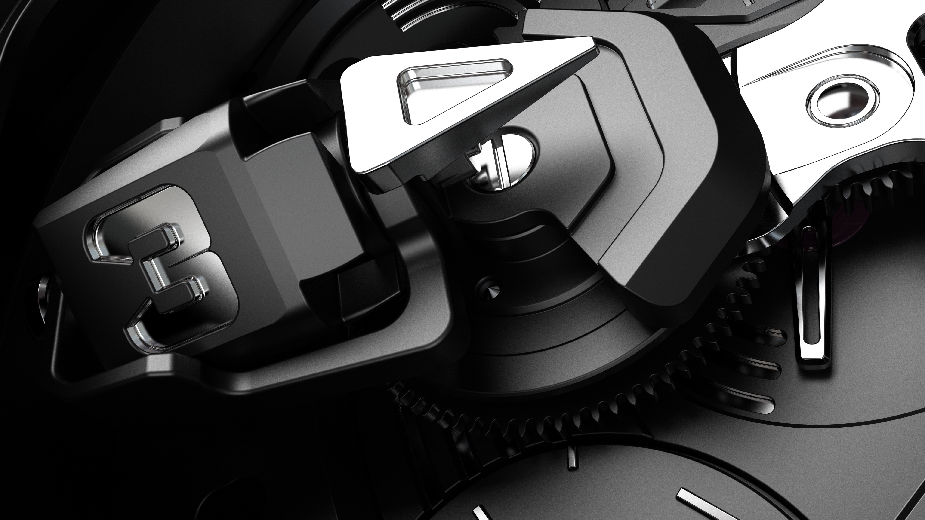

- A central carousel providing the complication with stability and equilibrium
- Planetary gearing assuring the parallel rotation of the three hour-satellites as they orbit the dial
- Three counter-rotating hour modules – each comprising an hour satellite, minute hand and counter balance – are each mounted on a planetary gear. These three modules are in constant counter-rotation to offset the direction of rotation of the central carousel.

The UR-110 RG is a timepiece in which its technology can be appreciated though the large panoramic sapphire crystal. As well as indicating the hours and minutes, the UR-110 also features a Control Board on the dial side with indicators for “Day/Night” and "Oil Change" – URWERK's service interval display, as well as small seconds on a sub dial. Turning the watch over, the titanium back encloses the innovative automatic winding system regulated by dual turbines.

The UR-110 RG therefore thoroughly enriches the 110 collection, where the classicism of a cherished material has been wonderfully juxtaposed with the avant-gardism of state-of-the-art micro-engineering.

Technical Specifications UR-110 RG

Case

Case in Grade 5 titanium with bezel in 5N red gold
Dimensions: 47mm x 51mm x 16mm

Two position crown with integrated protection

Water resistance: 3 ATM

Movement
Calibre: UR 9.01 mechanical, automatic winding
Balance: Monometallic
Frequency: 28,800v/h, 4Hz
Jewels: 46
Balance spring: Flat
Power: Single barrel
Power reserve: 39 hours
Winding system: Uni-directional rotor regulated by double turbines
Finish: Matting, circular graining and diamond-cuts

Indications
Satellite complication with rotating hour/minute modules mounted on planetary gears
Control Board: “Day/Night” indicator; “Oil Change” alerting service intervals and small seconds

________________________________
Media contact
Mrs Yacine Sar – URWERK S.A.
press@urwerk.com
mob: +41 79 834 46 65

