URWERK unveils its SpaceTime Blade limited series:
an intergalactic horological creation

Geneva, 03 April 2024 – URWERK invites you to a new kind of watchmaking experience that involves coming face to face with a creation transcending traditional notions of time and space and featuring an unparalleled system. There is no satellite complication here, no wandering hours, no planetary gears, no case and no dial. This instrument redefines time as only URWERK dares to do.
Introducing the SpaceTime Blades series (33-piece limited edition)

Each SpaceTime Blade is made of 1’446 components.

The SpaceTime Blades were designed to match URWERK's outsize dreams and made possible by the dexterity of top-rate specialists in their respective fields. URWERK's taste for originality and excess is well known, which meant it needed to find artisans driven by the same madness to bring its latest creation to life: a 1.70-meter-high, 20-kilogram metal and glass blade. This SpaceTime Blade is an imposing measuring instrument in the tradition of gnomons, the first pillars of time. SpaceTime Blades testifies to the Earth's revolution around the Sun, an URWERK-ian space-time indicator. Solidly anchored in the ground, the SpaceTime Blades reach for the skies and in this upward direction they display hours, minutes, seconds... and much more besides. As master watchmaker and co-founder of URWERK Felix Baumgartner explains: "We continue to explore the relationship between time and space. As far back as the 1800s, Gustave Sandoz made this relationship visible by creating a clock that, instead of displaying the hours, showed a countdown in kilometers. This totally original instrument reminded us of our condition as mere passengers on the space vessel Earth, hurtling through the galaxy at phenomenal speed. It's this concept that we picked up in our 100 collection and that we're now interpreting through our SpaceTime Blade. It’s about making our journey visible; translating the 940 million kilometers we travel around the Sun each year into hours, minutes and seconds. “

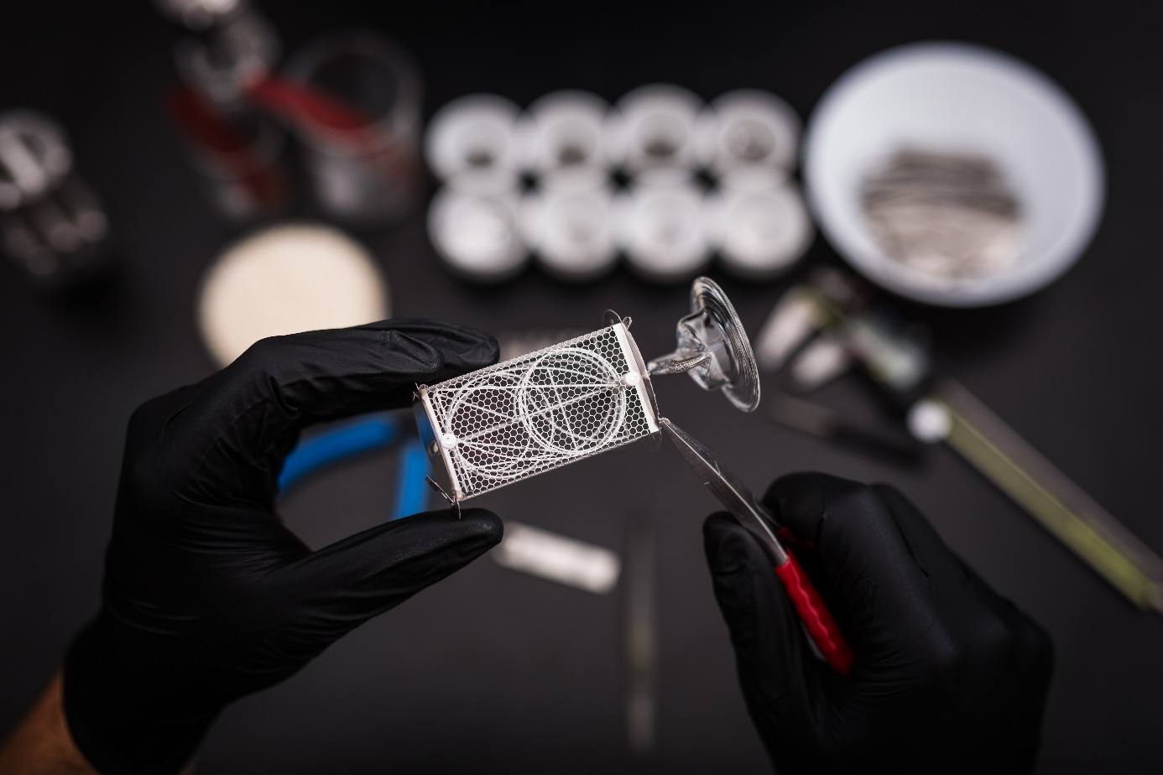

The base of the SpaceTime Blade is an URWERK crown, an imposing, oversized structure. This crown was crafted by Mr Lukuvka a specialist in lost-wax casting applied to bronze. He is an artisan in the purest sense of the term, custodian of a traditional, now almost extinct process used to create delicate jewelry and fine ornamental pieces. He was tasked with sculpting the wax model, whose imprint served as a mold for casting the molten bronze. The resulting bronze base was then polished, buffed and given a patina. Ensuring compliance with the demanding URWERK aesthetic standards represented a mammoth endeavor.

Standing on this crown, a glass dome – featuring the same thickness throughout from base to rounded top – protects the SpaceTime Blade indications from the elements. Beneath it are eight vertically aligned and individually flame-shaped handmade Nixie bulbs. Each of these oblong glass tubes has stood the test of fire. Each has danced and twirled under the blowtorch in order to acquire its characteristic appearance. They were then washed and freed of even the slightest impurities. These glass marvels were blown in Mr Votrubec's workshops in the Czech Republic, in the vicinity of Novy Bor, nicknamed the "Crystal Valley" and a region listed on UNESCO's Intangible Cultural Heritage List for its unique skills.

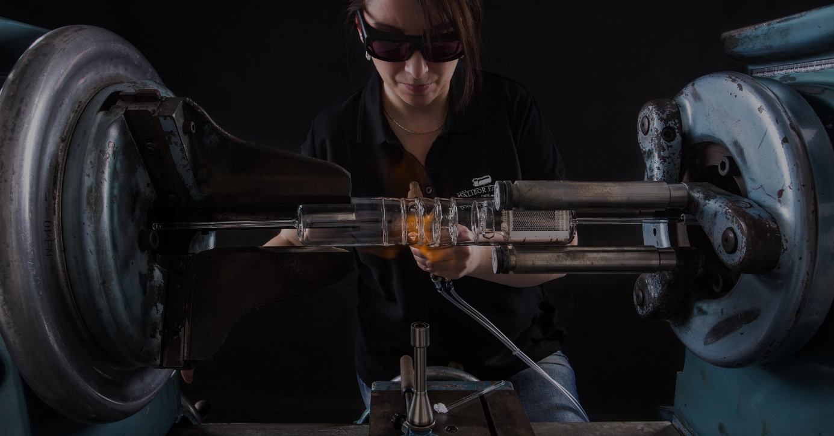

Under Dalibor Farny’s brilliant guidance, each glass tube becomes a Nixie bulb with its anodes arranged in a metal grid and its cathodes forming numerals. For each unit displayed from 0 to 9, a 0.1 mm-thick steel cathode is designed (the numerical font used here is identical to those displayed on URWERK dials), i.e. 10 per bulb. The entire creation is then delicately assembled element by element using precision tweezers, like the most delicate of constructions. Each bulb is composed of 88 parts! It is on this fine metal spider's web that the SpaceTime Blade's indications are displayed and it is the pleasing fluidity of the various elements that ensures the aesthetic appeal and airy lightness of this space measurement instrument.

He states: “Working alsongside URWERK, known for their avant-garde creations, was both an extraordinary journey and unparalleled experience. The creation of the SpaceTime Blade clock ushered me into the realm of the unconventional, a place where crazy ideas that might be dismissed in rational projects were welcomed with open arms. I'm particularly thrilled because, pushed out of my comfort zone by URWERK, has led us to elevate nixie tube technology to new heights, breathing new life into them”.

When the current is switched on, a warm orange glow stages a truly magical visual show featuring hundredths of a second ticking away. The display can change a stunning 500 times per second.

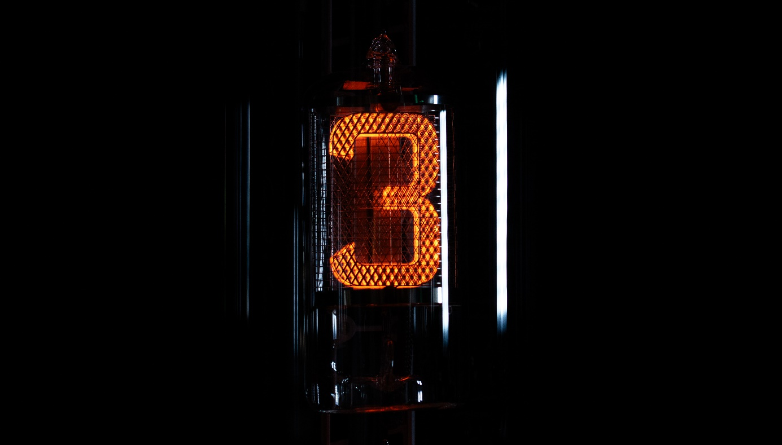

The remote control for this timepiece is just as exceptional, evoking the imaginary world of laser sabers, with eight display modes on offer ranging from time measurement to distance calculation:

Position 1: Indication of the hours, minutes and seconds
Position 2: Indication of the hours, minutes, seconds, 1/10ths and 1/100ths of a second
Position 3: Indication of the day, month and year
Position 4: Indication of the Earth's daily rotation expressed in km (measured at the Equator - counter over a period of one day)
Position 5: Indication of the Earth's revolution around the Sun expressed in km (counter covering a one-day period)
Position 6: Indication of the earth's revolution around the Sun expressed in km (counter covering a one-year period)
Position 7. Screensaver display
Position 8. Off mode

"Scientific instruments such as telescopes and microscopes, as well as clocks and other measuring tools, were traditionally made in bronze. The SpaceTime Blade draws its inspiration from such instruments, while incorporating aesthetic codes from the world of science fiction, anticipating the influence of popular culture. The SpaceTime Blade is both a clock and an Art & Design object, a time sculpture”, says URWERK artistic Director and co-founder Martin Frei in conclusion.

Technical specifications SpaceTime Blade (33 units)

Dimensions:
Height: 170cm
Weight: 20kg
For a total of 1’446 components

8 Nixies glass bulbs (88 components per Nixie unit) featuring:
Time indications (hour; minutes; seconds; 1/10 and 1/100 of a seconds)
Distance indications (Earth’s rotation and revolution expressed in km)

Electronic spinal column

Bronze base with black patina (lost wax casting)

Price:
CHF 55’000.00 (Swiss francs / no tax included)

.
Dalibor Farny
Dalibor Farny stands as a unique force in crafting Nixie tube lamps, fusing vintage aesthetics with modern innovation. With an artisan's touch, Farny's lamps become functional art pieces, meticulously designed and personalized. Notably, the company's collaboration with NASA underscores its reliability in space-grade applications. Dalibor Farny's expertise and commitment to quality shine through each handmade creation, showcasing a blend of traditional craftsmanship and cutting-edge technology.

URWERK
URWERK appeared on the watchmaking scene in 1997, and since then has been shaking up the world of haute horlogerie with its revolutionary vision of time. Rebellious and unconventional, URWERK may be a young company, but it is a pioneer in the independent watchmaking landscape. Producing 150 pieces a year, URWERK is a house of craftsmen where watchmaking expertise and avant-garde aesthetics coexist in the best of all worlds. URWERK designs complex, contemporary timepieces that meet the most demanding criteria of Haute Horlogerie: independent research and creation; cutting-edge materials; hand-finishing.

________________
Media contact
Ms. Yacine Sar
+41 22 9002027
press@urwerk.com

