URWERK reaches for the stars with the UR-102 “Gaïa”

Geneva, May 30th 2021
It is an iconic model, jealously safeguarded until now at the heart of the watch Maison, since it marks the beginning of the URWERK adventure in the 1990s. The foundation stone. A watch of almost disconcerting simplicity, with a wandering hour as its only marker of time. The UR-102. This one-of-a-kind model in asphalt-coloured anodised aluminium with a platinum caseback has been newly enhanced with a midnight blue lacquer. It will be auctioned on 6 November 2021 on behalf of the "Only Watch" charity to fund research into Duchenne muscular dystrophy.
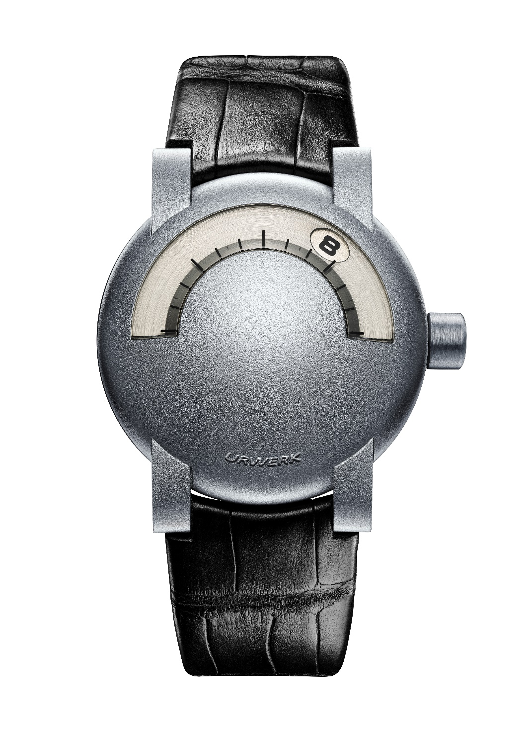

This unique piece embodies the wild aspirations of a team composed young dreamers who had only just graduated – from the School of Arts for Martin Frei and from the Solothurn Watchmaking School for Felix Baumgartner and his brother. In 1997, they set out to conquer the world, armed with a brilliant idea and modest capital. Their first watch, the UR-102, was presented at the Baselworld watch fair on the booth of the AHCI (Académie Horlogère des Créateurs Indépendants). This model ran resolutely counter to existing and generated a certain amount of controversy at the time its launch. It is now the symbol of victorious pugnacity, of salutary stubbornness. What a destiny!

"We have chosen to name this model ‘Gaïa’. We recently had the immense honour of receiving the Gaïa Prize* for Entrepreneurship from our peers. This award recognises a journey from oblivion to the limelight, along with tenacity, conviction and pugnacity that have repeatedly been put to the test. This model reflects this fierce determination that blazes new trails. We dedicate this symbol of hope to all those who struggle to make things happen”, said URWEK co-founders Felix Baumgartner and Martin Frei.
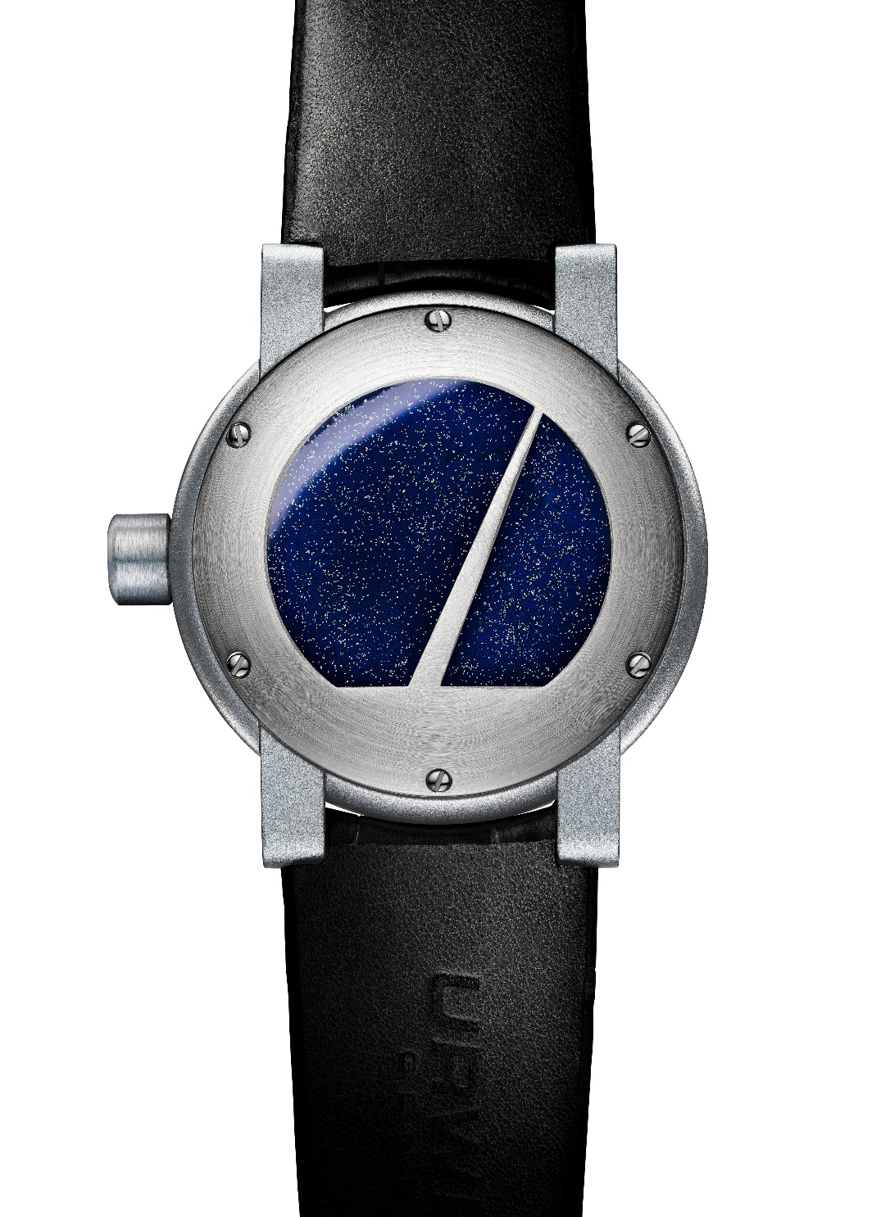

This UR-102 is unique in many ways. It is undoubtedly one of the first watch creations to honour a mixed-genre approach merging the common metal aluminium with the nobility of platinum.
Its full, round shape is seamlessly smooth. Framed by precious platinum, the caseback features an interpretation of the Gaïa prize, a dazzling flight of fancy symbolising URWERK’s unswerving resolve to reach for the stars.

Technical specifications: UR-102 “Gaïa “
Based on the historical UR-102
Original design by Martin Frei
Mechanism development and assembly by Felix Baumgartner
Case design and hand machining by Thomas Baumgartner

Movement Self-winding
Finishing Satin-brushed and rhodium-plated
Frequency 28,800 vph
Jewels 21
Power reserve 42 hours
Indications Hours indication by satin-brushed, rhodium-plated and engraved disks. Hour-marker engravings filled with matt black lacquer

Case Case middle and lugs in anodised aluminium;
Screw-down caseback in circular satin-brushed platinum, Gaïa logo filled with glittering hand-applied blue lacquer
Dimensions Diameter: 38mm; thickness 12mm; lugs 16mm
Glass Special-shaped sapphire crystal

Strap Sandblasted, polished and satin-brushed pin buckle
Strap hand-sewn in Geneva (1 x black Baltimora and 1x black Alligator)

Media contact | Mrs Yacine Sar  press@urwerk.com  +41 22 900 2027  www.urwerk.com/press

Gaïa Prize
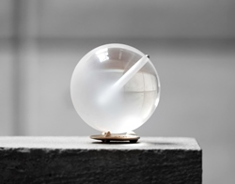

Presented for 25 years at the autumn equinox, the Prix Gaïa has become a benchmark distinction in the vast field of time measurement, and is awarded to craftspeople, manufacturers and researchers.
The Prix Gaïa is the only award of its kind to honour men and women who have dedicated their career to the measurement of time.
By awarding this distinction each year, the MIH underlines the undeniably major contribution its winners have made to the field of watchmaking, its profile and its culture.
https://www.chaux-de-fonds.ch/en/musees/mih/prix-gaia

